|  |
| --- |
| University of Westminster |
| Modernizing aspects of zamzamdirect.com by implementing the MVC methodology in Codeigniter |
| Student Name: Ali Zia |
|  |
| **Student ID: 12313392** |
| **4/25/2013** |

Supervisor: David Hearnshaw

School: Electronics and Computer Science

Key words: Web, CodeIgniter, MVC

|  |
| --- |
| This report is submitted in partial fulﬁllment of the requirements for the BEng (Hons) Software Engineering Degree at the University of Westminster.” |

Project Module Code: ECSC699

Contents

Section 1 – Introduction/Project Proposal 4

1.1 Aims 4

1.2 Objectives 4

1.3 Scope 4

1.4 Background/Business Case 5

1.5 Proposed Project Methodology 7

1.6 Requirements Gathering Process 11

1.7 Analysis Process 11

1.8 Design and Development Process 12

SECTION 2 – Security, Technical Information & Technologies Available 13

2.1 Security 13

2.2 MVC (Model-View-Controller) Pattern 18

2.3 Database Normalisation 20

2.4 Technologies Available 21

Section 3 – Data and Requirements Gathering 24

3.1 Requirements gathering techniques 24

3.2 Requirements through researching similar websites 26

3.3 Requirements Through Interviewing The Client / Prototyping 42

3.4 Requirements through Interviewing the Operational Stakeholder (Administrator) 44

Conclusion – Requirements Gathering Phase 46

SECTION 4 - Analysis Phase 47

4.1 Functional Requirements Analysis 47

SECTION 5 - Design Phase 55

5.1 Programming Languages and Framework 55

5.2 Client-side Languages/Libraries 56

5.3 Server and Database 57

5.4 Use-case Diagram 57

5.5 Class Diagrams 59

5.5.1 Class Diagram (Admin) 59

5.5.2 Class Diagram (Customer) 62

5.6 Entity Relationship Diagram 63

Section 6 - Implementation 66

6.1 CodeIgniter – structure and features 66

6.2 Configuration 67

6.3 Sprint 1 – Administration 70

6.4 Sprint 2 – Customer 93

Conclusion – Implementation 102

Section 7: Testing 104

7.1 Static Testing/Requirements Testing 104

7.2 Black Box Testing 105

7.3 White Box Testing 105

7.4 Performance Testing 106

7.5 Methods of testing employed in this project 106

7.6 Types of testing not included in this project 106

7.7 Functional test plan 107

Conclusion - Testing 109

Section 8 - Conclusion 110

Appendix 113

References 130

# Section 1 – Introduction/Project Proposal

## 1.1 Aims

To plan, design and develop a new e-commerce website that will be a technological advancement on that currently implemented by the company Zamzam International (website URL: zamzamdirect.com).

## 1.2 Objectives

* Collect a set of requirements from available stakeholders by gathering qualitative data to reveal functionality that is necessary – Requirement gathering will be done through some known techniques (i.e. prototyping, interviewing the client, researching similar applications, conducting questionnaires with the users, etc)
* Design and develop a user interface that complies with the requirements set out by the client – Once requirements are gathered and analysed, designs of the user interface will be produced and presented to the client for approval. Design will need to be approved by the client.
* Display product data from database onto the user interface – Specify the data requirement and processing required by analysing the requirements identified during the data gathering stage, to ensure that proper data is collected from related tables
* Breakdown project into activities to distribute workload effectively throughout time span
* Follow selected software development methodology to ensure project is on track in terms of time and product development
* Develop understanding of creating/displaying dynamic content onto a website
* Complete components of the newly developed website by 29/4/13

## 1.3 Scope

*In-scope*

User interface – To provide the client with a usable product, the user interface of the website will be developed in this project.

Front end (client-side code) – Front end coding will be produced to incorporate a dynamic feel for the new website. This is necessary to provide distinguishing features from the current website that will enhance the user experience. It is also necessary to reduce the footprint of the newly developed website when compared to that of the existing one.

Back end (server-side code) – Back end coding will be included as it is necessary to cooperate with a database to retrieve product information and build the interfaces the users will see.

Database – A database will be constructed to enable company products to be displayed on the website. The database will hold information about products (price, type of product, unique ID, etc) in tables where appropriate. An investigation will need to be conducted to confirm the structure of the database.

Web-based Administrative interface – To be able to edit and create new products, the client will need an interface to allow them to create, read, update or delete products on the website. Therefore an administrator interface will be developed and included within the scope of this project.

Software Testing – To ensure the product behaves as specified by stakeholders and provides appropriate results to users, there will be black box testing included within the scope of this project. This will help discover faults with current implementations, allowing progress to be made in future iterations within the project.

Security Measures –There will be some measures of security taken into consideration such as sanitizing data and using libraries within the framework instead of doing, for instance, direct queries, to make sure that the website is not vulnerable to known attacks from malicious users. Some security measures such as SSL will not however be implemented, as finance is a factor against this outcome.

*Out-Scope*

Social Media Integration – Due to time constraints the website will not contain social media integration (i.e. with facebook, twitter). This aspect can be introduced in a later stage after the completion of the project if it is highly in demand from the client or the potential users.

Server Configuration – Server configuration is no doubt a necessity when developing a website, especially an e-commerce site, however it requires much more time than is granted and therefore has to be excluded from the scope of this project. Granted more time, training and permission from the client is available to further the development/launch of this website, server configuration will be added to the scope of the project after the deadline (29/04/13) as an extension.

Payment Methods – Due to needing permissions, certificates and finances, the project will not include payment processes to allow the user to make purchases. Once the in-scope of the project is achieved successfully, these features will be highlighted as necessary and thus implemented if the project is approved by the client/stakeholders.

## 1.4 Background/Business Case

Zamzam International is a privately owned company which sells Islamic goods such as clothes, books, CDs/DVDs and perfumes among other products. As a family business, they started in 1980 and have since established their name in the Islamic retail industry as one of the leading Islamic department stores in the UK.

Nearly two years ago, Zamzam International launched their first ever e-commerce website to enter the world of online marketing. Throughout this time period they have realised there is huge potential and financial benefit in having an online presence in the industry provided that the customer receives the same, if not better, service than if they were to shop in-store and are provided a better experience than that of their competitors.

Like their local online competitors (i.e. Darussalam.co.uk, azharacademy.com), Zamzam Internationals website is static, meaning that it is just a standard webpage with no interactive feel, only links and images which lead to other static pages. This is why Zamzam International would like to advance the features offered on their website to gain a competitive advantage over their rivals before their competitors develop more sophisticated websites themselves.

As the company has been a leading retail brand in the Islamic goods industry for more than 30 years, they also intend to be a leading competitor in the Islamic e-commerce industry. In order for the company to fulfil this intent they must step away from the common approaches adopted by their rivals and look ahead to developing with the latest technologies and methodologies within the web programming industry. For this reason the proposal for the development of a new website to replace the current website is being made.

A new website will be developed instead of making enhancements to the one currently implemented, since integration with the current website would prove difficult in the time allocated to complete this project. This will leave room to innovate and produce a product that can fulfil the requirements of the company using technologies that are up to date, and avoiding errors in the current implementation. It would also be unsuitable to iterate over the current website as new technology offers more advanced ways of completing the same tasks and incorporating many mundane tasks into one feature, therefore it would render much of the elements that are present on the current website ineffective. The client would also be left with no alternative website to continue business online, which would result in losing the company their loyal customers and damage reputation.

The new website will be expected to deliver functionality that is already present in the current website but with the addition of providing an improved customer experience. Web technology advancement has improved the way users see and interact with content displayed on a website, therefore the development of the new website is expected to utilise these features and incorporate them where possible. Therefore, functionality such as a navigation bar, products list, account registration, and account management will be developed in a more modernised way to uplift the company’s presence in the e-commerce industry and improve the way the website functions.

This incorporation of advanced web technology will be achieved in this project by adhering to an appropriate software development methodology. This will ensure any risks are well anticipated and mitigated, any decisions are approved of by stakeholders to avoid situations such as scope creep and building the wrong product, and also to lay down an agreed upon set of requirements to aim to fulfil.

## 1.5 Proposed Project Methodology

**1.5.1 Software Development Methodologies: Background**

It is important to employ a methodology to ensure an actual thought process is going on in the development of the software program and not just a straight jump from having an idea to writing the code. Software engineering involves much more than just coding.

*“Software engineering is not just concerned with the technical processes of software development. It also includes activities such as software project management and the development of tools, methods and theories to support software production.”* (Sommerville, 2010)

Software development methodologies such as the Waterfall model, Incremental development, Extreme Programming (XP) and Rapid Application Development (RAD) have become a key tool for software project managers as it aids them in delivering software products that meet requirements set out by the client. Such methodologies also help in delivering the product on time.

Each methodology has its strengths and weaknesses, thus it must be taken up by a project with careful consideration as to whether the flow of events dictated by the methodology will be useful or required. For instance, a project that undertakes the development of a spaceship will need to be very thorough and have each phase of the project complete to ensure that no mistakes are made during design and development, as they cannot afford to reiterate back to a previous phase due to financial costs and lives at stake. A waterfall model would be ideal in this case as it requires one phase of the software development process to be completed before commencement of the next phase.

Newer methodologies have been introduced to cater for projects that don’t require such discipline in the order of steps but rather want to involve the user of the product in each phase. Methodologies such as RAD state as one of their principles that “Active user involvement is imperative”[1]. These methodologies work by doing increments that deliver some functionality until the client approves, and continue this process with the rest of the requirements until the system the client wants is built. This gives the project team the chance to cooperate closely with the client in order to discover and integrate new requirements, unlike with the waterfall model, where if a new requirement is found or if one is missed in a later phase of the process, and is demanded by the client, then the project returns to the requirements phase and forfeits everything they have done thus far, having wasted their previous time, effort and finances.

Today, businesses operate in a rapidly changing environment; having the pressure of responding to new opportunities, economical changes and the emergence of competing products and services.[2] They cannot afford to spend a huge amount of time waiting for their software to be completed, no matter how perfectly it would be made, while their competitors are taking advantage of their idleness. Taking into consideration the fact that technology is changing rapidly, if we follow a heavyweight methodology such as the waterfall model, we would not be able to incorporate and take advantage of the latest technology.

Agile methodologies allow changes to be made by giving the client the ability to request new requirements and having them implemented in the software. These types of methodologies are perfect for when you want to develop software for businesses that are in a highly competitive industry, such as retail, because they offer fast production of software along with active user involvement to assist the business in gaining a competitive edge with the software that is right for them.

**1.5.2 The Software Methodology Employed in This Project**

For the purposes of this project, the Agile software development framework will be implemented, specifically the Scrum development methodology.

Scrum has been chosen for many beneficial reasons. It allows the project to be focused around completing the requirements gathered from the client using appropriate requirement specification techniques. This is done by grouping together a set of requirements that the project team know they can fulfil, implementing the design and development of that set of requirements in a time limited ‘sprint’, and producing a working result that corresponds to the requirements initially set out for that sprint. Continuous sprints are done until the project is completed (i.e. product is complete, customer is satisfied, software is ready for release).

One of the main reasons for choosing the Scrum methodology is that it confines you in terms of time. Sprints are limited to a certain time period that is given to the team before they start. Requirements chosen to be completed in a sprint from the product backlog (known as the list of requirements in the Scrum methodology) must be completed within this given timeframe. If one is not completed, it is returned to the product backlog and is taken up in a future sprint, depending on its priority (i.e. high, medium or low).

Scrum allows you to list requirements of the customer using user stories. User stories are simple sentences that show what the customer would like to have as a feature and for what purpose. This allows developers to gather information about what they need to build, for whom they need to cater that functionality for (i.e. a customer, or it could be a special type of user like an admin), and what the outcome of using that feature should be. User stories are written in the following structure:

*"As a <user type> I want to <do some action> so that <desired result>"[3]*

User stories can also be conveyed easily to the client and amended by them. The product backlog is analysed with the client to see what functionality they desire to be included in the product and remove what they don’t require. This provides a good opportunity in the project to get the clients input as technical work has not yet started, and also to ensure that the product being built is what the client actually wants.

Obviously Scrum is based on a team effort, with daily scrum meetings being made with the project team and having a scrum master to overlook the progress of the project. It is possible however to adopt its process of flow to a one man project because if you look at how the methodology structures its approach to completing projects, you can see that its simply an organised way to get *the right* things done.

So each aspect of the methodology can be performed without having a project team. Product backlogs (list of requirements) can easily be made by using requirement elicitation techniques; sprints can be carried out on your own by making a sprint backlog to implement, and can be kept track of by recording progress of each task in a personal journal. This would make as an equivalent to conducting daily scrum meetings where the project team come together and discuss any problems and next steps. Then at the end of the sprint, the product owner (in this case, the client) can be shown the results produced and whether they approve/would like to add any extra requirements.

The fact that this project is limited in terms of having only one person involved, apart from the project supervisor who acts as the ‘Scrum Master’, doesn’t justify not taking advantage of the organised approach that the Scrum PM Methodology offers in getting the requirements set out to be implemented on time. It is a logical approach in the sense that you would distribute your tasks into manageable portions and work from them instead of slowly going linearly through the list. For this reason it is felt that this methodology will provide this structure along with deadlines and other aiding features to successfully complete this project.

**1.5.3 Scrum Process Flow**

The Scrum process flow is done iteratively and incrementally. This means that a certain flow of events are carried out repeatedly until the objective is reached, which is the completion of the product. The following diagram shows the steps involved in implementing the Scrum methodology:

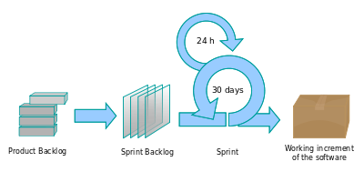

Figure .1 Scrum Process Flow

The following explains what each segment shown in Figure 1.1 mean and what happens in each step of the process.

*Product Backlog*

The product backlog contains a prioritized list of requirements that should be included in the product. Items on this list are picked by the development team to implement in upcoming sprints.

*Sprint Backlog*

This is the gathered list of requirements the product owner has chosen for the development team to work on in the upcoming sprint. These requirements are broken down into tasks that are given an estimate in time, which should ideally range from 4-16hrs[4]. In the first few sprints the development team should concentrate on the highest priority requirements in order to build the foundations of the product. Later on, sprint backlogs will contain only medium to low priority requirements to finalise the product. Before the sprint has begun, a ‘sprint planning’ meeting is held to select what work has to be done during the sprint and to assess whether the selected work can be completed within the timeframe.

*Sprint*

A sprint is a time based development period where tasks from the sprint backlog are implemented. The time for a sprint is determined by the collective time period of all tasks contained in the sprint backlog, but normally ranges from 7-30 days. Each sprint must end on time, regardless of whether or not the selected requirements have been met successfully or not. If for some reason a requirement is not met at the end of the sprint, it is returned back to the product backlog to complete in a future sprint. Within a sprint, daily meetings are held to update team members on what they have done, what they plan to do and whether they require help in completing a task i.e. they are stuck.[5] This is illustrated in the above diagram by the 24hr loop shown above the sprint cycle which also represents the tasks the team has chosen to complete for that day.

Once the sprint has ended, there are two meetings which are held. The ‘sprint review meeting’ is held to demo the results of the sprint to the client and review what work was and was not completed. The ‘sprint retrospective’ gives the project team the chance to assess what went wrong in the process during the last sprint and what went well, in order to document and improve on future sprints.

## 1.6 Requirements Gathering Process

This section will provide information on how functional requirements will be gathered in this project.

Functional requirements explain what actions need to be accomplished by the product, in our case the website, to achieve an end goal. Below is a list of ways we will identify functional requirements for the new website:

* Researching similar websites
* Interviewing Stakeholders
* Prototyping

These techniques will help us in gathering requirements. Once an initial list has been produced, we can then make a firm list of requirements and go over them with the client for confirmation of what the web application that is being built will consist of in terms of functionality. This will be done in the analysis phase, where we will scrutinize each requirement to see if they are actually needed and how they fit into the overall structure of the web application.

## 1.7 Analysis Process

An analysis phase is where requirements found in the requirements gathering process are documented and thought over to see whether they make sense if they are applied in the problem domain. It is in this phase that a conclusive list of requirements is made to be used in the design and implementation phases.

The analysis phase allows us to see if any essential requirements are missing, essential meaning here that without the requirement in question the web application would be incomplete. Not only that, but we can also make decisions about the requirements we have gathered, to see if they are actually needed, complimentary, or not applicable at all in the problem domain.

Functional and non-functional requirements are prioritised to show what is absolutely necessary to implement in order to provide a working solution, and what can be considered a luxury quality. This will help keep the project focused on high priority tasks instead of getting dragged into spending time on functionality which can be put off until a later date.

## 1.8 Design and Development Process

It is important to have an understanding of what the website that is being developed should actually do and how that functionality will fit into the architecture of the system, which also needs to be clearly laid out. To gain this understanding, a few modelling techniques will be employed, namely use case diagrams, class diagrams and prototyping.

Use case diagrams will be used to illustrate how the functionality gathered from the client and similar existing systems will form parts of the whole website. Having analysed a final list of requirements will allow the production of a final use case diagram, which will help in giving a diagrammatic view of the functionality the website aims to achieve.

Since the Scrum methodology will be used as a basis for the project which caters for change in requirements, the use case diagram will also help in understanding whether that change will positively or negatively impact the website and whether the change/addition of a requirement will fit into the design of the website. It may also help lessen additions to the list of requirements from stakeholders as we will be able to see whether the proposed requirement is already implemented or something similar to it is already enlisted.

It is assumed that an underlying architecture will be needed to structure the production of the website, such as MVC (Model-View-Controller); therefore a class diagram model will be produced to outline the details of various classes that will be necessary in the development of the website. This will help recognise what classes need to be included to fulfil functionality and what actions they will need to perform.

Once the architecture is laid out and a firm list of requirements is ready, we will then be able to design how the functionalities to be included in the website will be put together in an interface. This process will be handled by either using paper prototypes or wireframes to give a graphical representation of how the website will look and function, given the requirements set out for it.

The prototype design will be shown to the client while conducting an interview, as it will act as a tool which can be used to elicit requirements out of the client which they want the new website to fulfil. During this process, we will go through user testing such as a prototype demo to highlight any errors in the design, user expectancies and additional features to add to the design based on the clients input.

# SECTION 2 – Security, Technical Information & Technologies Available

In this section of the report we will cover the topic of security; what threats are posed to web applications and various ways to mitigate them. Technical terms used in this project will also be explained here to give the moderators an overview of my understanding of the aspects discussed. A brief introduction into the technologies available to successfully create the new website will also be given here.

## 2.1 Security

The Web is now being used extensively to accomplish tasks that took too much time, money and effort to do. Companies are relying on web applications to manage their business, such as using control management systems to keep track of their stock, business trends and employees; while individuals are communicating with their friends and family by signing up with social networks because it provides them with instant communication, it’s simple to work with, plus it’s free!

However, with all these benefits comes a major drawback. Companies, who run their business online, such as e-commerce companies, are making their precious data vulnerable to attack by hackers. A company might store employee records in a database, which is accessed by an administrator account on a web application. These records contain the employee’s personal details such as their address, contact information, gender, date of birth; and also their company specific details such as their ID number, job title and salary. That’s a huge risk to take. Not only are you vulnerable to internal personnel misusing the information, which is always a risk, but you have opened yourself up to external attacks.

Social networks require you to register an account with them in order for you to use their services. The process may require you to supply information such as your email address, along with creating a username and password. The registration process itself is not the issue here, because social networks such as Facebook and Twitter secure this step, rather it is the information they encourage you to supply (name, address, friends, occupation, location, etc) in order to enjoy a better user experience that can cause problems.

It wouldn’t take a genius to figure out your password for Facebook or Twitter, especially if they were close friends or relatives. That could lead to loss of reputation, if they posted something unacceptable on your Facebook wall[6], or even cause you to lose your job if they posted something hateful to your boss who you’ve included as your friend. So for the benefit of utilizing a free service, you’ve endangered yourself to people trespassing into your account and ruining your social life.

Companies who use web applications face a greater risk if their system is compromised. A company that administers their employee’s records online can face legal consequences if an employee finds out that their data has been stolen or used by unauthorized personnel. Professional hackers can find information about the administrator(s) in their reconnaissance phase, and have a greater chance at guessing the credentials for the administrator’s login information and getting into their account. Then once they’re in, they have complete access to see and manipulate all the data about anyone in the company.

It therefore becomes essential to know what these attacks are, how they are carried out, and what measures can be taken to prevent or lessen their execution.

We will now take a look at some common attacks which pose a threat to web applications and prevention measures we can use to make a website safer from them.

**2.1.1 SQL Injection**

This attack has been listed as the number one vulnerability which affects web applications in the OWASP top ten lists of vulnerabilities for 2010[7]. An SQL injection attack targets your database in one of two ways: using the URL or through form inputs which validate or query the database.

The attacker uses any input field that they think may be used to insert or get data back from a database to execute this attack. They can also do this directly in the URL by getting information about the variable names you use to query data in a database table.

This attack can be used to bypass your authentication system for logging into an account. The attacker can enter a simple SQL query, into your username and password fields for instance, instead of proper usernames and passwords to gain access into an account. This can be achieved by modifying the original SQL query to accept no credentials which are present in your login table, instead of finding a matching username and password combination.

The SQL Injection attack can also be used by an attacker to completely ruin your database by deleting all the data of your users, products and any other data you may have stored. This would mean months of preparing the launch of your website can go right down the drain in a matter of minutes because you didn’t take prevention measures to protect your website from this attack.

Taking the example of a company who keeps track of employee records via a web application above, we said that there is an account the administrator uses to login and perform these actions. It is a common way, and sometimes the only way, to restrict access to sensitive information by providing authorized users with a username and password. We know that we can get access to a website which has a domain name and is hosted on a server by entering it in the URL box. This can be done for any website. Assume that this figurative company has a URL of [www.wesecureemployees.com/login_form](http://www.wesecureemployees.com/login_form) which the administrator uses to login by entering a username and password. Also assume that a hacker has located this URL in their reconnaissance phase.

That hacker can try to login by entering obvious combinations of usernames and passwords, but if their combinations fail they can try to login through manipulating the SQL query which performs validation checks by seeing whether the users input matches the username and password combination stored in the database table. This can be done by entering the following SQL query in the username and password fields in the login form to bypass the check:

*Username*: ‘ OR ‘’=’ *Password*: ‘ OR ‘’=’

The original query is: SELECT ‘username’ AND ‘password’ FROM ‘login’ WHERE ‘username’ = $username AND ‘password’ = $password

But when the hacker enters the above SQL query in the same username and password form fields, the query would be modified into:

SELECT ‘username’ AND ‘password’ FROM ‘login’ WHERE ‘username’ = ‘ OR ‘’=’ AND ‘password’ = ‘ OR ‘’=’

This would make the query’s ‘WHERE’ clause read “where username equals nothing or nothing equals nothing and where password equals nothing or nothing equals nothing”, which means that the query no longer checks the input of the hacker to see if it matches the record stored in the login table, rather the input was itself made part of the query. This would give the hacker access to the administrator’s panel where they could carry out further malicious attacks.

**SQL Injection Prevention**

To prevent from this attack, it is important to sanitize the input fields whose values you would use to query a database’s table. This can be done in raw PHP using the function ‘mysqli_real_escape_string()’. This function removes quotes that are present in the input field, which carry meaning in an SQL query, and returns only text, thus there is no way to modify the query.

In PHP frameworks such as CodeIgniter, this is done for you automatically when receiving form input into the server by using the syntax ‘$this->input->...’, which is a convenience that PHP frameworks provide. Although this escaping is done for you automatically in frameworks such as CodeIgniter, it is still beneficial to know that such an attack exists and how to counter it.

**2.1.2 XSS (Cross Site Scripting) Attacks**

XSS (Cross Site Scripting) is a very popular attacking method used by hackers to attack a website that is not secured against it. It basically allows an ill-intentioned user to input JavaScript, HTML code, or iframes (mostly JS) in an input field or in the URL directly, which gets run on your website. This is dangerous for many reasons and should not be allowed, as normal users should not be able to insert content onto your website.

The attacker can insert links to web pages they have created, directly into your website. These sites can be designed to look exactly like your website, but they’re not. Your customers will think they are on your website and browsing around, logging into their account, buying products, etc, but they are actually sending their personal data such as usernames, passwords and credit card information directly to the hacker. This is made possible by directing your customers to an imposter website through XSS vulnerabilities.

Your customers can also be tricked into installing dangerous software and malware i.e. viruses and spyware. This can be done the same way as mentioned above, by inserting content onto your website. This will cause your customers computers to become infected. It is also dangerous to online businesses because it gives the attacker a platform to add content to your website. This method can be used to slander your company, post false information, redirect users to malicious websites, and anything else that the hacker can think of.

**XSS Prevention**

XSS attacks can be prevented in much the same way as SQL injection attacks are prevented, by using functions that are catered to stripping away unwanted content from the input fields. PHP offers two functions to help prevent this attack: htmlentities() and strip_tags(). Both functions can be used in conjunction (i.e. htmlentities(strip_tags($safe_input))) to have optimum security from this attack. Basically these functions remove any character entities that are known to be used in HTML or JavaScript (i.e. ‘<’, ‘>’, ‘(‘, ‘ ) ’, ‘/ ‘, etc ), leaving only the allowed characters intact and returning the sanitized string back.

PHP frameworks also cater to mitigating this common attack by providing configuration settings to help sanitize variables easier. CodeIgniter offers the option of applying a global configuration setting to automatically filter any GET, POST or cookie data. Sanitization can also be done manually when you feel it is needed. More information about how CodeIgniter can be configured to help prevent XSS attacks can be found in the documentation[8].

**2.1.3 Passwords**

Websites that require authentication in order to access privileges usually require the user to create an account where they specify the username and password they wish to use for that website. Examples of such websites are social networking websites such as Facebook and Twitter, as well as e-commerce websites that store a user’s personal information such as their shipping address, credit card information and shopping basket contents. All these websites want to give access to anyone who is willing to use their service, and therefore need an easy to access, general validation system to keep the users information safe. Therefore passwords are ideal because they don’t require the user to have something physical such as fingerprint or retinal scanners; rather they create something which they can easily remember and use that to gain access to the website.

This can be dangerous, as the nature of human beings is that we cannot remember many important pieces of information all the time, which means that people are likely to use the same password across different websites to help tone down the amount of passwords they need to remember. This can mean that if the attacker knows one password from the user, they can try that password, along with different variations of it, in different websites to see if they can gain access to more than one account.

Users are also in danger of their passwords being guessed or stolen if the passwords are weak in the first place. A weak password can be seen as being less than 7 characters, containing complete English words, is something that is obvious about you (i.e. your first/last name), is an obvious candidate for a password (i.e. password, 123456789).

Hackers these days have sophisticated tools that can help them run through a list of possible password combinations to help them guess your password. Tools such as Hydra GTK are brute forcing tools that can run through a list of possible passwords until a match is found for the username specified. These tools utilise a list of passwords, which contains a variety of passwords novice users are likely to use. Tools such as this make it easy to guess passwords, especially if your password is not strong in the first place.

**Password Protection**

There are quite a few ways to protect a password when developing a web application: encrypt the password, use the HTTPS protocol when the page is submitting sensitive data, and making sure the user has a strong password.

Password encryption is essential. As seen above, hackers have gotten their hands on more sophisticated tools that can make their job easier. Initially, passwords are sent in plain-text if your application uses the HTTP protocol. This can make the password easy to see by using a network sniffer to detect HTTP requests sent from an IP address using a network mapping tool.

To protect user’s passwords within the application, the user entered password can be hashed before it is stored inside the database. For this, there are a few functions which can generate random strings to append onto the users chosen password, such as md5(), sha1() and crypt(). MD5 produces a 128-bit hash value and is considered the weakest hash function, sha1 produces a 160-bit hash value[9], and crypt’s hash value can be defined. All these functions allow encrypted versions of the user defined password to be stored in the database, lessening the chances of internal personnel tampering with the data. To further add security to the passwords, ‘salt’ can be attached to the password defined by the user which prefixes/affixes random characters to it. This random calculation can make it much more difficult, if not impossible due to the length of time it would take a hacker to decrypt the password, to find out the users password.

Another measure which should be taken is to use the HTTPS protocol. This will encrypt data sent from pages that run this protocol so that it isn’t seen in plain-text by network sniffer tools. This will provide network level security.

Regardless of the level of protection that is incorporated, it is important to educate and enforce the user to come up with a password that is easy for them to remember, as well as being strong. A strong password is seen to contain one or more characters that are upper-case, lower-case, numeric and symbols[10]. If the user produces a strong password and a good technique for authorizing users is implemented in the application, it will add certainty that the password won’t be guessed, either by a hacker using a brute forcing tool, or by someone close to the user.

## 2.2 MVC (Model-View-Controller) Pattern

The MVC architectural pattern implies that a program is sorted into one of three groups: a model, view or controller. The idea is to organise your code better by splitting up aspects of an application into their relevant parts so that it is easier to read, test, change and reuse. PHP frameworks such as CodeIgniter, Ruby and Zend run this pattern at their core.

It’s important to know what each component is used for; thus a brief summary will follow. When building a web application for a company, you would rightly assume that somehow you will need to produce something the user can see (View) and have data (Model) to present, to showcase whatever it is that the company wants the user to see. Controllers are introduced by the pattern to have a platform where a view component can send requests to receive data from a model, and then pass the request to the model to query and assemble the required data.

Below is an explanation of each component in the MVC pattern to understand what goes on inside them.

**Model**

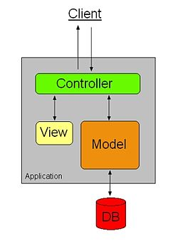The model is the data control component in the MVC pattern, where interaction with a database or file system is carried out in order to read or manipulate data. The model receives a request from a controller which tells it to perform a query, which could be anything from a validation check in the database, reading/writing data or editing/deleting data, executes the query logic and returns the data that was requested, or a success/error message. Models interact with the controller component only, not directly with a view. This is in order to have a purpose for the controller component, which deals with the business logic of the application. Otherwise if models and views were allowed to interact directly with each other, there would either be reputation of code in the view and controller components, or no purpose whatsoever of the controller.

Figure 2.1: MVC Process Flow

**View**

The view is the user interface layer of the architecture, which deals with presenting the users with a platform which they can interact with in order to use the application. Views are used to get data input and/or perform actions, which are then passed to the controller to execute. If interaction with a model is needed, the controller then passes data to the model component, which handles the query and returns the results back to the controller. Once the data is received, the controller then loads the view with the results. It is received by the view component to present the data to the user in a user friendly manner.

**Controller**

The controller deals with the business logic of the application, sending and receiving data from the view to the model and back to the view. Data is taken from the view, which requests an action to be performed by the controller, which then takes that data and makes a request to the model to perform an action. The model may then return data back, in which case the controller would take that data and load a view to present that data on. The controller is where the behaviour of the application is assigned; without the addition of controllers in the pattern, the business logic of an application would get scrambled and lost in the other two components. For this reason, controllers deal with handling function calls and responding to them appropriately.

## 2.3 Database Normalisation

Normalisation in database terms means that the tables in your database are designed with one purpose in mind: to represent one ‘thing’ only, with columns and atomic data defined in a way to help making queries to get to that data easy, and to make that returned data fit for purpose.[11]

The extent to which a database is normalised is understood by categorising the state of normalisation for that database. Normalisation comes in three forms, each containing rules to fit into the category. These ‘normal forms’ are also sequential, meaning that they require their preceding normalised forms rules to be met in order to progress onto the next (i.e. a table in the third normal form must have followed the rules set out for the first and second normal forms, along with its own rules). At first sight this may depict that being in the third normal form is optimum, but this isn’t necessarily true; it all depends on what your trying to achieve and how complicated it gets.

**First Normal Form**

Rule 1: Columns contain only atomic values[12] - This means that each column in a table should represent only one piece of the same information, not groups of the same information. So a table which holds information about a products size in a column called sizes cannot have multiple sizes crammed together in one field. This is good practice as it is keeping easy querying in mind, and having multiple values in one field delimited by a comma would be a nightmare to read into the application (by making the query complicated and slowing down performance of the application). Columns should therefore contain only one value.

Rule 2: No repeating groups of data[13] - A table should not hold the same information repeatedly, this gives a limitation to the number of attributes (i.e. if you have three columns that describe a products colour, you are limited to a maximum of three colours only) that can be associated with an entity. This limitation would prove costly if new products with a huge array of colours or sizes were acquired, as you wouldn’t be able to completely describe the products attributes. It is therefore good practice to break apart the columns that are in the same group into a table of their own, referencing the entity as a foreign key so that the colours/sizes/etc would still be associated with it, if this is suitable.

**Second Normal Form**

Rule 1: Be in First Normal Form[14] – Must have met the rules set out in the first normal form.

Rule 2: Have no partial functional dependencies[15] - This simply means that all the columns in the table should represent only what is related to the primary keys. The purpose of the table comes into play here, as you would need to think about whether the information you want in the table is relevant to the purpose of creating the table, or is that information redundant/present in another table. For example, a table that represents the amount of stock for each product would not need to hold data about a products colour or size; it would just need to know what product it is referring to and how much stock is available.

**Third Normal Form**

Rule 1: Be in Second Normal Form – The rules for being in the second normal form are met.

Rule 2: Have no transitive dependencies – This means that the types of data present in a table should not be dependent on other field data present in the same table. For example, a table that defines courses available in an educational institute stores the course’s name and ID, the teacher who teaches that course, and their contact information. The contact information for the teacher is dependent on who the teacher is, so that information would be need to change if the teacher was replaced. That would make querying harder, as every time a teacher was replaced, the contact information for the new teacher would need to be updated. It is therefore better to not include the contact information of a teacher in the courses table, but rather provide a foreign key to the courses table from a teachers table which holds their personal information. This would allow the courses table to be in third normal form, making it easier to query and omitting any unnecessary pieces of information.

## 2.4 Technologies Available

Below is a summarisation of web technologies that are available and may be considered for use in the development of the new website.

**2.4.1 Web Servers**

*Apache HTTP Server* **–** Apache is a free, open source web server than runs on all operating systems (Windows, Linux, OS X, Solaris, IBM, etc). It is a popular web server as it enables plug-in modules that can be used to include features such as security/filtering and rewriting, allowing for wide support in building dynamic websites and providing authentication. It is known to be used in combination with MySQL and PHP.[16]

*Microsoft Internet Information Server (IIS)* – This is Microsoft’s server application designed for use with Microsoft Windows. It provides support for HTTP/HTTPS and the latest version also has authentication modules (extensions) for URL authorization, IP security and filtering requests.

*Nginx* – nginx is the second most popular web server in the world according to Netcraft’s January 2012 Web Server Survey[17]. The web server runs on all operating systems. It provides the ability to handle more than 10,000 simultaneous connections, load balancing, and OpenSSL.

**2.4.2 Programming/Scripting Languages**

*PHP* – PHP is the most well known open source programming language that’s used for developing dynamic web pages. It’s a server-side programming language which is commonly used in conjunction with HTML, allowing dynamic data to be embedded into a web page. The programming language was the creation of software engineer Rasmus Lerdorf, who publicised the language in 1995, a year after having personally used the language[18].

*Perl –*Perl is a general purpose programming language which was originally developed for text manipulation and is now used for other tasks such as system administration, web development, network programming, games development and more. It supports both procedural and object-oriented types of programming.[19] The language was originally developed by Larry Wall in 1987, as a general purpose Unix scripting language to make report processing easier, however it has gone through many changes and redesigns, allowing it to cater to a variety of different applications (CGI, graphics, systems admin, bioinformatics, and more).[20]

*JavaScript* – JavaScript is considered the most popular client-side scripting language. It supports both object oriented and procedural types of programming. JavaScript is used to manipulate the document object model (DOM) of an HTML page, validate user input in forms and creating animations, however it is mostly used nowadays while implementing a library such as JQuery or YUI.

*CSS*- Cascading Style Sheets are used to add life to a web page by allowing the developer to design and layout the web page that holds content. It allows the developer to design a website so that it is catered to the websites purpose and the company’s image. Design is done through styling individual or groups of HTML tags, which formats the structure of the document, allowing an aesthetically pleasing page layout.

*HTML* – HTML is used for the purpose of structuring a web page. This is the technology that the user is directly in contact with and is the tool that displays the information sent from the server to the client. HTML consists of Meta tags, which describe the content on the page i.e. a form, a title, a header, etc and also the content itself. This information can be sent from the server and become part of the DOM of a webpage, or it can be statically written.

**2.4.3 Databases**

*MySQL* – MySQL is an open source relational database management system. It is the most used open source database for web applications, allowing information stored in a database to be used/manipulated via querying tables that hold the information. The first version of MySQL was developed in 1995 by Monty Widenius, and has since then rivalled commercial database applications such as Oracle and Informix.[21] MySQL provides a GUI interface called phpmyadmin which is extremely helpful in managing the tables in your database.

There are many other databases available such as SQLite, MariaDB and Oracles database, all more or less doing the same thing.

**2.4.4 Code Libraries**

There are many libraries available for Javascript that can enhance and simplify the usability and creation of a web application. Below is a list of well-known JS libraries:

* DOJO
* Yahoo (YUI)
* Prototype
* JQuery
* Moo Tools
* Script.aculo.us

These libraries may be used in the development of the new website to make animations and use methods/functions available in the chosen libraries to simplify the code in terms of number of lines for functionalities that may need to be done frequently.

**2.4.5 Frameworks**

*Zend* – An objected oriented framework for PHP, provides a loose architecture which means its components are not interdependent, therefore it can easily be customised to cater for its intended purposes. Zend also provides support for many database systems such as MySQL, SQLite, Oracle, and MariaDB. It offers an abundance of libraries, more than any other web development framework, however this can affect performance of applications that run on this framework.

*CodeIgniter* - CodeIgniter is a lightweight framework which runs under the MVC paradigm. It provides developers with the ability to create much simpler code by following the MVC guidelines and is much faster than Zend due to its small footprint. CodeIgniter also provides good documentation which helps understand its usage. It also uses the Active Record pattern to query databases, and offers libraries to make common tasks simpler and safer.

*Ruby on Rails* – Rails is also an open source web application framework based on the general purpose programming language ‘Ruby’. It also follows the MVC architecture pattern and emphasizes many software engineering patterns and principles such as the Active Record pattern which makes producing database queries safer and easier to read; Don’t Repeat Yourself which promotes the idea of not using duplicate code i.e. not making two functions do the same thing, and MVC.[22]

# Section 3 – Data and Requirements Gathering

First we will briefly describe some of the different ways in which requirements for a system can be gathered.

## 3.1 Requirements gathering techniques

Introspection

Introspection is the observation or examination of one’s own mental state and processes. It is the act of looking within oneself.[23] When taken in terms of finding requirements for a system, it means using one’s own intuition and domain knowledge to find out what would be needed to allow the software to function properly. This is a way for the one working on the software application to brainstorm and put together what they think, through past experience or through reviewing literature, should be included to make the application run successfully.

Researching similar applications

This technique can be linked to introspection. It deals with the examination of applications that are similar to what is being built, in order to find out what functionality is fundamental in order to have a complete and absolute application. Researching similar applications is also used to find trends within the particular industry, what can be done, what implementation of a functionality works/doesn’t work and why, how could you improve the way things are done, etc.

Interviewing stakeholders

Interviewing the stakeholders of a project is a way to get detailed requirements from the people who will be using the software. It is a direct way of interacting with stakeholders and getting them involved in the building of the application. This process helps insure that the people the software is being built for are actually used to develop the correct software by including functionality that is gathered off of them. Some methodologies, mostly agile, use this as one of their main methods of gathering requirements because it offers interaction with the stakeholders.

Prototyping

Prototyping allows stakeholders to see aspects of the application, stimulating a response much more quickly than answering to questions. This is because it is easier for them to see an example of the new application and respond with their input. Using prototypes allows stakeholders to see different, often better, ways of completing tasks that they are currently doing. It also helps in receiving feedback for the design you’re proposing, allowing you to improve on it and thereby aiding you in gathering firm requirements.

**Requirement techniques used in this project**

Looking at existing similar websites: We will look at some of the major names in the e-commerce industry, such as Amazon.co.uk and Waterstones.com, to observe what information and functionality they have included, as well as looking at more related websites to Zamzam International such as Darussalam.co.uk, Islamic-Foundation.com and AzharAcademy.com, to find what functionality, if any, is common within the industry.

**Justification**

This method will help in creating understanding of how an ecommerce website should be structured, what key elements it must have, how one functionality can be implemented in different ways, what the wrong ways of implementing a functionality are, and what can be done that is not present within any of the above websites which can be useful for Zamzam’s customers.

Interviewing the stakeholders: This will provide the client with an open platform where they can voice their opinions as to what the website should contain. We will be assuming that looking at similar websites will provide the basic functionality that any e-commerce website should have, and interviewing the client and operational stakeholders to gather requirements which are more specific.

**Justification**

This method of requirements gathering is necessary as interaction with the stakeholders is crucial to providing the right product, and interviewing them will allow us to extract information that will lead to creating that right product for them. Otherwise, simply researching similar websites will give us what we need in terms of general functionality, but without knowing the specifics of what the client wants, it can lead to building the wrong product, or one that the client won’t accept to use.

Prototyping: Having a visual aid when conducting an interview with the stakeholders will provide a better chance of getting requirements out of the interviewee. It will help them to actually see the proposed design and make changes to it if they feel it is needed. Presenting the prototypes to the stakeholders will allow us to gather specified requirements from those who will be using the web application.

**Justification**

Prototypes are a good tool for visualising a proposed product. In order to get information out of a stakeholder, it is important that they feel compelled to support the project. Drawing up a prototype and presenting them with ideas of how their website can be improved can intrigue them to help you, as they can see what is being proposed instead of just hearing about it. All businessmen and workers want to support what can help them make more money and make their daily tasks easier, and it helps to be able to see what that improvement looks like and make contributions to it.

## 3.2 Requirements through researching similar websites

Here we will analyse Zamzam’s existing e-commerce website by seeing how it compares with some of the leading e-commerce websites available. This will allow us to highlight the improvements that can be made when implementing the new website, what is lacking in terms of functionality (if anything), and whether there are better ways of doing the same thing done on the existing website.

The websites chosen for comparison are:

* Amazon.co.uk
* Waterstones.com
* Darussalam.co.uk
* AzharAcademy.com

Amazon and Waterstones have been chosen as they are recognised brands and therefore they are active in uploading the highest standards that web technologies have to offer to give customers a good experience and be able to successfully manage their content. Islamic ecommerce sellers have been selected to analyse what trends are common within the Islamic ecommerce industry, if any.

Using this technique, we will look at different aspects of e-commerce websites and how they are implemented, along with a comparison with the current Zamzam website to gather a list of functional requirements.

**3.2.1 Getting to the Shopping Basket**

When looking at the current websites process we can see there is a large checkout button on the top right of the webpage. Assume that the user had added something to their basket a couple of days ago and has returned to complete the transaction. They may or may not remember what item they added to their basket, therefore may feel hesitant to click a button that leads straight to the payment process. Thus it may not be convenient to display such a button in a prime position.

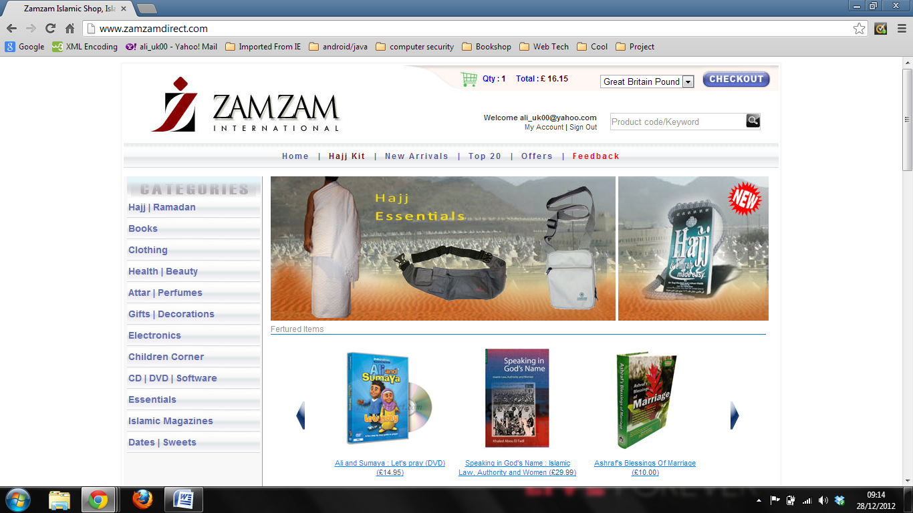If we look at what happens when clicking the ‘checkout’ button, it leads us to the page which requests us to confirm/add our billing address.

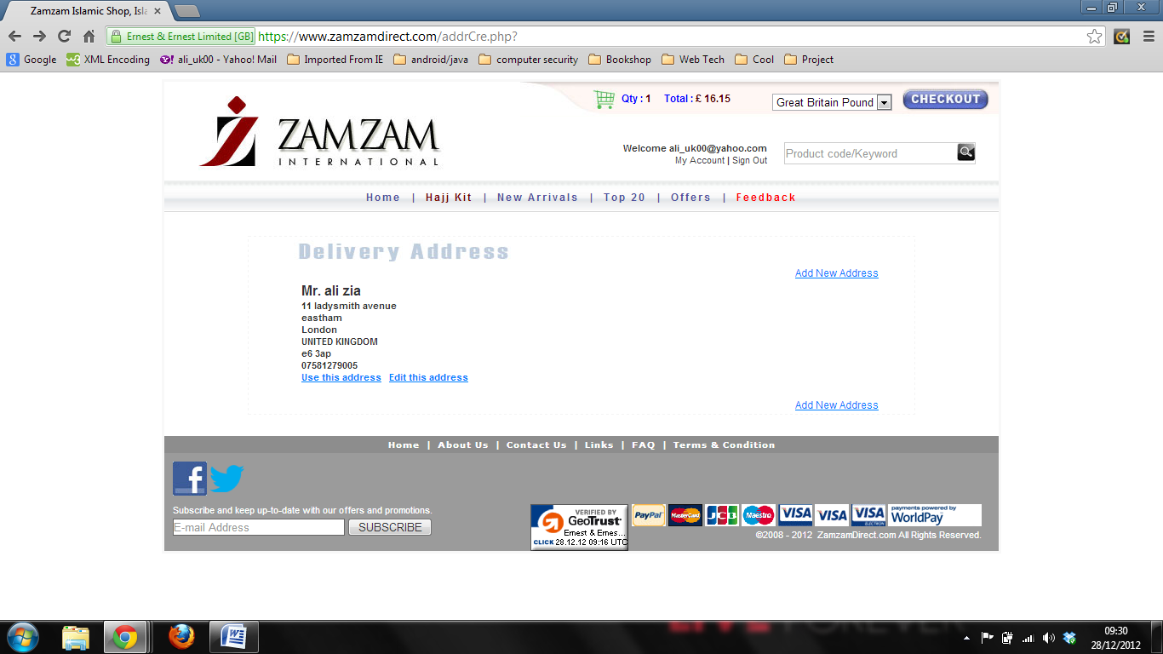

This process assumes that the customer knows what they have purchased, which may or may not be true. They are not allowed to make alterations to their purchase, such as deleting an item from their shopping basket, adding more quantity, etc. After this page the customer is lead to a page displaying a summary of their order, where there is no functionality to edit the items in the order.

This ambiguity could have been avoided if priority was given instead to the shopping basket, like it is in Amazon and Waterstones, instead of boldly highlighting the checkout functionality.

Looking at Waterstones, we can see that they have highlighted the customers shopping basket, and within that shopping basket they have included the checkout functionality.

It could be said that the current system has included the checkout functionality in their home page to assist their customers in quickly purchasing their products. This however doesn’t cater for different situations i.e. if the customer doesn’t have an account, the customer doesn’t have anything in their basket. What would you do in such situations? The checkout button would be unsuitable for users in such situations.

Instead it would be better to implement the ‘view shopping basket’ functionality where the current system implements the ‘checkout’ functionality, as this will provide more convenience to the customer as they will not be unintentionally directed to the payment process.

**Requirements Gathered:**

* The web application should allow the user to create an account
* The web application should allow customers to add desired products in a shopping basket
* The web application should give customers the ability to view items in their shopping basket
* The web application should allow customers to edit the quantity of a product and update the price accordingly
* The customer should be able to delete any product in their shopping basket
* The customer should be able to continue to check out the items they have selected via their shopping basket.

**3.2.2. Remembering the products in the users shopping basket**

In the current system, you are not able to ‘add on’ to your shopping basket if you sign out, or are automatically signed out (which happens if you are not active for a period of time on the website) of your account. Once you sign out and sign back in, the products you placed in your shopping basket are gone.

That can cause nuisance to the customer, as they may have spent quite a while looking for the products, especially taking into account the static feel of the website with all the page loading, and if they decide to buy the products later or restart their browser , they won’t be able to continue their purchase from where they left off.

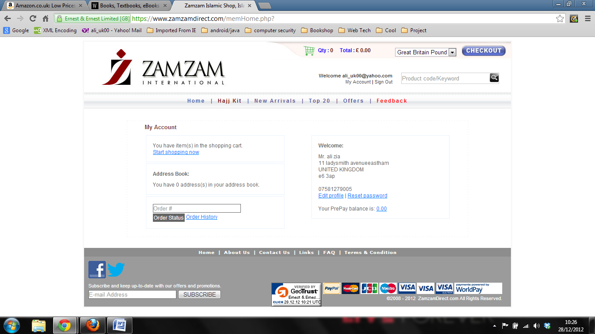The following screenshots illustrate the above point.

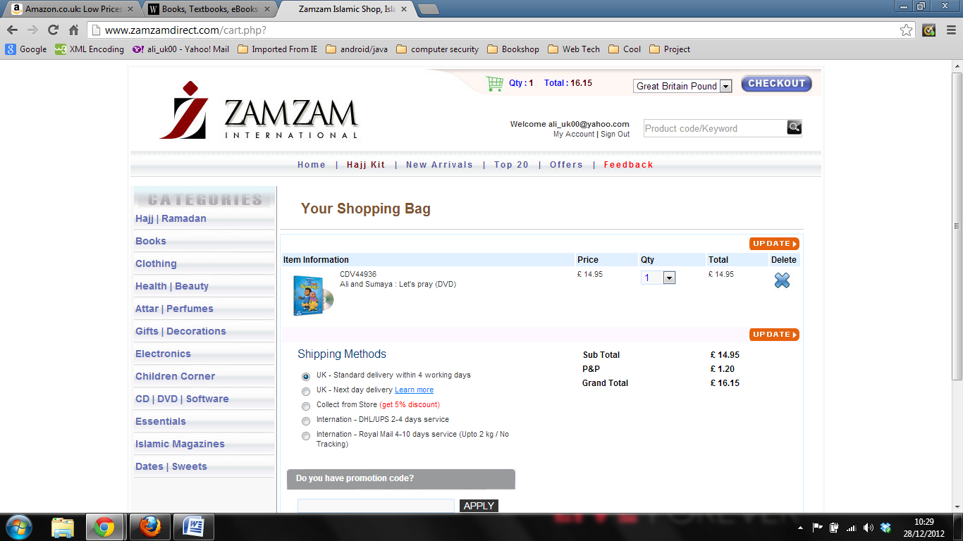The above screenshot shows that I am now logged into my account. This means I should now be able to add products to my shopping basket.

We see that now I’ve added a product to my shopping basket. If I proceed to the checkout option I will be able to purchase the product from this point because I’m completing the transaction in one session.

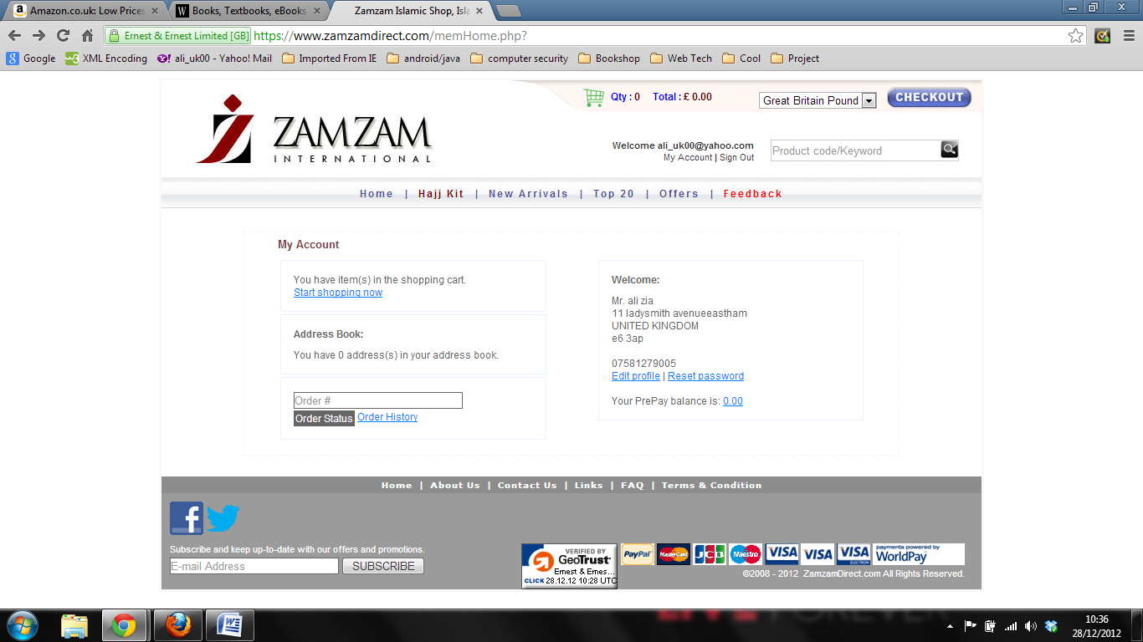However, if I log out for some reason (i.e. I may want to save this item in my basket and search for other items later so I can purchase everything in one go), or am automatically logged out, this is what will be shown to me upon logging back in to my account:

We can see that the quantity and total cost above are zero, which is not a good indication to the customer and shows that the web application is not able to provide the functionality of remembering a customer’s shopping cart contents.

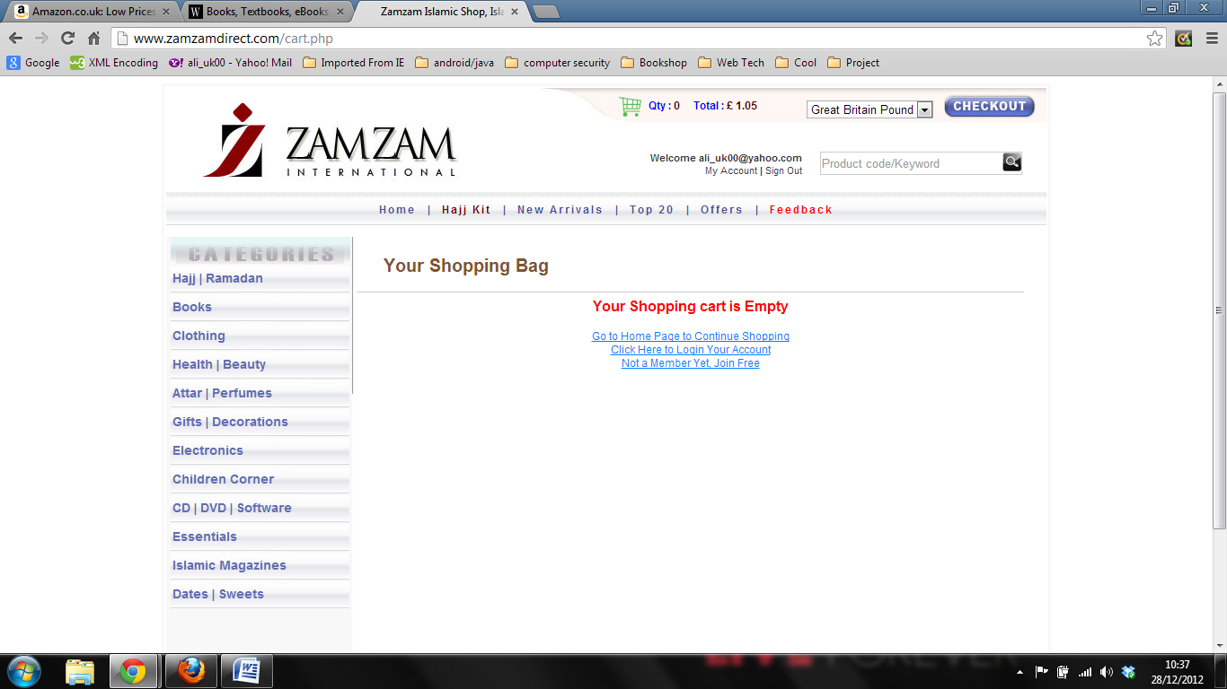And if we go to the shopping basket itself, we will see the above page. We also notice an error in the total costs indicator at the top, which shows a charge of some sort for £1.05. This won’t however charge the customer, as once you start shopping for products by clicking another link to navigate elsewhere, the mysterious charge will disappear. It does however show that there might be some logical error in the calculations for the total cost.

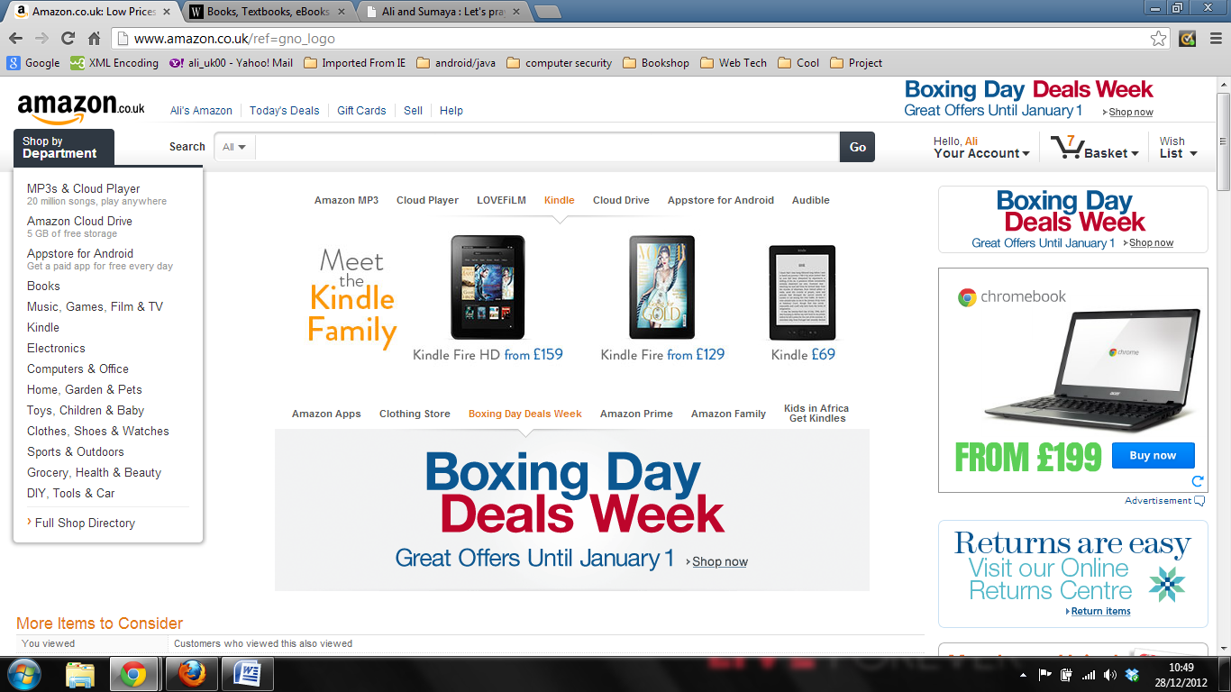Back to the issue at hand, we can see from sites like Amazon that the products in your shopping basket are always there, no matter if you’re logged in or not, or whether you have an account or not.

Not having remembered the last state of the users shopping basket can make things difficult for the user by having to re-do all their previous searching for products instead of continuing from where they left off. It also affects the sales of the company, as users may tend to buy less because the facility of remembering products that they added to their shopping basket is not available. Therefore it should be necessary to correct this flaw in the current website when designing the new web application.

**Requirements Gathered:**

* The web application should save and remember the state of the customers shopping basket upon their return to the website and when logging back in to their account

**3.2.3. Searching products using the search facility**

The search box is one of the main functionalities of any e-commerce website, and thus should be a reliable option for customers to use when they decide to search for their products instead of going through the navigation process. It is especially used when customers know exactly what they’re after and want to know whether the website offers the product by searching especially for it using the search box.

Judging by the performance of the current search box, it does what it’s supposed to in terms of giving back all matching criteria, but it does need to produce more accurate results.

If we search for the book ‘Purification of the Heart’ in the current website, we get the following results:

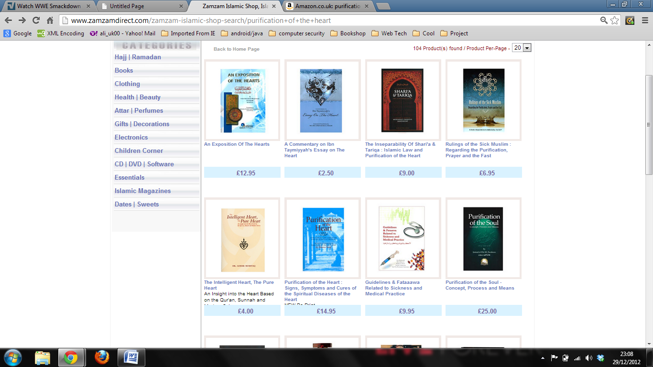

The actual book is the fifth result, but it has done its job. It is however expected, given today’s standards, that if the user types in specific product details, they would be presented with the most precisely matching results first. In this case we are given only a list of products that contain the words matching the criteria with no specific ordering in the results. The actual book ‘Purification of the Heart’ is a better match than ‘An Exposition of the Hearts’ and should therefore be prioritized.

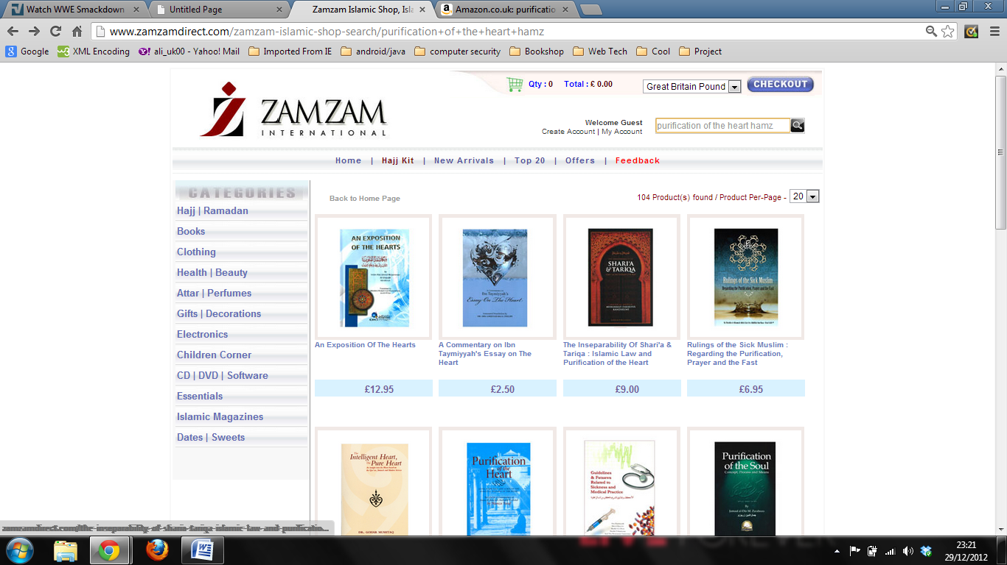What if we try to search by the book title and author, to hopefully refine the search and get the desired product listed as the first result?

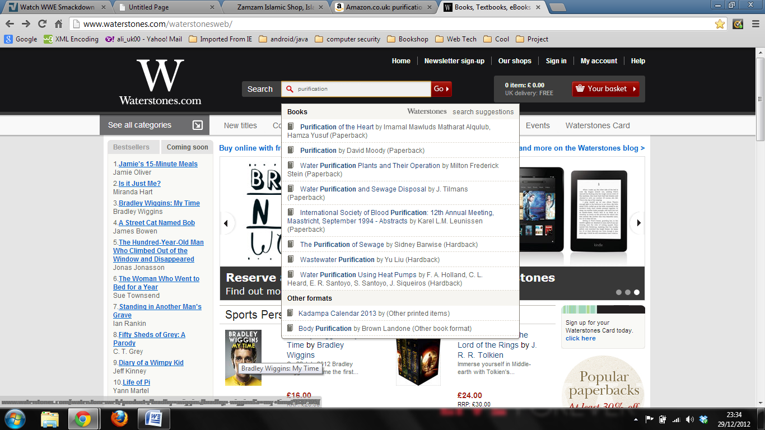We cannot do so as there is a low character restriction placed on the text box. This might mean that the search facility does not cater for personalised searches.

Looking at Waterstones implementation of the search box, it is highly sophisticated because it provides the feature of giving instant feedback as to what is available, and allowing you to enter different kinds of data i.e. a title, author, keywords or unique codes such as ISBN numbers. This helps a great deal for pinpointing the exact product.

What Waterstones has done is take away the old way of searching for products, which involved including a drop down menu list that allowed users to select the type of criteria to use when searching (i.e. the drop down menu included searching by title/author/ISBN/etc only) and then entering the values in the search box, and have allowed users to type in any and all types of data together in one query.

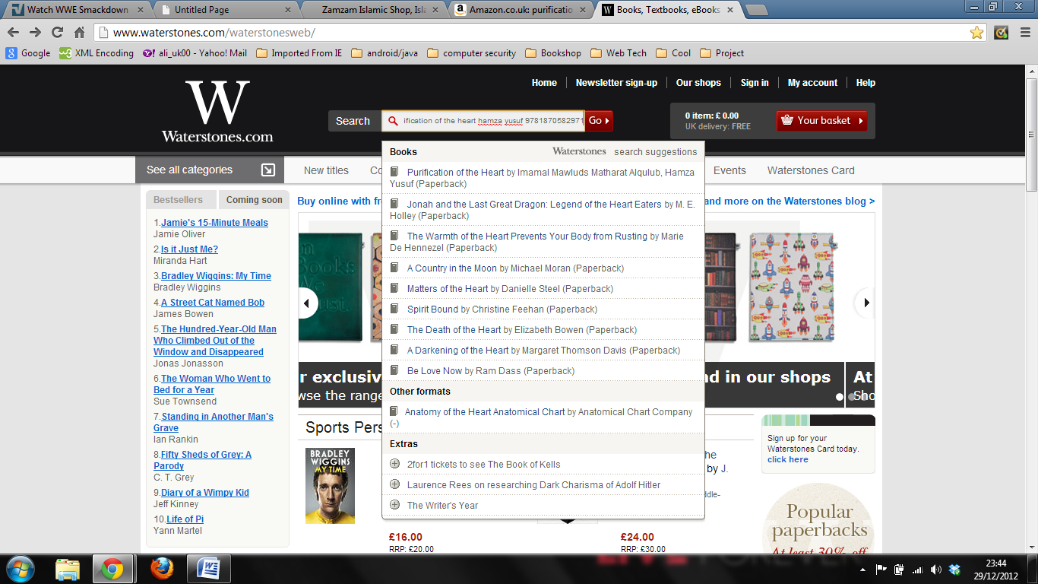For example, if I enter the title, author and ISBN of the same book, I get the exact book as the first result.

If I enter just the ISBN number, which is supposed to be unique to that book, and press ‘Go’, I’m lead directly to the books page. There is no loading of search suggestions as the ISBN number is unique and therefore the website doesn’t implement that functionality.

On the current website, the search box is not suited to give prioritized results back to the customer. It also fails to identify *exact* matches of titles by not displaying the product searched for as the primary result. There should be some kind of criteria matching technique in place.

**Requirements Gathered:**

* The web application should return prioritised matching results to the user upon search, starting from the exact or best matching result.
* The web application should allow users to search using any relevant search criteria i.e. product title, author, ISBN, etc.
* The web application must query using only the relevant search criteria i.e. the query doesn’t match products via a products description, as that would not be a unique identifier.

**3.2.4. Structure of the navigation menu**

Navigation menus are used to help the customer get to the product they desire by following a path down to the products page. It works as a hierarchy, with the initial content being general, leading to more specific headings within each category to locate the desired product.

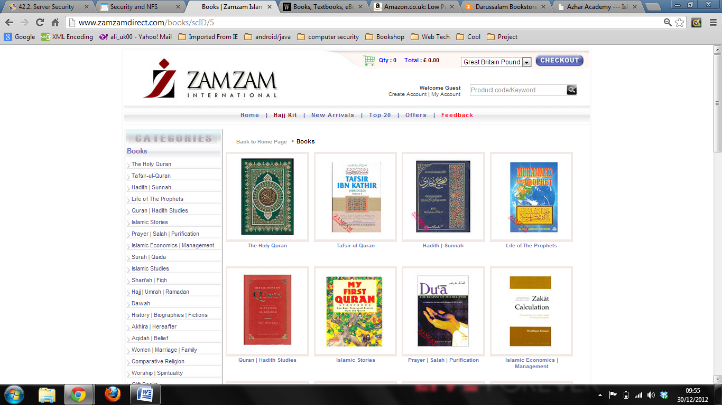In the current website, navigation is twofold. When the user clicks on a category in the navigation bar, they are presented with a new page that displays specific categories both as sub-headings in the navigation bar and as clickable images in the main body. Both ways have the same sub-content.

It seems unnecessary to display two different methods side-by-side. Users may tend to use the images in the main body to continue navigating through the website as they may recognise the image of the product. In that case, the sub-headings in the navigation bar would go unrecognised and discarded from use.

Once you click on an image shown above, you will be lead to either a sub-category within that topic or a list of products if there is no need to specify the category anymore.

Amazon and Waterstones both implement different styles of navigation tools. Amazon uses a fly out menu, which once hovered over will produce a list of general categories. When you hover over a category title, it will produce a sub-menu which contains sub-categories for that topic. Amazon have just recently added in this type of functionality, which is also extends to their shopping basket.

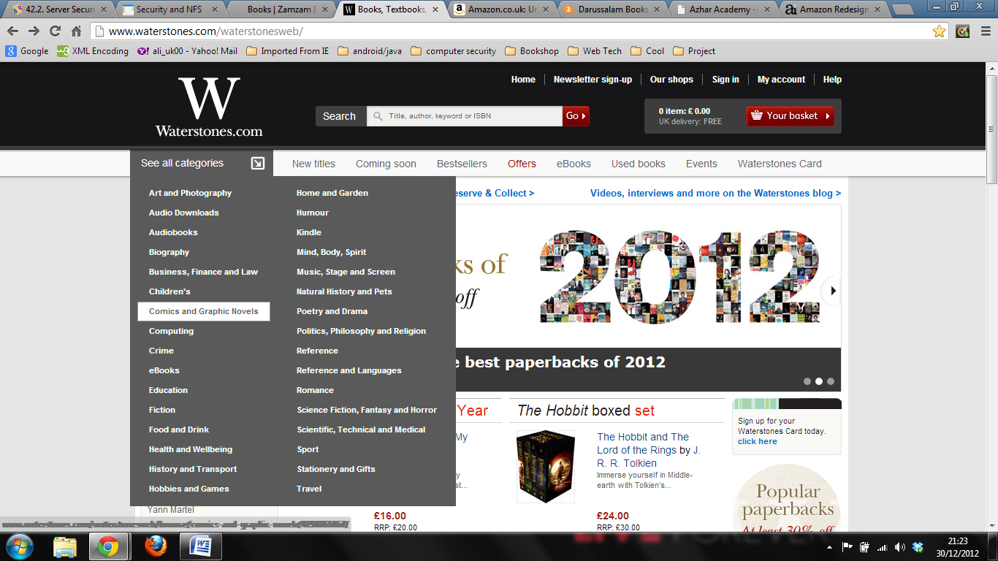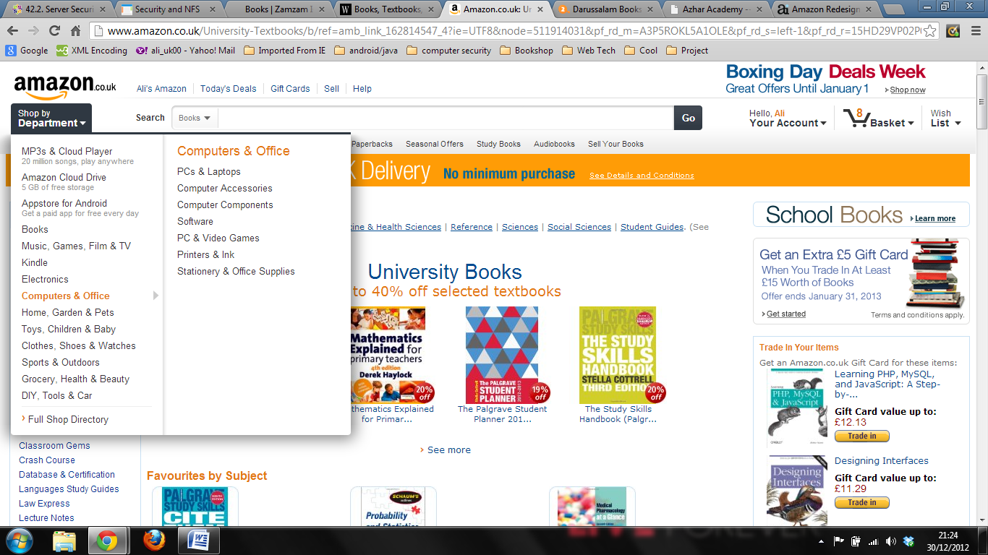The benefit of Amazons method of navigation is that it is not an intrusion. Whenever you need to switch categories, you can just hover over the ‘Shop by Department’ link under the amazon.co.uk logo and it will drop down the list of categories. This way the navigation menu doesn’t become a static part of the main body, therefore allowing more room for products or other functionalities (i.e. Amazon placed a category specific menu that refines the search for customers, allowing them to fill in details such as price range, colour, brand, etc until they have a highly specified set of results).

Waterstones also has a fly out menu, but it doesn’t come up with sub-categories because the company only sells one product type i.e. books. Instead they fly out a list of general topics where the user is able to click on links to direct them to the home page of that topic. This allows them to save space in the main body as well, where they decided to present a list of books that are best selling and coming soon.

Both websites placed the navigation menu in the header of the page, leaving them with more room to add different functionality. This is the main benefit of choosing a dynamically styled navigation menu over a static one.

**Required Gathered:**

* The web application must structure products into relevant sections
* The web application must allow customers to browse through products listed in any given category
* The web application must provide users with a tool to navigate through the various product categories

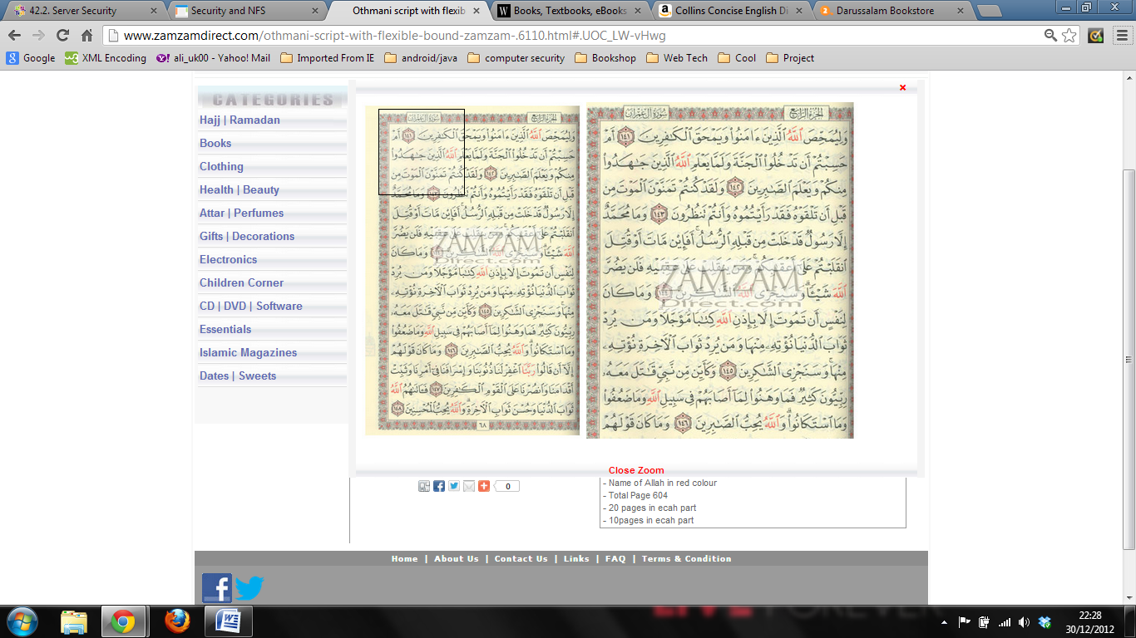**3.2.5. Zooming in/out of images**

It is important for users to be able to see the product they want to buy and analyse it before they commit to buying it. Zooming in to view the product is the way to help achieve this functionality.

Currently, the Zamzam website uses ‘iframes’ to implement the zoom functionality. This is fine and it gets the work done, but produces slow page loads and slowly loads the frame compared to Amazon who don’t use frames, and Darussalam, who provide an enlarged image via a button. So there are better ways to implement this functionality.

If there are multiple images to choose from for a product, the zoom functionality automatically comes up. This is a good feature as users will be able to view the enlarged image, but it would have been much more helpful if users were able to zoom in to other images without having to close the frame first, as that would have reduced repetitive loading. On the other hand they could also have made the zoom functionality within the page itself so that when the user hovers over the image they can get a zoomed in view. This feature is especially helpful for customers who are viewing clothing.

JS libraries may be looked into to implement a better way to add the zoom functionality for a product, such as Fancybox.

**Requirements Gathered:**

* The web application should allow customers to zoom into a products image

**3.2.6. Product descriptions/data required**

It is important to display to customers as much information about a product as possible. This is because they are not physically present to ask questions to a salesperson. The product description should describe aspects of the product that cannot be noticed by just viewing an image of it. So for a book this information might be the type of binding (hardback/paperback), price, publisher, language and size. Similarly for clothing, information such as colour, size and price must be included.

Zamzam does a great job of displaying this information on their website. They place all details of the product in a table on the products page, with different criteria catering for each product type.

|  |  |  |  |  |  |  |  |
| --- | --- | --- | --- | --- | --- | --- | --- |
| Categories | | Data Properties for each Product Type | | | | | |
| Books | Author | | Publisher | Binding | Size | # of Pages | Language |
| Clothes | Brand | | Sizes Avail. | Colour |  |  |  |
| Perfumes | Brand | | Vol/Size |  |  |  |  |
| Decorations | Size | | Colour |  |  |  |  |
| Health & Beauty | Brand | | Size |  |  |  |  |
| Electronics | Brand | | Size |  |  |  |  |
| CD-DVD | Format | | Artist | Producer | Language |  |  |
| Dates & Sweets | Brand | | Weight |  |  |  |  |
| Childrens Products | Brand | | Size |  |  |  |  |
| Accessories | Brand | | Weight/Size |  |  |  |  |

Types of data required to successfully display this information on the web pages is depicted in the table below.

This list has been gathered through observing the product types included in Zamzam’s website, as they provide all the details that would be required.

All products will need to include prices and a brief description of the product. It may also help to display the product code, as currently the company uses this piece of information to recognise the product a customer has a query about. However, if in the new website a better search box is implemented, the need to have this information may become unnecessary because we will be able to locate the queried product easily.

**Requirements Gathered:**

* The web application should display the correct product details for each product
* The web application must display the correct type of data for each product

**3.2.7. Product reviews**

Product reviews are included in major e-commerce websites because they give customers looking to buy the product reassurance or feedback from people who have already bought and used the product. It can be the deciding factor of whether or not the user will purchase the product, but that all depends on the product itself.

Amazon highlights the product review feature of their website, and because of this, their customers have utilized this feature to really quality assess the product in question. This is one of the benefits they acquire from having millions of customers.

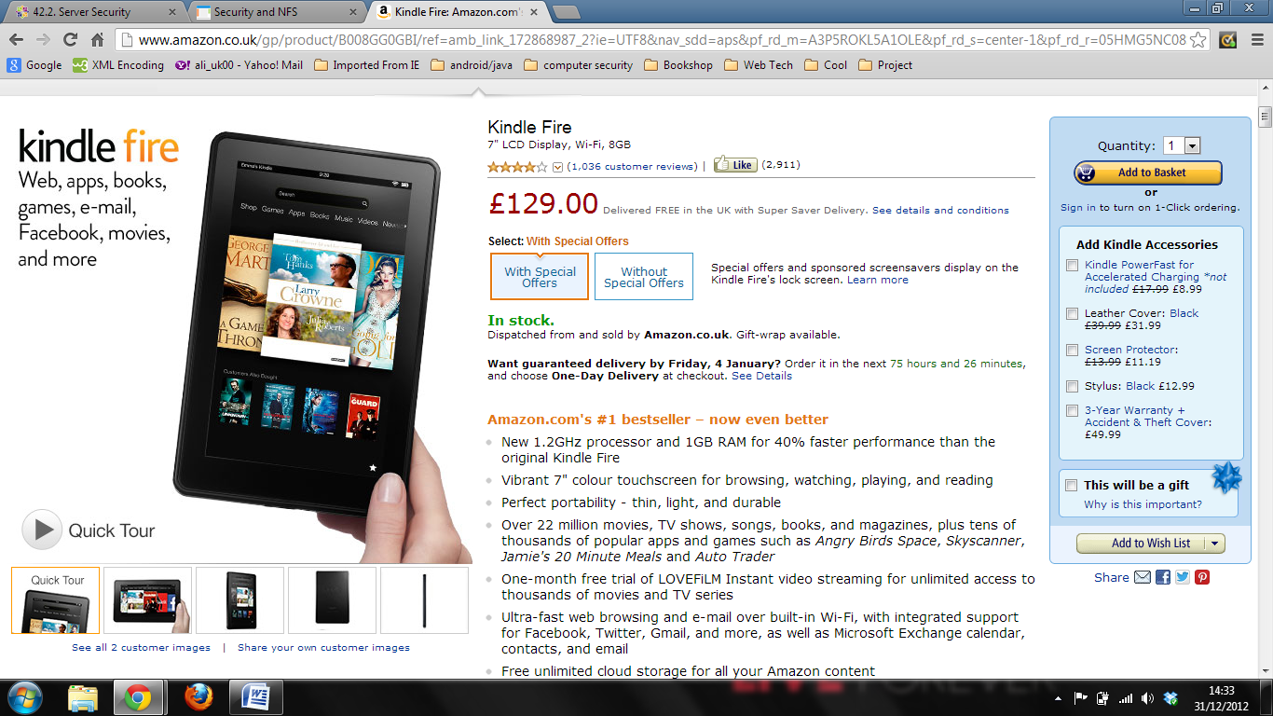The first thing you would do after visually analysing the product, its price, whether it’s in stock and the product description, would be to check the product rating and what customers have to say. Amazon uses a 5 star rating system that assess the level of customer satisfaction for the product.

Zamzam doesn’t currently implement a product rating feature, but it would add more life to the product if such a feature were to be introduced. However, looking at other Islamic retailing websites, this feature is implemented but doesn’t produce a high net of users rating products.

Further analysis will need to be done as to whether this feature will be required and whether customers will use the feature. We can also ask for statistics of sales in a period of time (i.e. sales per week) to get a better idea of whether there are enough users who buy products a week, so that we can decide if there will be a high frequency of users who will be reviewing products or not.

Nonetheless, it can still work even if there are low numbers of customers, in a week for instance, as having one person write a good review for the product can be helpful for those customers who are in doubt. We must also decide what type of product rating system we will need i.e. just a 5 star rating scale with no written review, a rating scale and a written review, or maybe just a written review on its own for customers to express their opinions about the product they’ve purchased.

**3.2.8. Updating the quantity of a product in the shopping basket**

Customers should be able to decide on the quantity of a product they wish to purchase, and this is done in ecommerce websites in the customers shopping basket.

We can notice from the above screen shot that the current website uses a drop down menu for users to select the quantity of the product they wish to purchase. This is not suitable for bulk buyers, which the company receives quite regularly.

If we look at how Amazon gives the functionality of updating the quantity of a product, we can see they offer a simple textbox where the user can enter any integer value, and if the seller has that much quantity available, they will successfully add that amount to the users shopping basket, otherwise they will display an error message and cleverly put the full amount of stock the seller has into the customers basket, as the customer wants everything they have.

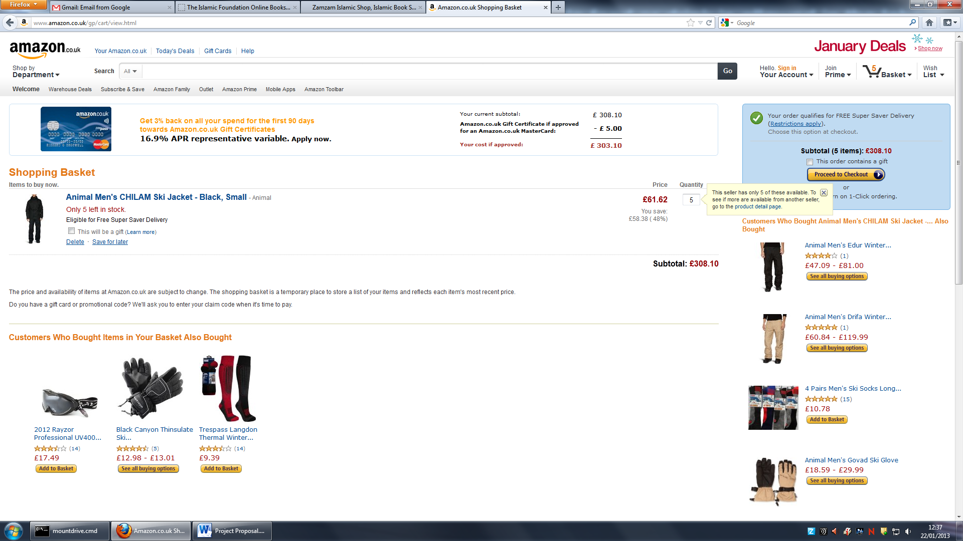Waterstones also updates the quantity of a product in a shopping basket the same way, however they do not check the amount requested against the actual stock they have available. Instead they calculate the amount based on the price and quantity and display that back to the user, with no error messages if the desired quantity is not available. The following screen shot shows how that works:

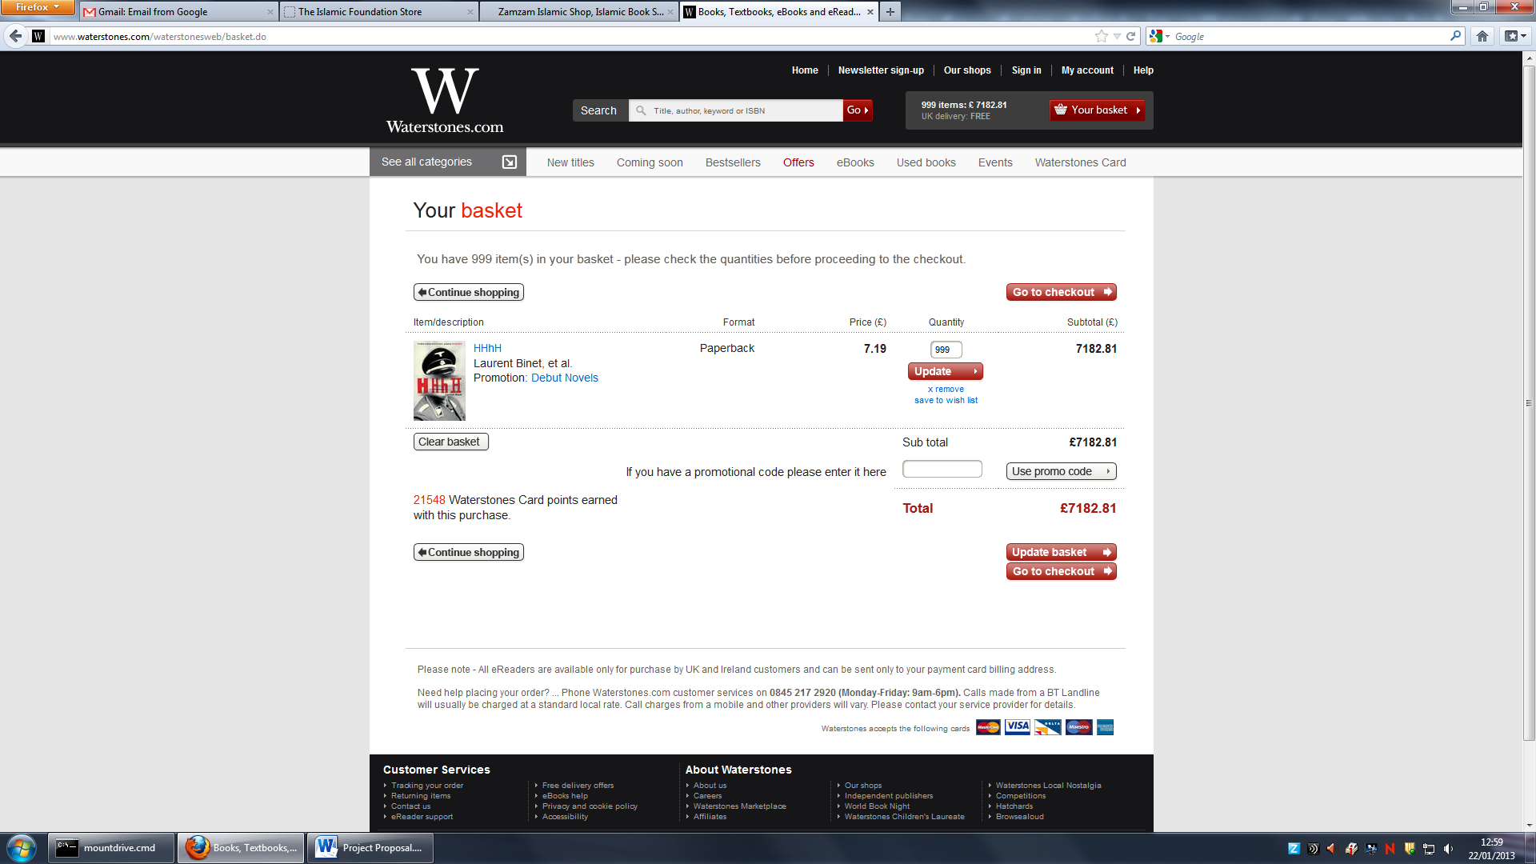

Here I’ve entered an exaggerated amount; however Waterstones have not catered to checking the quantity of the product available against my requested amount. Islamic-Foundation.co.uk has also done the same, where the quantity entered is not checked to see if it is available. This can cause problems when the customer receives confirmation of an order, as they will then need to be contacted and informed that the desired quantity is not available, which can lead to retraction of the order and loss of reputation.

Therefore it would be best when designing the new website to provide the functionality of checking whether the desired quantity of a product is available before the customer proceeds with their purchase.

**Requirements Gathered:**

* The web application should verify that the quantity requested by the customer for a product is actually available.

**3.2.9 Comparison with Islamic Ecommerce websites**

**Homepage**

Unlike Zamzam, Darussalam.co.uk provide a list of product on their homepage in the main body, which highlights types of products they sell and provides the customer with the ability to dive right into the products on offer for each category. This can be better than providing links to take you to a certain category as customers will see an image instead, which is more recognisable.

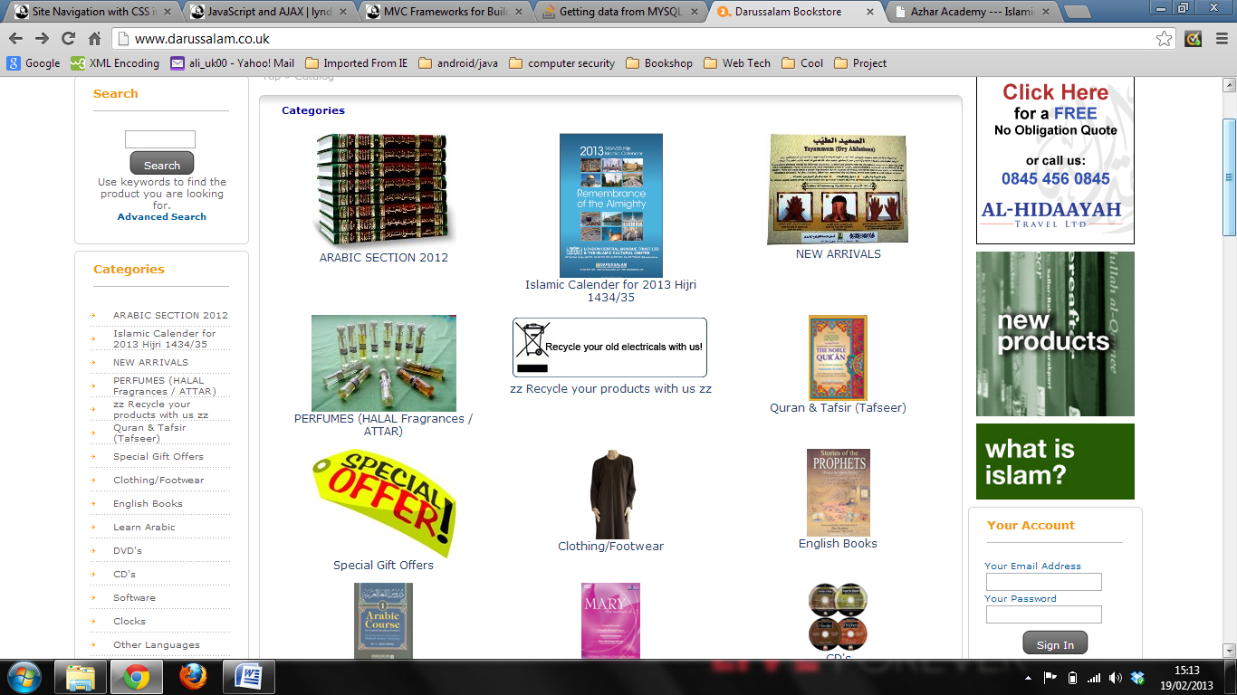However, they have duplicated this functionality by providing a category listing not only in the main body, but also in a navigation menu to the left of the main body. This list contains the exact same listing of product categories.

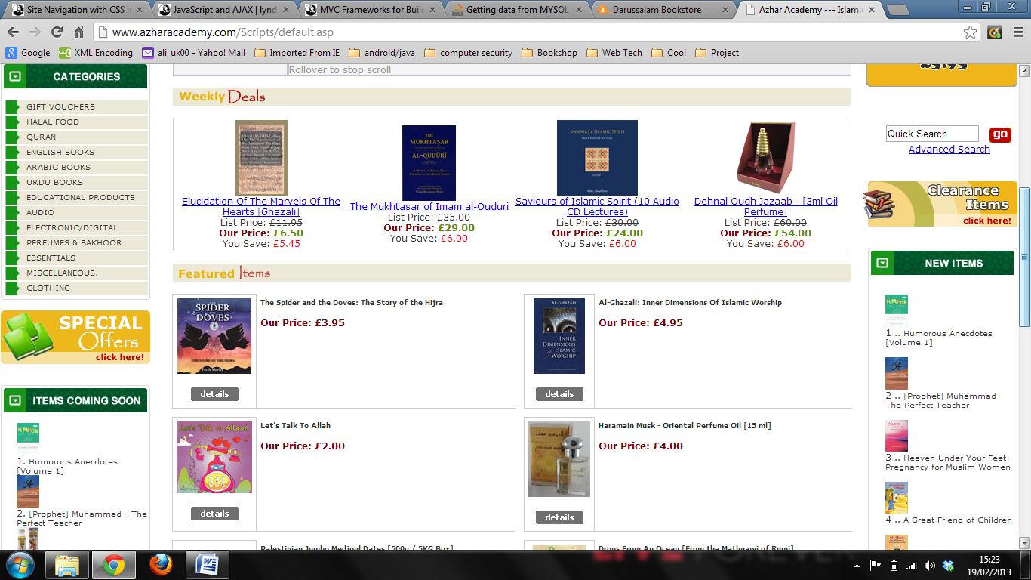It can be a waste of a chance to promote products by duplicating the categories list in the main body. They have included featured products, new products of the month and special offers in their main body, but this gets overshadowed by the huge categories menu at the top, which would be the first thing customers see and use. If a customer wants to see new products, there is a ‘new arrivals’ category which they can click on instead of using the functionality provided below the categories menu which shows them the new products on the same page.

Azhar Academy promotes their featured items along with weekly deals at the top of their homepage, which highlights the great offers they provide and their best sellers. New items are displayed in a side section to the right with the featured items, along with a list of products which are coming soon to the left of the main body, which is a good usage of space. This is much like the way Amazon structure their homepage, which a bestsellers section on the right which covers random categories.

The priority of what goes on top is a major issue for both Zamzam and Darussalam, but more so for Darussalam, as both featured and special offer products are overshadowed by a category menu which could be removed, directing attention to the category menu they provide on the left of the main body. Zamzam highlight their featured products at the top and special offers at the bottom of the page, with a list of categories in-between the two. This list of categories can be good, as it provides the customer with options of subcategories they can go into if they are not sure where to go. However, in Darussalam’s website it is just repetition of the category navigation menu, which takes up valuable space for promoting products.

Azhar Academy does a good job of promoting their special offers and showing new and featured items because they display them at the top, giving the promotion priority.

**Requirements gathered:**

* Provide featured, new and special offer products on the homepage where customers can easily access them.

**Navigation and Products list**

Darussalam provide two ways to navigate categories of products from their homepage as mentioned above. One way is through a list of categories in the left side panel which contain links to products matching that category, and another where categories are listed with images depicting recognisable products for that category in the main body.

Once the user clicks on a link to view products in that category, they are taken to a page which shows all products under the category. If the category contains subcategories, for example ‘English books’ contains subcategories such as ‘Biographies’, the user is taken to a list of products which has a few products from all subcategories. They can then navigate through the subcategories via an indented list of subcategories for English books. This can be a good approach because users will know where they are in the website and can easily navigate into different categories. However, the navigation menu could have been placed somewhere less obstructive, allowing more room for products to be displayed in a less congested manner (you can see the lack of spacing between products).

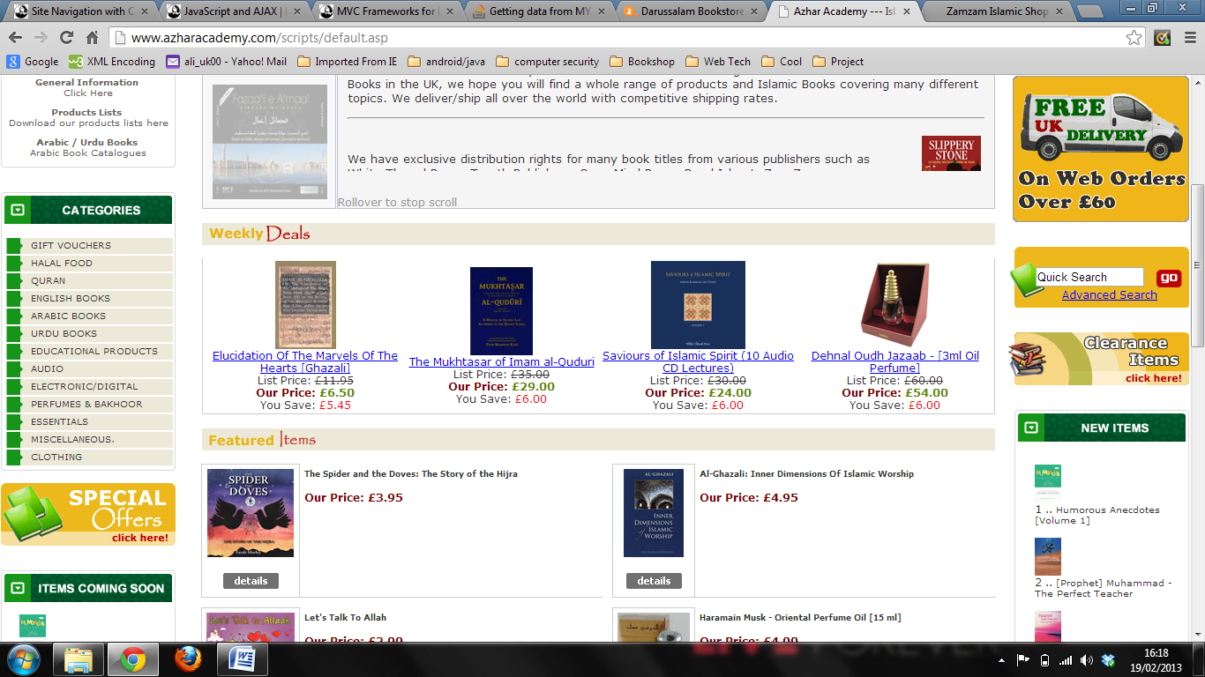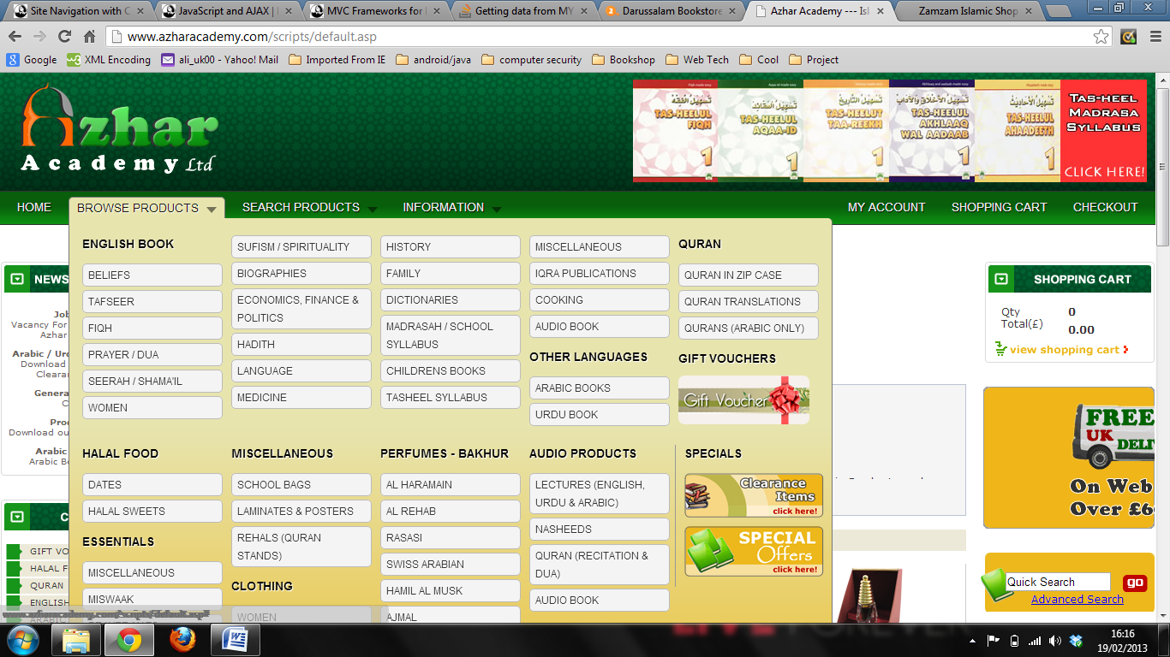Azhar Academy has done exactly that, providing a horizontal navigation menu at the top of every page. A tab which says ‘Browse products’ is given, which displays a mega menu of all the product categories they have. They also provided a vertical navigation menu in the left side panel of each page, which is also obstructive but acts as a nice way to highlight the main body, which contains the list of products.

Zamzam provides the same navigation style as Darussalam, incorporating it in the main body of the page and providing a list of categories to browse through. The list then expands to show subcategories so the user can see other products as well.

Giving users the ability to navigate wherever they are a website is key for ecommerce websites because it gives customers easier control of where they are, and that is important if you want customers to return to your website in the future.

**Requirements gathered:**

* Provide navigation for each webpage the user will use to search through products.

## 3.3 Requirements Through Interviewing The Client / Prototyping

An informal interview was conducted on the 15th of January 2013, with the owner of Zamzam International, Mahmud Hassan. The interview lasted approximately 45 minutes, discussing the initial prototype design (found in Appendix - Item 1).

Conducting the interview confirmed that the client was indeed looking to revamp the existing website. Upon explaining the purpose of the interview and what the project is about, the client was asked whether this initiative was required (i.e. is it worth doing this project, would you be interested in a redesigned website), and responded by saying that he is “looking for a more modernized product”.

The client was told before the commencement of the interview that the prototype does not have to represent the layout and functionality of the actual website; rather it is an attempt to open up new and better ways to accomplish the goals that they need to accomplish. Having a design that’s different from the current website will help broaden their sense of possibilities of what can be made.

Below are the clients input regarding the initial prototype. Screens 5 and 6 did not receive input and screens 2 and 3 were accepted and agreed upon by the client, although without any input.

**Home Page (Screen 1)**

The first idea put forth by the client on this screen, upon seeing the list of categories, was that they are looking to expand into a new category, ‘E-Books’. There are currently no e-books sold by the company, but this insight indicated that they would require the website to easily integrate new categories. This meant that the admin would need to be given the ability to add, and therefore delete, categories and sub-categories on the website.

Having a carousel display at the top of the main body was a feature favoured by the client, saying that it would make the homepage feel more interactive and would give customers an idea of what type of products the company sold.

Regarding the main body of the prototype, the client disagreed with where the quick links were placed, saying that many customers rely on the ‘Hajj Kit’ link to direct them to products specific for the event. He suggested that such links remain visible, preferably staying where they currently are, and instead of having the quick links in the main body, they would rather have an advertisement of a company who they support which would lead to that company’s website.

**Registration Form (Screen 5)**

The purpose of giving customers a user account was brought up. The client said that the only reason the customer currently had an account was to store their postal address information. The idea of removing the functionality of accounts until there were further privileges added for creating an account was suggested. The reasoning for this idea was that users may find it irritating to be obliged to register an account to purchase a product, and that without necessitating having an account they would be providing a more ‘in-store’ experience. The idea appealed to the client who said it was a good solution until they added more functionality that would necessitate the user having an account, such as personalised home pages and suggested products based on what the customer purchased.

**Add to Basket (Screen 4)**

At first the client was intrigued with the idea of allowing customers to add products to their basket without having to go on the products page, as it was explained to him that it would allow customers who knew what they wanted to buy to quickly add the item to their shopping basket. However, it was pointed out that it was not such a good idea due to some products requiring various aspects to be specified before the product was added to the basket, such as the size of clothes. Therefore the client was not satisfied with the feature, saying that it would make the page look inconsistent if some products had the ‘add to basket’ button and others didn’t.

**Miscellaneous Client Input**

The functionality of displaying related products on a products page was suggested by the client, saying that he would like customers to have the ability to search for products similar to the one they are viewing. The client hinted to how Amazon provides this feature and how they would like something along the same line.

The client requested that the stock availability be shown to customers, as there are many orders that are put through confirmation when there is no stock available for that product.

## 3.4 Requirements through Interviewing the Operational Stakeholder (Administrator)

An informal interview was conducted on the 20th of January 2013 with a key operational stakeholder Tansen, who administers the current Zamzam website, carrying out operations such as adding, editing and deleting products in the product catalogue. The interview was held at his work post and lasted approximately 20 minutes; discussing his role as the administrator, what tasks he performs and what could be done to make these tasks more efficient and easier to do.

No prototypes were used in this interview as the only reason for conducting an interview with the administrator was to see the current interface he operates on and how it can be improved.

The interview began with greetings, and an explanation as to why the interview was being conducted. No indication was given to Tansen before the actual interview and so a justification was required in order for him to understand why I was there.

Tansen was then asked to demonstrate how he adds products to the website. He was already logged in to the administrator’s account, which led to him being able to securely see the required admin pages, as was noticed by the presence of an HTTPS protocol.

The demonstration of how he would add new products to the product catalogue was then shown. This showed that the current website requires three steps to be completed before the product is added. The first is to fill out the basic information of the product, such as name, price, stock and description. Once this is done, a new form is presented which asks to categorise the product. When that is completed, another form is shown which asks for dimensions of the product and its weight, for shipping information. This last step is required as the weight of the product needs to be known in order to calculate the shipping costs.

Tansen mentioned that there was no need to add a product in three steps; it could easily be done in one form with all the required fields present.

One interesting concept which was revealed when he was performing this demonstration was the fact that they used the same fields for different types of products. For example, the field for size: it is universal, meaning it is needed for each type of product (books, clothes, perfumes, accessories, etc). They catered to all types of products by providing two dropdown input fields, one containing book sizes and the other for clothing. An additional text input was provided for entering the size for perfumes. This was a very intriguing discovery, as it showed that properties of a product can be generalised, which can ease the structure of the database while still being normalised.

Images of products were stored in a folder and not in the database. This was a key piece of information that I needed in order to understand how to retrieve and store images. Tansen was able to add up to five images for a product which included thumbnails. The images were scaled and configured using Adobe Photoshop by him, from photos taken in a booth. The reason for taking photos in-house was that they could produce images of a higher resolution than those found elsewhere.

A demonstration of how he would edit a product then followed. This process started by first searching for the desired product, which was done through a search input field. Tansen searched for the product by name, which returned a list of products that matched the search criteria. Each product had options to edit and delete them. Once the desired product was located, the option to edit a product was selected and a pop-up form was shown with the details of the product populated in the input fields, ready to be modified. This provided a clean interface to edit products as everything could be done in one step. Everything was editable, with dropdown boxes showing the appropriate values chosen for that product upon insertion into the product catalogue. Nothing negative was said about the method used for editing products, it was a well made functionality.

A discussion followed about the product information displayed to customers. Tansen wanted more information to be displayed so that customers could see more details. He showed an example of an Islamic website which he liked very much, Islamicbookstore.com. An indication was made as to how much information they provide and how well structured that information is when compared to their website.

The interview was then concluded, thanking the administrator for his time and cooperation.

## Conclusion – Requirements Gathering Phase

The requirements elicited from the chosen techniques allowed a comprehensive list of requirements to be made that cover a broad range of functionality that the new website can incorporate. Similar websites were researched by taking into consideration various aspects of Zamzam’s current website and comparing them with ways other websites implemented the same aspects. Interviews were held with the client and a key operational stakeholder, which provided opinions and contributions to be made to the project design. The interview with the client was successful in terms of seeing whether they had any specific functionality they would want in the new website, and the interview with the administrator was successful in terms of understanding the process of adding and editing products.

The interview with the client could have been improved by including a product page prototype which was accidently not made, due to not keeping in mind whether the client would like the idea of an ‘add to basket’ button for each product outside of the product’s detailed page. This would have allowed for a better comparison between the two methods by having the alternative prototype for the ‘add to basket’ functionality present, and give more solid proof as to why the client thought the idea of having that button everywhere was not such a good idea.

More time could have been spent with the administrator, allowing a deeper understanding of how information is stored in the database. I was enthusiastic in seeing the actual database being used for the current website, which runs on MySQL, but the administrator was hesitant in showing me this information, so no further persuasion was done in that respect.

Further prototypes could have been made showing the improvements the client suggested being considered, allowing for further ideas to be given along with their approval of how their suggestions were depicted.

# SECTION 4 - Analysis Phase

In this section of the report, we will take the initial list of functional requirements (found in Appendix, Item 2) accumulated in the requirements gathering phase and prioritise them. Along with this activity, the requirements will be re-evaluated to assess whether they should be included in the implementation of the new website. Justification for such decisions will be followed up in such cases.

In analysing each requirement, we will include why it is present and a justification for the priority level chosen for it. A final requirements list will be formed, which will be included in the Appendix (Item 4).

## 4.1 Functional Requirements Analysis

**F1 (reference: Section 3 – Item 3.2.1)**

The whole point of having an e-commerce platform for your company is to bring your products to the customer in a virtual environment. However, it is not enough to just present them with your products; they must also have a way to purchase a desired product. A shopping basket is a way for customers to accumulate the products they wish to purchase and have them stored in a virtual shopping basket which they can pick up and take to the register.

Much like the scenario of having a physical shopping basket while shopping in-store, customers want to be in control of what they want to buy. You can often see customers adding products to their baskets, removing them, and adding the same product more than once. E-commerce websites aim to imitate the real-world experience of shopping as much as possible, and giving customers such control over the products they want to buy will provide a means for them to purchase their desired product(s).

**Prioritisation:** F1 was prioritised as essential because it is a defining tool for an e-commerce website. This means that without some way for customers to add the products they want to buy and be able to finalise their order by editing/deleting the chosen products, they wouldn’t be able to buy anything. Therefore it is a necessity to give customers the functionality of adding, editing and deleting products in their own shopping basket.

**F2 (reference: Section 3 – Item 3.2.1)**

Without the ability to view their shopping basket, customers will feel like they are dealing with an imaginary list of items which they are going to buy. In order to provide a platform in which customers are able to manage the products in their shopping baskets, they will need to first be able to view what is inside it. This will then act as a means from which they can start editing the quantity of a product and possibly deleting it if they so wish.

**Prioritisation:** F2 was prioritised as essential because it is necessary for the customer to be able to view products listed in their shopping basket before they can edit, delete, or continue with their purchase. Without this functionality the customer would not be able to edit/delete products because there would be no way to look at the list of products they have gathered.

**F3 (reference: Section 3 – Item 3.2.3)**

When you have thousands of products to sell, it is important to give customers the convenience of being able to filter through to find a product they are looking for. Providing a search box which takes the name, and possibly other parameters as well, of a product and returns results of matching queries will allow customers to do just that. Even though categorising products correctly can be seen as filtering too, it is a much simpler process to be able to enter a specific title (which the customer is expected to know if they are using the search functionality) and be given a set of results.

**Prioritisation:** F3 was prioritised as essential because it is necessary for customers that know what they are looking for, or possibly doing comparisons of some sort (i.e. price, quality, etc) with other companies, to be able to quickly find a product without having to follow a hierarchical pattern.

**F4 (reference: Section 3 – Item 3.2.4)**

When making an e-commerce website, it is important to categorise your products where they best fit. This provides ease for customers who don’t know what they want to buy but would like to look at what’s available. It won’t be enough to allow customers to search a product by using a search box, because using a search box is not always fit for purpose. For example, a customer wants to buy a decoration piece for their home but is not sure which one. If they use the search box, then they are likely to type things like “vase”, “bud”, “wall frame”, etc because they don’t know what that is available from your website at first glance.

And what would happen if your website has thousands of products? Using the search box to search for terms like the above might return unrelated products, if for some reason they have these letters in their title. Moreover, if the administrator doesn’t use those search values as part of the products title, they won’t show up if you search for them. So why not make it convenient for the customer as well as the administrator to supply categories, where customers can see what kind of products are available and dive into them directly, instead of having to manually search for them?

**Prioritisation:** F4 was prioritised as essential because it is important to allow customers, who don’t know exactly what they want, to be able to conveniently search through related products of their interests. Without such a feature, it would be difficult to design a structure for a massive amount of products i.e. where and how would you display them, as well as being a risk of not presenting the customer with all related products. With the ability to categorise products, it would leave the administrator free to come up with unique product titles, without having to append any keywords on the end.

**F5 (reference: Section 3 – Item 3.2.4)**

Needless to say, it is essential for customers to be able to go through products available to purchase on an e-commerce website. Without this ability, e-commerce websites would not have any content to display which would mean customers don’t have anything to buy, thus losing the definition of being an e-commerce website. Since it is a requirement to list products under categories, browsing products can be seen as a derived requirement from it. This is because in order to categorise products respectively, you need them in the first place.

**Prioritisation:** F5 has been prioritised as essential because it is needed to allow customers to purchase and browse through products. Zamzam is a retail store, and thus sells products. Without there being products to display on the website, there can be no business for them. It can be thought of as having an empty shop; it just wouldn’t make sense.

**F6 (reference: Section 3 – Item 3.4)**

How a retail company structures its products are not written in stone, thus are subject to change. This can be for various reasons: such products not being available anymore i.e. cassettes, new product types coming into the market i.e. eBooks, such products not being demanded anymore, a new name being introduced for a product type due to trends, and the company deciding not to further buy such products. Providing the ability to manage the list of categories/subcategories of the website will allow the company to be ready for any changes in the future. If they decide to introduce a new category, they should be able to add it in. Likewise, if they decide to no longer provide a certain type of product, they should be given the option to remove it.

**Prioritisation:** F6 has been prioritised as essential because although it may not happen often, it is necessary to allow Zamzam the ability to manage the categories/subcategories that are going to be on their new website. This will leave them with the opportunity to expand and control the way their products are structured.

**F7 (reference: Section 3 – Item 3.4)**

The administrator will be the one who will manage products on the website. In order for there to be products, the functionality to create those products must exist. Having said that, managing products does not only entail that you simply keep adding products; rather you must be able to edit them as well, in case mistakes are made in the products initial data entry.

The ability to delete products should also be included, as it is not always the case that a product in the website will be coming back in stock. Products that are not available anymore should be removed from the system as there would be no point in having a product displayed on the website which cannot be bought.

**Prioritisation:** F7 has been prioritised as essential because products must exist on the website in order for there to be something for the customer to purchase. The administrator must be given the functionality to add products into their respective categories, as well as edit and delete them when necessary so information can stay up to date.

**F8 (reference: Section 3 – Item 3.4)**

Since the administrator will have a private area where they can manage the product catalogue for the website, it is necessary that some form of authentication be provided to access this area, known as the administrator’s panel. Without providing a means of authenticating the user, it would be an open invitation for anyone who happens to stumble upon the URL to manipulate the product catalogue.

There are many means of authenticating a user, the most common one used for websites being providing login credentials (username/password). This is because other methods such as fingerprint scans, retinal scans, voice recognition and the like are dependent on having certain hardware available in order to carry out such methods, whereas having to provide the correct username and password combination that is stored in a database to successfully gain access can be fairly simple to do, and if done right can be highly secure as well.

However it does no harm to include other means along with another, adding layers of authentication. This depends on how much you value the information that is being accessed.

**Prioritisation:** F8 has been prioritised as essential as some form of authentication must exist in order for the administrator’s panel to be restricted to only those who are authorised to gain access to it.

**F9 (reference: Section 3 – Item 3.4)**

Since we will be having products of different types on the website i.e. books, clothing, etc, it will be the case that not all products have the same type of data. For example, a shirt doesn’t have an author, nor does a book necessarily need to have a defined colour. Products should therefore be added/edited using their own respective data, in fields which make sense for them to have. This is necessary in order to avoid conflicts when customers see the products on the website.

**Prioritisation:** F9 has been prioritised as essential as it is common sense that when you have different product types, those different products will not carry the same attributes. It is therefore essential to allow a product to carry data that is associated with its product type.

**F10 (reference: Section 3 – Item 3.4)**

The main duty of the administrator is to manage the product catalogue. Once they have entered the product into the database, they will then want to view it afterwards in order to edit or delete it. This can be made possible if they are given the ability to search for the products they have entered into the database, and then decide on what action to take. Otherwise if they are not given a way to see the products in the system, they will not be able to take an action.

**Prioritisation:** F10 has been prioritised as essential as without this ability the administrator would not be able to find the products in the product catalogue, nor would they be able to manage them.

**F11(reference: Section 3 – Item 3.2.8)**

If the customer has a product in their basket and they wish to buy more than one quantity of it, their shopping baskets total should reflect the new price based on the quantity times the products unit price. Just like an in-store experience, if you see a product you like and you have your shopping basket at hand, you can add more than one quantity of it into your basket before you head over to the till. You don’t have to keep going back to that product after you put one in your shopping basket.

**Prioritisation:** F11 has been prioritised as essential as without the ability to do this, customers might have to go back to the product page repeatedly in order to add more quantity for each product. This is not user friendly; therefore it would be much simpler to provide this functionality on the same page as the shopping baskets content.

**F12 (reference: Section 3 – Item 3.2.6)**

Each product will have its own data attributes and values and therefore needs to carry that information around and not any other products information. We don’t want one product type to be carrying another product types attributes (i.e. perfumes having the attribute of ‘number of pages’) and we also don’t want a products values to be misrepresented by another products values.

**Prioritisation:** F12 has been prioritised as essential because if we have this misrepresentation of product details, not only will customers lose confidence in the way we run the website, but values of each product will be lost and it would become very difficult to know which details belong to a product.

**F13 (reference: Section 3 – Item 3.3)**

As is the case with any retail store, some products are considered as ‘headline’ products; products which the company is proud to sell and wish to highlight. Such products are given the spotlight in the store. The same should be done in the e-commerce website, where products the company wishes to put at centre stage are viewable immediately when the customer enters the website.

With the website displaying special offers, new arrivals, and featured products on the homepage, customers can look forward to new products arriving, special offers popping up and a few products the company recommends. It can be a means to communicate with customers by letting them know what’s going on in the company, that they are not missing out on great deals/products, and to let them know that you are keeping the website up to date with the latest information.

**Prioritisation:** F13 has been prioritised as desirable as it is not necessary for the website to contain this information in order to function properly; it is a design feature that would work out to be better for business and more convenient for the customers. The website can function properly without such a feature, but to include it would provide better content.

**F14, F15 (reference: Section 3 – Item 3.2.1 & 3.3)**

It is now common to see that websites, no matter what they are for, all allow customers the ability to create accounts. These accounts are then used to hold their personal information and sometimes display personalised content for them based on their past activities on the website.

Some websites however, do not utilise the functionality of allowing customers to hold accounts/memberships with them. For instance, the current Zamzam website does not do anything with the account you create except storing your postal address, making it more convenient for you to complete the transaction process. There are no statistics gathered to recommend products for you based on your browsing history (like Amazon), or member exclusive offers. Moreover, an account is required in order to continue to the checkout phase.

What would happen if, as a first time user, I didn’t feel comfortable with the website, or that I’m not likely to come back to it again for a very long time to make another purchase? Having to impose on the customers that they require an account to make a purchase would in such cases more than likely put the customer off from buying the product, and they would likely go somewhere else.

Would it then justify the fact that an account is not needed for customers until a reason other than holding their postal address information is found and implemented? Let’s look at it from an in-store experience. A customer walks up to the till with a basket full of items and they are ready to purchase them. Then the cashier says to them “Do you have a membership card? I can’t let you buy these items unless you have one.” The customer may or may not sign up for a membership at that moment, but you’ve introduced a 50-50 scenario where you might lose the customer.

So are memberships really needed in order to allow customers to purchase products? It would make more sense to allow them to complete the transaction and then offer them the chance to sign up, like Waterstones do.

The argument comes back to the reason why an account exists on the current Zamzam website. It is only there to hold your postal address. Does this justify having to create an account?

The interview with the client shows that they are comfortable with the idea of dropping the ability of creating accounts/memberships for customers, until further features can be developed that can help justify the reason to create one in the first place. This doesn’t mean that this functionality will not be available, but more incentives need to be added in order to make it a worthwhile feature for the customer and necessitating it for purchasing items needs to be removed.

**Prioritisation:** F14 and F15 have been prioritised as desirable in the initial requirements list, but after an analysis of whether or not they are necessary it has been concluded that they are not in the company’s best interests at the moment. This is because the functionality of allowing customers to have accounts is not reasonable as implemented in the current website, and hinders the process of purchasing items for customers who don’t wish to create an account.

**F16, F17 (reference: Section 3 – Item 3.2.8 & 3.3 respectively)**

Currently, Zamzam do not have the feature of providing customers with stock levels that are available for a given product. This causes some orders to be processed when there is not enough quantity available for that product. Providing customers with this information will allow them to know whether the product is available or not as well as how much leeway they have in terms of time, if they really desire the product.

**Prioritisation:** F16 and F17 has been prioritised as desirable because it would allow less hassle for the administrator by not having to deal with customers who need to be informed of the quantity available, but is not essential for the website to allow customers to purchase products. They would still be able to purchase the product, but would need to be informed that the amount they requested is not available and given a refund if appropriate.

**F18 (reference: Section 3 – Item 3.2.1)**

Products which are out of stock need to be displayed as such, with the ability to add them to the shopping basket removed. This is to ensure that purchases are not made which cannot be fulfilled.

Providing this functionality is different from deleting the product entirely, as products go out of stock all the time and are then replenished by the company. Out of stock normally means that the company will get the product again soon, but temporarily it cannot be purchased. Customers who see this symbol are waiting for it to come back in stock, thus being different from completely removing the product and not giving customers that hope of the product returning.

**Prioritisation:** F18 has been prioritised as desirable in the initial requirements list; however it can be seen as rather crucial for the running of the website. Customers should not be able to add out of stock products to their basket; as such orders cannot be fulfilled. If they are given the ability to do so, it would increase the toll on the administrator by having to inform the customer about the situation. Therefore, the priority status for this requirement has been changed to ‘Essential’, to ensure this functionality is given its rightful attention.

One can also think of the worst case scenario, where the company receives an abundance of orders for products that are all out of stock and having to refund customers for their purchases. This would cause a huge financial loss to the company, as payment gateways charge you if a refund has to be done.

**F19 (reference: Section 3 – Item 3.2.5)**

When shopping online, customers do not have a physical experience with the product. It is therefore necessary to provide as much detail about the product to make the customer comfortable enough to make the purchase. Part of the details of a product is its images, which shows how the product actually looks likes. It is the most attractive detail of the product, and therefore needs to be viewable by the customer in a way that they can extract all the fine details of the product by looking at its images.

**Prioritisation:** F19 has been prioritised as a luxury requirement as it is not a crucial part of making the website function, rather it is a feature that is useful for customers to be able to do.

**F20 (reference: Section 3 – Item 3.3)**

Zamzam is a company that’s been around for more than two decades, and within that timeframe has developed close relationships with other companies. They therefore would like to provide a way of displaying to the public their relationships by providing advertisements on their website for companies that they want to support. They currently provide an advertisement for Sisters Magazine on their website, which is a company that publishes monthly magazines for Muslim women.

**Prioritisation:** F20 has been prioritised as a luxury requirement as the feature does not affect the way the website will function; rather it is a request by the client.

The final list of non-functional and functional requirements can be found in the Appendix (Items 3 & 4), with the amendments found above being applied.

# SECTION 5 - Design Phase

This section will contain UML diagrams showing how the users will be able to interact with the website, and how the website will be built to accommodate the functionality needed. To illustrate these two points, use case and class diagrams will be produced. Since there is a database involved, a discussion about the database structure and relationship will be included, along with an entity relationship diagram to show this relationship. Justification about the chosen programming languages, libraries and frameworks will also be included in this section of the report.

## 5.1 Programming Languages and Framework

**PHP and CodeIgniter**

PHP has been chosen as the appropriate server-side programming language to create Zamzam’s website mainly because it provides easy embedding of HTML elements onto a website that uses the language, which allows dynamic content to be shown on web pages. It is also a free, open source language which means that there is a lot of community support i.e. thorough documentation that helps explain functions that are available and how to use them by example. Many websites such as Google, Amazon, Facebook and YouTube use PHP as their chosen server-side language for the reason above, along with the fact that it also works seamlessly with many database systems such as MySQL, SQLite and others[24], allowing huge amounts of data to be taken from the database and displayed onto the website dynamically.

CodeIgniter is a framework that runs on the PHP language. It is an object-oriented framework, which means that programs are run by creating classes and calling methods. It’s the most lightweight framework currently available for PHP, which means that there is not much of a learning curve in terms of the framework itself. It comes configured with the absolute basics, leaving the developer to decide what they need from the framework and using it. This can make website performance greatly enhanced, compared to frameworks such Zend, which come heavily configured.

CodeIgniter is known for the thorough documentation it provides which greatly assists the developer in understanding the ways in which a task can be completed using the framework. It also comes with many useful core library classes that make mundane tasks such as interacting with databases, creating tables and forms, dissecting a URL, easier and safer to do.

One of the main reasons for choosing a PHP framework instead of building the website using the native PHP language was because frameworks such as CodeIgniter force good coding standards on the developer. Since my knowledge of PHP is at a beginner’s level, it will be advantageous to use a framework that will enforce coding standards on me early on, giving me the advantage of producing a website in a professional manner, hopefully producing a habit of developing with good readability in mind, as well as gaining experience in a framework which is professionally recognised and acknowledged.

## 5.2 Client-side Languages/Libraries

To produce client side code and provide an enhanced user experience, HTML, JavaScript and CSS will be used. HTML’s latest version, HTML5, will be used as it gives off many benefits such as enhanced form and search input fields, as well as providing a more refined structure to pages by introducing new tags to define headers, footers and navigation systems. Even though some features of HTML5 are not compatible with all browsers, they can still be implemented as long as there are fallbacks that cater to older versions of browsers such as IE.

The JavaScript library JQuery will be used to handle AJAX requests to the server and producing its results to the browser. JQuery has been chosen because it offers an easier way to manipulate elements on a web page, along with their styling properties. Since it is a JavaScript library, JQuery can do everything you would want to do in JavaScript using fewer lines of code, which is always helpful. Not only that, JQuery also makes handing AJAX requests much more simple, as it creates XHR instances for you, again simplifying your code.

Current versions of JQuery (currently 1.9.1) are compatible across all major browsers, including IE 6+, Chrome, Safari, Firefox and Opera, which is a feature not found in JavaScript. JQuery fixes stability issues found in JavaScript with older browsers, allowing the website to function the same across them.

Twitter Bootstrap, which is a CSS framework, will be used to style the website. The decision to use a CSS framework to style the website was made as the focus for the project is on producing the required functionality, and although styling is not directly included in the scope of the project, it can be very beneficial to include styling of the application as the website aims to provide a more modernised web application. Bootstrap is one of the most powerful CSS frameworks around, providing easy to use, built in JavaScript plug-ins that can produce features such as carousels, dropdown navigation menus, tooltips and more, with having to write little to no JavaScript at all. It comes with a standard style for websites, which can be overridden to customise the look of the website, and therefore provides extensibility if Zamzam ever decide to change the front end design.

## 5.3 Server and Database

Apache has been chosen as the server which will be used in development, along with the MySQL database. Apache has been chosen because it comes with built in support for the PHP language, as well as for MySQL. These components, PHP, Apache and MySQL; can be installed together in a package. For the purpose of this project, these three components will be downloaded using WAMP, which stands for Windows, Apache, MySQL and PHP. This will allow all configurations to be done automatically between the three, along with installation of a GUI application to manage the MySQL database for the website.

MySQL will be the employed database management system in this project as it provides a relational mapping between tables. This means that tables in one database can be connected to other tables in the same database using reference points, such as row ID’s. Such mapping allows a structure to be formed within the database, with each table containing information about only one thing, and all those tables holding references to a parent table. This principle alone will prove helpful as it will make querying for product information much less complicated, as well as storing product information into the database.

Apache, MySQL and PHP can be downloaded as a package that comes readily configured to provide a local server that has MySQL and PHP ready to go. This package is known as WAMP (or MAMP for Mac users) and it conveniently allows you to download all three components into a ready to use web application development environment.

## 5.4 Use-case Diagram

Use case diagrams are made in order to bring to life the requirements of an application. They are used in the early part of a project to describe to stakeholders or, more generally, those without programming knowledge, the outcome of what the application will be capable of doing. This diagram is easy for them to understand because it doesn’t contain a hefty amount of notation. A use case diagram consists of three components: the use cases themselves, actors, and associations.

Use cases describe the behaviour of the application, which means that each use case represents something the system will be able to do. They do not however specify the detail of how that behaviour is carried out.[25] This is done in other modelling diagrams, such as sequence and activity diagrams. Alternatively, a use case diagram can show specifications for each use case, which describes its inner workings.

Actors are seen as the operational stakeholders; the ones who will use the application. Not only can they be users, but also other systems who interact with the system being modelled.[26] Actors are shown in the diagram to represent actions that such a role can do. For example, in the application being made in this project, the actor ‘Admin’ can edit products.

Associations can be made between actors and use cases, between actors and other actors, as well as between one use case and another. In the case of an association between actors and use cases, this shows that an actor can perform the use cases action. Associations between one actor and another, such as generalisation, shows that the former can do the same actions as the latter but other, more specific, actions as well. Finally, associations between one use case and another can depict that one can include or extend the functionality of the other. Use cases can also be generalised.

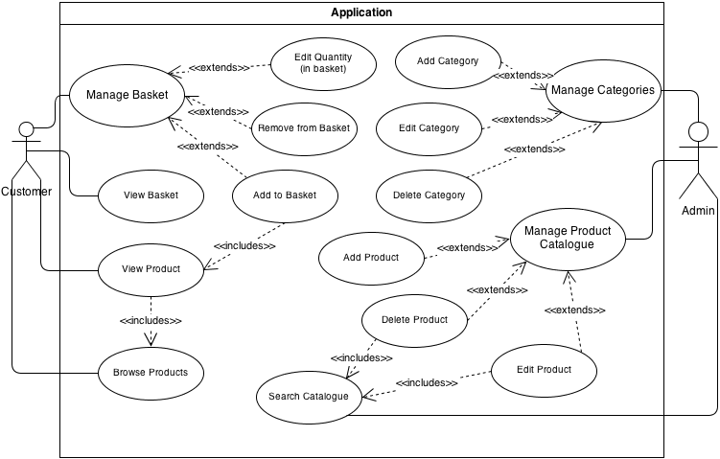Below is the use case diagram for this project, created using the functional requirements found in the requirements list (see Appendix Item 4). To explain the diagram, detailed use case specifications for each use case have been made (see Appendix Item 5).

Figure 5.1: Use Case Diagram

## 5.5 Class Diagrams

Class diagrams are made in order to understand the core of any object oriented application. The main building blocks of any OO application are its classes, since they make up the entire system. Classes are represented by boxes which contain attributes and operations the respective class can hold/perform; with relationships showing the connection between it and (instances of) other classes that illustrate how classes interact with each other to become a whole system. The way a class diagram can show any given requirement can be known by the following passage, which gives an analogy of a class diagram using the example of a road map:

“The interactions and collaborations that actually take place to support any one particular functional requirement represent one specific route across the map. That route will navigate from class to class, traversing the relationships between those classes.”[27]

This means that in order to depict a functionality in a class diagram, the functionality can be shown as a route (represented by relationships) that goes through many towns (classes) that get to the desired destination (the functionality). Taking into consideration all possibilities of the system, the class diagram reflects what the system can actually do.

With that brief introduction into the anatomy of a class diagram, we will now look at those that have been derived for this project. In order to show the distinction between the two types of users (administrators and customers), two separate class diagrams have been designed. This is because we have two actors who do not have the same privileges, thus a distinctive characteristic.

### C:\Users\Ali\Downloads\Project - Admin class diagram (1).png5.5.1 Class Diagram (Admin)

Figure 5.2: Class Diagram (Admin)

The class diagram above shows three main components for the admin part of the application: a model, controller, and several views. This is in accordance with the MVC paradigm, where all aspects of the software must be designed to fall under one of the three components. An explanation of each class and its relationships will now follow.

**Admin Controller –** This is where requests will be directed to from the views in order to perform the requested actions. For example, in the interface ‘Add Product View’, the user can request to ‘add_book()’, which then sends a request to the Admin Controller to execute the command which is requested (in this case, ‘add_book()’). The controller will then receive that request, and carry out the actions of the function being called.

This is likely to include a change of state in the database, and therefore interaction with the Admin Model. That is where the association between the controller and model becomes an interaction, where the controller passes data to the model, which then returns a success or failure value in order for the controller to work out which view would be appropriate to display.

**Admin Model –** The Admin Model receives data passed to it from the view, based on the called function from the controller. For instance, if the ‘Admin Panel View’ requests the function ‘search()’ in the controller, the controller will then, in that same function, execute a function call to the Admin Model class which sends data to that function (in this case, the search value) in order to get out data from the database. The data gathered based on the request is then returned back to the controller, which will then load that data into the appropriate view and display it to the user. The Admin Model is where querying the database will be done.

**Login Controller –** The functionality for logging into accounts has been separated out from the main Admin Controller. This is in order to cater to the possibility of giving customers the ability to create accounts, which will make the application extensible in the future. In this way, not only will the administrator be able to access the Login Controller, but also customers (once that functionality is given to them). The Login Controller simply validates whether or not the username and password combination submitted in the ‘Login View’ correctly matches the values stored in the database, which is done by calling the ‘validate_login()’ function in the Admin Model, and making a decision of which view to display based on the results.

The Admin Controller, for each page, will carry out a function called ‘is_loggedin()’ every time the class is instantiated. This will be done in order to enforce the idea of authentication being required to be able to carry out actions in this domain.

**Add Product View –** This view, which is not a class but an interface because it is a display that interacts with the user, calls the add_ functions in the Admin Controller, which in turn calls the appropriate add_ method in the Admin Model. The function calls from this view deal with adding new products into the database.

**Admin Search View –** This view comes into effect by way of the ‘Admin Panel View’ calling the function ‘search()’ in the Admin Controller. The view is not directly accessible, because in order for there to be something to view, data (a search value) must be passed to generate an output. This is done by the method ‘search()’ in the controller calling the ‘search_products($value)’ method in the model. Once data has been given, this view can then display the products returned as the result set, along with function calls for each product that lead to either editing or deleting each respective product.

One might say that this then denotes that the ‘Admin Search View’ therefore has a composition relationship between it and the ‘Admin Panel View’, as it does not exist without being called by it. However, it is not the ‘Admin Search View’ that is calling the view directly; rather it is being generated by the Admin Controller, following the MVC pattern. So in reality, none of these views exist until they are loaded by the controller via one of its functions, making all of them have a composition relationship with the controller. I have not depicted them as such, as it would make the diagram seem more like a sequence diagram with the additional relationships that show the request of each view.

**Admin Panel View –** This view is the first view displayed once authentication has been achieved from the Login Controller. From here, the user can either search for products or request other views such as ‘Add Product View’ or ‘Add Category View’.

**Add Category View –** This is where the user will be able to create new categories/subcategories for the product catalogue. The values of the new entry will be passed to the Admin Model via the Admin Controller, which will insert the new value in the appropriate database table.

**Edit Product View –** This view will be the result of the function call ‘edit_product()’ from the ‘Admin Search View’. Once here, the user can edit the chosen product and call the edit_ function for the respective product type in the Admin Controller. This will then call the edit_ function in the Admin Model, which will then return a success or failure report back to the controller.

### 5.5.2 Class Diagram (Customer)

Figure 5.3: Class Diagram (Customer)

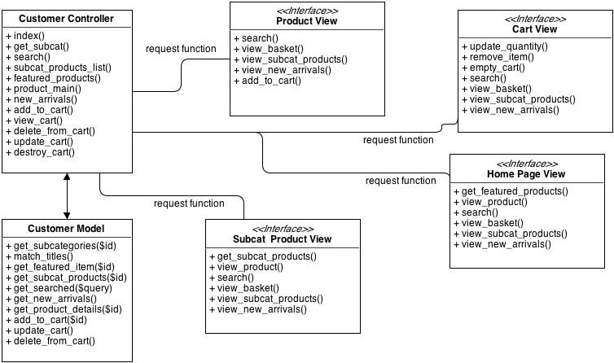

The above class diagram depicts the architecture of how the customer facing side of the application will work. This is the much simpler side of the application, where business logic can come into play. Below is an explanation of the classes and interfaces shown above.

**Customer Controller –** This controller will be handle requests made from each interface, dealing with the Customer Model when required. It will carry out actions such as generating subcategories to display to the users, deciding on a featured product list, organizing products based on their entry date, and more. These functions will first be executed, then the respective views loaded and shown to the users; much like the ‘Admin Search View’ (see Admin Search View description above).

The function ‘get_subcat()’ will be passed to each view before interaction begins with the user. This is in order to be able to generate the view with preloaded data so that the user is able to interact with something.

**Customer Model –** This model will receive requests from the Customer Controller to get specific data from the database and return it back to the controller, which will then process it. It is necessary to have this class in order to separate the business logic of the application from the gathering of data from the database, in order to more clearly see the business logic in the controller.

**Homepage View –** This will be the first view seen by the user. From here, the user can view featured products, which must be preloaded by calling the method featured_products() in the controller, view products which are on the homepage (i.e. featured products, best sellers, products on sale, etc), and search for a product using the search feature. The user can also from the home page, request to view their basket, pick a categories subcategory and view its products, as well as viewing new arrivals.

**Subcategory Product View –** This view will be a result of the user choosing a subcategory from the navigation menu in order to view products listed under it. This view can be requested from every page by calling a function in the controller ‘subcat_products_list()’, which will take the assigned value for each subcategory and query the database in the model, returning the results, and then loading the subcategory view. From this view, the user can see the products listed under the chosen subcategory, as well as view the desired product. The user is also able to search, pick another subcategory, view new arrivals and their basket from here as well.

**Product View –** This view can be accessed from a request made from the subcategory product view and the homepage. The interface invokes the method ‘product_main()’ in the controller, which gets all the product details for the main product page. From here, the user can also search, pick a subcategory to view its products, view new arrivals and their basket from here as well.

**Cart View –** This view will be shown once the user adds a product to their cart or when they activate the view_basket() function. From here, the user will be able to modify the contents of their cart, by changing its quantity (update_quantity()), deleting a product (remove_item()), or emptying the cart completely (empty_cart()). The user will also be given the same functionality in this page as the other views have i.e. searching, choosing subcategories, viewing new arrivals and their basket.

## 5.6 Entity Relationship Diagram

An ER diagram is used to describe a relational databases structure. The following ER diagram represents the way the database will be setup for the purpose of creating the Zamzam website.

Figure 5.3: ER Diagram

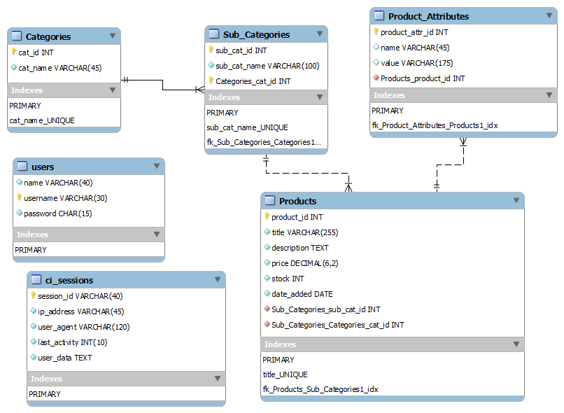

An explanation of the tables above will be given below.

**5.6.1 Categories**

The categories table is the simplest of the tables, consisting of only two columns: ID and name. The primary key is the ID, which means that MySQL won’t create a duplicate value in that column for every row. This allows mapping/referencing between tables to be done, otherwise if there were duplicate values for an ID field, the query would become ambiguous.

The category name column is set to be unique; meaning no other entry in that column can contain the same value as another. This will allow category names to not be accidently repeated.

**5.6.2 Subcategories**

The subcategories table consists of three columns, mainly the same as the categories table, except that the third column contains a foreign key constraint to the ‘cat_id’ column in the categories table. This means that this field can accept values only if they are present in that column, otherwise the query is rejected. Placing this constraint will allow the application to query the database in order to find subcategories that belong to a category.

**5.6.3 Products**

The products table will be where all the common data between products will be held. This is in order to make querying around the customer side of the application much easier, as the full list of details for the product are not needed around the application i.e. to display products on the home page, in the subcategory view, in search results, in the shopping cart; rather the full details are not needed until the user decides to view the product page. Only two pieces of information are required for these pages; the title and price. The title is unique, meaning no two products can have *exactly* the same name. This will allow specific products to be found i.e. books.

Stock levels and the date the product was inserted into the database are also stored in this table as they come under the general scope of the products details. The description is set with type text; so that it can hold a large amount of data (the TEXT data type can hold up to 64kb of data).

The products table consists of two foreign key constraints, both referring to the subcategories table. These consist of the subcategory ID and the category ID, both of which must be present in the subcategories table for their values to be included in the products table. This will allow products to be mapped to a subcategory, which is in turn mapped to a main category. This will prove useful when determining which products to display upon request for a subcategories product list.

The price column is of type decimal to allow products to contain prices with a decimal point which denotes the amount of pence i.e. £9.99. The parameters for the decimal value are (6, 2); the first value denoting how many digits are allowed in the entire value i.e. 6 digits altogether (i.e. £1234.56), and the second referring to how many decimal places will be allowed after the decimal point. The value 6 has been chosen because it is not likely that the small business will store products valued any higher, no offense intended.

**5.6.4 Product Attributes**

The product attributes table is where specific details of each product will be kept, such as authors, publishers, sizes, weight, brand, etc. This is done in order to keep from having to create multiple tables for each product type i.e. a books table, clothes table, etc, which would, after contemplating having to query for a product, make it difficult to know which product is requested.

For example if the approach of separating each product type into their own tables was taken, each one of those tables would consist of their own primary keys for their product ID. When querying for a product that has a product ID of for example, 3, how would you know from which table to get the product from? You would need a condition, apart from knowing the products ID, that would let you know which table to query.

In order to avoid having to deal with messy queries, the product attributes table was created, which allowed housing for each product specific detail, known by referencing the product ID of the products table via a foreign key constraint. The form used by the admin to enter these details will contain all the details required by each product type so that each product within that product type will contain the same data properties. That way, every product will contain the values necessary (i.e. all books will contain the properties author, publisher, page number, etc) for their type.

Since there is a likely possibility that some columns will contain the same data i.e. the name and value column might be the same for two or more products, there is no unique constraint put on the two columns. The fact that there will be a foreign key constraint referencing the products product ID column will ensure that each products details are correctly mapped.

**5.6.5 Users**

The users table is used to hold account information for the administrator’s panel. In order for there to be authentication, the user must first create an account for their username and password to be entered into the system, and then in order to verify their credentials when they decide to login, their submitted data must be checked against the values in this table to see if they match correctly.

The name column in this table refers to the human name of the admin. This will be used to display their name upon login so that there is some form of identification. This value may also be used to log their activities, to keep track of system updates in the future. The username column will hold the value the admin submitted during account creation, as well as their password.

**5.6.6 CI_sessions**

This sessions table, which holds information which is created in a users session (such as their basket contents and logins), is given as added security from CodeIgniters user documentation[28]. Normally sessions are stored on the users chosen browser, but by storing the sessions in a database instead, it is more secure in terms of providing validation for the values stored in this table.

# Section 6 - Implementation

This section will cover key aspects during development in making the new Zamzam website. We will begin by first giving an explanation of some of the benefits CodeIgniter will offer in helping to build the website and how such benefits will come into play.

## 6.1 CodeIgniter – structure and features

CodeIgniter provides its framework users with a thorough documentation that covers the majority of features the framework has and makes it easy for a novice user to get a grasp on how to use it. Topics such as how to configure the framework to your own custom settings, make use of the variety of classes the framework offers, as well as how to use helper functions that CI provides to make tasks performed in a majority of applications easier to handle. In this project, the user documentation is heavily relied on to understand how to work with CI in completing the website using the benefits given above, as it offers explanations and examples on how to use the necessary classes.

The classes that come built into CI are used to help complete tasks which are supported by the frameworks given classes. This is to reuse code that is available from the framework and not waste time on implementing functions that are already given, but focus on completing the requirements of the application on time. Using classes that are built into CI will also allow the application to be more secure because using the classes in CI allows automatic filtration and sanitizing.

CodeIgniter is organised using the MVC design pattern which splits the application into three parts, Models, Views and Controllers. This structure will help in separating the functionality of the admin interface from the customer interface, allowing the two interfaces to be completely separated from each other, with only the database between them with which they both interact. This separation is necessary as it will allow the functionality of the admin interface to be concealed. The idea of how the implementation will be split to cater to both interfaces is shown in the class diagrams (see section 6: 6.5.1 & 6.5.2). Each interface will consist of its own controller and model class, allowing such distinction to be made as to what each interface is capable of doing.

Decisions as to what will be included in each model, view and controller will be made by first taking the requirement being implemented i.e. insert an item into product catalogue. The requirement will then be assessed as to what it will need from each aspect of the MVC pattern i.e. what does it require the view to do, what needs to be done in the model for it to carry out this insertion, etc. Then once this is thought over it will be implemented for each aspect, starting from what is needed from the view i.e. a form must be put together with all necessary data, calling a function upon submission within the controller that triggers a function in the model to insert the data sent through, returning true or false back to the controller which loads a confirmation view.

The implementation phase will now begin, starting with how the configuration of the CI framework for the application is setup.

## 6.2 Configuration

**Folder Structure**

The application runs under the ‘www’ directory in Apache. The root folder is named ‘CodeIgniter’, under which you will find the main folder named ‘application’, where all coding and configuration is found. There are three main folders under ‘application’ which are where coding for the application will be found, namely ‘controllers’, ‘models’ and ‘views’. Configuration settings are set under the ‘config’ folder in a file named ‘config.php’. Any configuration settings made in this file will be described below, along with configuration settings in other files.

1. Autoload.php – This is a convenience configuration file that CodeIgniter provides, allowing you to automatically load certain libraries that you know will be used throughout the application. This gives the advantage of using methods for each library without having to manually load them every time. I’ve auto loaded the database and sessions libraries, as the application will constantly be getting and manipulating data, and sessions will be tracked for the admin login and users shopping carts. The URL helper will provide methods such as ‘redirect()’ and ‘base_url()’ to be used without having to load the helper class in the controller(s).
2. // File Path: CodeIgniter/application/config/autoload.php
4. $autoload['libraries'] = **array**('database', 'session');
6. $autoload['helper'] = **array**('url', ‘file’);
7. Config.php – This file is used mainly to define custom settings for sessions and the base URL path for the application.

Defining the base URL helps when creating anchor elements in view files and inserting product images into a folder. With the help of the URL helper class, this variable can be used to reference to the base URL for the application with ease, so that whenever the root folder changes (which is likely to happen if the application is moving into production), the only thing you will need to update would be this ‘base_url’ index in the config.php file. This makes the code more maintainable, as long as you use the ‘base_url()’ function every time you need to refer to the path of the application.

CodeIgniter comes with an ‘index.php’ file attached to the URL. Index.php is a file that is responsible for processing all the requests made to the application. Removing it from the URL is only a matter of preference, and I’ve chosen to do so because it provides a cleaner way to access controllers from the URL. In order to do this, the ‘index_page’ variable was set to an empty string, and a ‘.htaccess’ file was added to the root directory of the project which sets rules for a module called ‘mod_rewrite’ on the Apache server. The module had to be loaded by un-commenting it in the ‘httpd.conf’ file also found on the Apache server.

1. // File path: CodeIgniter/application/config/config.php
3. $config['base_url'] = 'http://localhost/CodeIgniter/';
5. $config['index_page'] = '';
6. // File path: CodeIgniter/.htaccess
7. **<IfModule** mod_rewrite.c**>**
8. RewriteEngine On
9. RewriteBase /CodeIgniter/
11. RewriteCond %{REQUEST_URI} ^system.*
12. RewriteRule ^(.*)$ /index.php?/$1 [L]
14. RewriteCond %{REQUEST_URI} ^application.*
15. RewriteRule ^(.*)$ /index.php?/$1 [L]
17. RewriteCond %{REQUEST_FILENAME} !-f
18. RewriteCond %{REQUEST_FILENAME} !-d
19. RewriteRule ^(.*)$ index.php?/$1 [L]
20. **</IfModule>**

Session variables were set as follows:

1. $config['sess_cookie_name']     = 'ci_session';
2. $config['sess_expiration']      = 0;  // no expiration
3. $config['sess_expire_on_close'] = FALSE;
4. $config['sess_encrypt_cookie']  = TRUE;
5. $config['sess_use_database']    = TRUE;
6. $config['sess_table_name']      = 'ci_sessions';
7. $config['sess_match_ip']        = FALSE;
8. $config['sess_match_useragent'] = FALSE;
9. $config['sess_time_to_update']  = 300;
10. $config['encryption_key'] = 'ictg8yHAiU';

The two main indexes to focus on in the session configuration above are ‘sess_expiration’ and ‘sess_expiration’. The first allows you to set an expiration time for every session in seconds. The default value for this index was ‘7200’ seconds. This would not have worked out for either the admin, whose login authentication is done via sessions, or the users shopping cart because every two hours their shopping cart contents would be destroyed. Since the sessions will be stored in a database, allowing each session to be able to store more data (as originally a cookie has a 4K limit on the amount of data it can hold, and sessions are stored in cookies), the expiration time was set to zero to allow users more control over when they would like to delete their session.

For example, the admin will be logged in until they want to logout, as opposed to having the application log out the admin automatically. The main benefit of not letting sessions expire is for customers shopping carts, as their content will remain intact, unlike the current Zamzam website. The other sessions index which helps achieve this is the ‘sess_expire_on_close’ index, as this allows the application to decide on whether to destroy the users session data when they close their browser or not. This index has been set to false, mainly in order to provide the ability to remember the customers shopping cart contents.

‘Sess_time_to_update’ updates the session ID field in the database table ‘ci_sessions’. This provides for more security, as if your session data is taken, it will be generated again, so the ID that was taken by the hacker would not become associated with yours.

1. // File path: CodeIgniter/application/config/config.php
2. $config['global_xss_filtering'] = TRUE;

Global XSS filtering has been enabled to automatically filter each input field in the application. This includes the search box in the customer end interface as well as the forms in the administrators interface, in case it gets compromised and the hacker does malicious actions. Enabling this feature will result in input fields being sent through the POST method to be filtered to remove any JavaScript code intents and the like.

An encryption key is required by CodeIgniter (CI) in order to use the session’s class, otherwise CI throws an error. Therefore a random string was created to cater to this need. The reason CI forces the need for an encryption key is to further secure a session from getting stolen or duplicated. If you set your own encryption key, it makes it customised, making it harder for a hacker to disguise themselves using your session data.

1. Database.php

// File path: CodeIgniter/application/config/database.php

1. $db['default']['hostname'] = 'localhost';
2. $db['default']['username'] = 'root';
3. $db['default']['password'] = ‘xxx’;
4. $db['default']['database'] = 'zamzamdb';
5. $db['default']['dbdriver'] = 'mysql';
6. $db['default']['db_debug'] = FALSE;

In order to connect to my database, the above constants had to be custom defined. Since I am running this application on my local machine which runs a private apache setup, ‘localhost’ is the default host name that is used. The root user, also the default apache username, is supplied along with my chosen password (removed here). The name of the database used by the application is given as ‘zamzamdb’ as well as the type of database ‘mysql’.

This information is supplied not only to be able to use the database, but to make it more convenient in model classes for performing queries, as the database supplied here can be referenced using CI’s Database class.

In the end of the implementation, the database errors were turned off by setting the ‘db_debug’ index to false, in order to prevent giving away database information to malicious users when attempting to perform SQL Injection attacks.

## 6.3 Sprint 1 – Administration

Sprint backlog: F6-10 (referencing requirements list found in Appendix Item 4)

**Login (requirements carried out: F8)**

The first functionality carried out was providing the administrator with the ability to login/logout. The first controller to be created was the Login controller.

1. //File Path: CodeIgniter/application/controllers/login.php
2. **class** Login **extends** CI_Controller {
4. **function** __construct()
5. {
6. parent::__construct();
7. }
9. **public** **function** index()
10. {
11. $this->load->view('admin/login_form');
12. }
13. }

In order to inherit the functionality of a controller in CodeIgniter, controllers have to extend the base controller class, called CI_Controller. The index() method is the first method that is called when the controller runs and so here would be the ideal place to load the login page. Using the Load class, the view ‘login_form’, which is under the ‘admin’ folder in the view folder, is called and displayed. The view for the admin to type in their username and password is then presented.

1. <!--File Path: CodeIgniter/application/views/admin/login_form.php-->
2. <form action="<?php echo base_url();?>login/validate_login" class="form-signin" method="POST">
3. <h2 class="form-signin-heading">Zamzam Admin Panel Login</h2>
4. <input type="text" name="username" class="input-block-level" placeholder="Username">
5. <input type="password" name="password" class="input-block-level" placeholder="Password">
7. <button class="btn btn-large btn-primary" type="submit">Login</button>
8. </form>

The above form’s action indicates which method to run in the specified controller. After using base_url() to specify the tedious part of the path, we can see that the form points to the ‘validate_login’ method in the Login controller, using the POST method. Two input form fields are supplied for the admin to enter their username and password, along with a submit button to allow the form to request the ‘validate_login’ method in the controller.

Once the form is submitted, the validate_login() function will be called in the Login controller.

1. //File Path: CodeIgniter/application/controllers/login.php
2. **public** **function** validate_login()
3. {
4. /*Load admin model inside function to not allow global class access when you start to create customer accounts in the future*/
5. $this->load->model('admin_model');
6. $res = $this->admin_model->validate();
7. }

The validate_login() function first loads a model class ‘admin_model’ and then calls the function validate() under it, expecting a result to return and then assigning that value to a variable.

The model could have been loaded outside of the function, namely in the __construct() function, to allow global access within the Login class to the model, but this was avoided to allow restricted access to that model when the functionality to include creating customer accounts will be added in the future. Customers should not have access to the admin_model, which will be used to manage products, among other things.

1. //File Path: CodeIgniter/application/models/admin_model.php
2. **function** validate()
3. {
4. $username = $this->input->post('username');
5. $password = $this->input->post('password');
7. $salt = substr($username, 0, 2);
9. $crypted_password = crypt($password, $salt);
11. $this->db->where('username', $username);
12. $this->db->where('password', $crypted_password);
13. $res = $this->db->get('users');
15. **if**($res->num_rows == 1)
16. {
17. **return** TRUE;
18. }
19. }

Once the validate() method is called in the admin_model, the application first receives the input values entered by the admin in the login form.

Now, when dealing with the issue of storing passwords, I was confused by the idea of how to randomly salt each user’s password, so that one salt is not the same as other users. This article[29] showed a nice way of ensuring that every user has a unique encrypted password stored in the database, even if there are users that have the same password. The technique is to take the users username value and extract a number of characters from it, append it to the user’s password and then store it in the database.

Using this technique has its limitations; one of the most obvious being what if more than one users username starts with the same letters. This would be a problem if this technique was used in a public setting, where hundreds of users would be creating and logging into their accounts, but since it is a more restricted space where only a handful of people at most will have access, the solution can be free from this threat.

Once the salt has been retrieved, it is added onto the password, which is hashed using the function crypt(), found in PHP. Crypt() can be made to use one of a number of hashing algorithms to hash the provided string parameter. It only requires one parameter, in which case it will salt the input automatically, but if you want to make custom salt you can provide an optional second parameter with it. I chose to provide a custom salt, which would be taken from the username, as described above.

I was unsure how to deal with the idea of ‘salting’ passwords randomly, storing them in a database and then later retrieving them. How to generate random salt was something I could get my head around, but how to compare and retrieve it? For example, you generate a 22 character salt randomly, append it to the password and store it in the database. Then later when you want to authenticate the admin who wants to log back in to their account, how would compare that value when the salt you generated can no longer be known because it was random? Creating a static salt for all users was also another idea, but that would have defeated the purpose of salting passwords because if a hacker compromises your database and can find out how you salted one of your passwords, they can and will try that salt with all other passwords in your database.

The issue was puzzling, and so I decided to go with a simpler approach which was still salting the passwords but not in such a strong way, until the time comes when customer accounts will need to be created, which will demand an authentication mechanism with more integrity.

Once the password is hashed and salted, it is compared to the values present in the ‘users’ table. Using CodeIgniter’s Active Record class to query the database, the username and hashed password are compared to the values entered by the user. Since every word produces the same hash, the comparison between one hash and another can be done. Along with the hash, the first two characters of the submitted username are taken and added to the hash value as salt, so if the username is incorrect, the password will not authenticate.

Once the query is complete, it is checked in order to see if there were any results from it. This is done using the num_rows() function which returns the number of rows that resulted from the query. In this case, if the username and password supplied by the user were correct the value would be 1, indicating that the values supplied by the user are correct. If this is the case, then the function will return true, indicating that the user has been successfully authenticated.

When the function is finished, the result of it is checked in the controller.

1. //File Path: CodeIgniter/application/controllers/login.php
2. **public** **function** validate_login()
3. {
4. ...
5. $res = $this->admin_model->validate();
7. **if**($res)
8. {
10. $data = **array**( 'username' => $this->input->post('username'),
11. 'is_loggedin' => true);
13. $this->session->set_userdata($data);
14. /* direct them to the index() method in the admin controller
15. which leads to the main admin page */
16. redirect('admin');
18. }
19. **else**
20. {
21. $this->index();
22. }
23. }

If the variable ‘$res’ is true, meaning that the model returned true upon querying the database table, the user is granted admission into the administrator space. Along with that, a session is created for them, containing their name and an index to confirm whether the user is logged in or not, which will be used later to check whether the administrators session is valid or not. If the result of the validate() function in the admin_model is not true however, the user will be shown the login page again.

The Admin controller was then created along with an index function that showed the welcome page to the administrator.

1. //File Path: CodeIgniter/application/controllers/admin.php
2. **class** Admin **extends** CI_Controller {
4. /* Represents the number of image upload fields per product. Is declared as global for extensibility. */
5. **var** $upload_image = **array**("1","2","3", "4", "5", "6", "7");
7. **function** __construct()
8. {
9. parent::__construct();
10. $this->load->model('admin_model');
11. $this->load->helper('form');
12. $this->load->library('form_validation');
13. /* call the is_loggedin() method before doing anything else, to check
14. whether the user is allowed to be here (i.e. they are logged in) or not. */
15. $this->is_loggedin();
16. }
18. **public** **function** index()
19. {
20. $this->load->view('admin/admin_panel');
21. }
23. **public** **function** is_loggedin()
24. {
25. $check_login = $this->session->userdata('is_loggedin');
27. **if**(!isset($check_login) || $check_login != 1)
28. {
29. redirect('login');
30. }
31. }
32. }

The __construct() function in CodeIgniter give you a space where you can run any default processes when your class is instantiated[30]. This makes for a perfect place to check whether the user is allowed to be in the administrator’s panel. The is_loggedin() function provides this functionality, where it checks to see if the session variable ‘is_loggedin’, which was set when the user was authenticated (see: CodeIgniter/application/controllers/login.php, function: validate_login()), for the user is set to be true, and exists, or not. If either one is found to be false, the user is redirected back to the Login controllers index function, which shows the login form page.

The index function for the Admin controller loads a view called ‘admin_panel’ which is the welcome screen for the administrator space. From this page, the administrator can request to do several actions via a navigation menu, such as search the product database, add products/subcategories, and create admin accounts as well as logout.

1. <!--File Path: CodeIgniter/application/views/admin/admin_panel.php-->
2. <ul class="nav">
3. <li class="active"><a href="<?php echo base_url();?>admin">Home</a></li>
4. <li><a href="<?php echo base_url();?>admin/add_products_page">Add Products</a></li>
5. <li><a href="<?php echo base_url();?>admin/add_categories_page">Add SubCategories</a></li>
6. <li><a href="<?php echo base_url();?>login/create_account">Create Account</a></li>
7. <li><a href="<?php echo base_url();?>login/logout">Log out</a></li>
8. </ul>

Each menu item points to another page that gives the appropriate forms to perform their respective actions. All list items have an anchor element with the structure of ‘controller/method’, pointing to the methods of the controller which will load the view files.

**Admin Search (requirements carried out: F10)**

1. <!--File Path: CodeIgniter/application/views/admin/admin_panel.php-->
2. <form action="<?php echo base_url();?>admin/search_products" method="POST" class="form-inline">
3. <input type="text" name="search_field" class="input-large" placeholder="Search products by name or ID">
4. <button type="submit" class="btn btn-primary">Search</button>
5. </form>

Also found on the admin_panel page is a search form, which the admin can use by typing in product names or ID’s (if they know them) in order to find out a products details or perform actions on the desired product.

From the above code it can be seen that the form points to a function called search_products() in the Admin controller. Let’s take a look at the function.

1. **public** **function** search_products()
2. {
3. $val = $this->input->post('search_field');
4. $results = $this->admin_model->search($val);
5. }

The first thing done in the search function is to retrieve the posted data in order to know what to search for. This is done using CodeIgniters Input class, which has a distinct advantage over using the native PHP method of retrieving submitted data (i.e. $_GET/$_POST), in that it sanitizes the data sent without you having to manually do it.

Once the value is retrieved, the function search($val) in the admin_model is called, passing the search inputs value as a parameter. The result of this function will be stored in the variable $results.

1. //File Path: CodeIgniter/application/models/admin_model.php
2. function search($val)
3. {
4. $this->db->select('products.product_id,
5. products.title,
6. products.description,
7. products.price,
8. products.stock,
9. categories.cat_name,
10. subcategories.subcat_name');
11. $this->db->from('products');
12. $this->db->like('products.title', $val);
13. $this->db->or_like('products.product_id', $val);
14. $this->db->join('categories', 'categories.cat_id = products.cat_id', 'inner');
15. $this->db->join('subcategories', 'subcategories.subcat_id = products.subcat_id', 'inner');
16. return $this->db->get();
17. }

Above is the Admin_model function that is called by the Admin controller to gather matching results for the search query together. The Active Record pattern is used to query the database. In the select statement, the columns which are to be gathered based on the criteria are specified. This is done by using the *table.fieldname* way of specifying which column needs to be returned from which table. This is required when selecting columns from multiple tables, otherwise MySQL will not query the database as it will consider the columns provided as ambiguous, since there is no restriction on having the same column name for different tables.

The database is then given a restriction as to what rows to select by the ‘like’ and ‘or_like’ operators. These allow a more loose restriction than using a ‘where’ clause, as using the ‘where’ clause would mean an absolute match. This wouldn’t be suitable for a search query as the user will be typing data such as “senorita”, when the title for that product is “senorita – lip balm (cherry)”. In that case, no results will be returned, as the user did not type in the latter fully. This would not be practical in such a case. The ‘like’ operator takes a third parameter that allows you to specify where the wildcard will be placed. If it is left empty, it will place it both before and after, allowing more variety of results to be returned.

In order to get the selected column names from the categories and subcategories tables, the ‘join’ clause is used. This is where defining foreign keys when creating the MySQL tables comes into play, as we are now able to combine tables to gather specified information between them. The two tables are connected their respective ID’s to match the product ID of the current product that is being run through in the query. This will allow the correct category and subcategory names to be produced as the outcome of the query for each product.

For example in the products table, the product with the ID ‘158’ has cat_id ‘3’ and subcat_id ‘58’. When the query runs through the database to collect the matching results, it will check to see if the title/ID of the product matches the search value entered by the user. Then in order to gather the data specified in the ‘select’ statement, it will need to somehow gather the subcat_name and cat_name for the matching products. This is done by using the subcat_id and cat_id in the products table to match the ones in the categories and subcategories tables.

When the query has been written, it is then executed by calling the Database classes get() function and returned back to the controller.

After the results from the database have come through to the controller, the data is ready to be passed to the view and be displayed. Since the data being returned will produce many columns for any single product returned, it was best to store this data in a table. CodeIgniter provides a Table class, which allows an HTML table to be created on the server side. This class was used simply because CodeIgniter provided the feature, otherwise the table could have just as easily been created using a ‘for each’ loop over the result set in the view.

1. $this->load->library('table');
2. $tmpl = **array** (
3. 'table_open' => '<table class="table table-striped table-bordered table-condensed">',
4. 'heading_row_start' => '<tr bgcolor="#66cc44">',
5. 'row_start' => '<tr bgcolor="#dddddd">'
6. );
7. $this->table->set_template($tmpl);
9. $this->table->set_heading('','ID', 'Title', 'Description', 'Price',
10. 'Stock', 'Category', 'Subcategory', 'Options');
12. $row = **array**();
13. **foreach** ($results->result() **as** $product)
14. {
15. $row = NULL;
16. $row[] = "<img src='" . base_url() . "images/" . $one_product->product_id . "_1.jpg' height='100' width='100'/>";
17. $row[] = $one_product->product_id;
18. $row[] = $one_product->title;
19. $row[] = substr($one_product->description, 0, 90);
20. $row[] = $one_product->price;
21. $row[] = $one_product->stock;
22. $row[] = $one_product->cat_name;
23. $row[] = $one_product->subcat_name;
24. $row[] = anchor('admin/load_edit_page/' . $one_product->product_id, 'edit', **array**('class' => 'label label-info')) . ' &middot; ' .
25. anchor('admin/confirm_delete/' . $one_product->product_id, 'delete', **array**('class' => 'label label-important'));
27. $this->table->add_row($row);
28. }
30. $data['search_results'] = $this->table->generate();

The Table library was loaded in this function as it is the only place where the Table class would be used. The class provides a function called set_template($template) which takes an array of key/value pairs. This function lets you provide HTML table tags with additional attributes such as classes and ID’s. Here the function was used to style the table with Bootstrap CSS, such as ‘table-condensed/bordered/striped’.

Then customer headings were set via the set_headings() function, corresponding to each column coming from the database.

Once the table was ready, the result set was iterated over using a for each loop. What that permits you to do is take an array which consists of many indexes and treat each one the same way. To cooperate with the Table class, an array is declared before the loop in order to hold one rows data. The data is extracted inside the loop using the Table class’ function add_row(). This function takes an array as its parameter, which contains the values each row will have in the table. You can either supply the values altogether in a single statement i.e. $this->table->add_row($product->title, $product->price, etc), but it was much cleaner to appoint each of $product’s value into the $table_row array’s index and pass that array to the add_row() function. Before the next iteration starts, the $table_row array is reset, in order to avoid adding multiple values into the same row.

Anchor tags are created for each product in the row, which lead to methods for editing and deleting that product. The products are recognised by their ID which comes from the database, so that the correct product is modified. Both functions take the ID from the URL via the URI Class, which will be explained later.

The table is then generated by calling the generate() function in the Table class. The results of this function are stored in a variables index called $data and passed to the view as the second parameter.

1. $this->load->view('admin/search_page',$data);

The view() function can take a second parameter which holds data you wish the view being loaded to contain. In this case it was the entire table. It does this by taking the array passed to it and converting all of its indexes into PHP variables, so they can be called in the loaded view using the ‘$’ variable declaration i.e. $search_results.

When the data is passed to the view ‘search_page’, all that needs to be done is echo out the results since that variable holds the entire table:

1. //File Path: CodeIgniter/application/views/admin/search_page.php
2. <?php echo $search_results; ?>

This will produce the returned results for the search query.

**Create Account (requirements carried out: F8)**

In order to create user accounts for the admin, a form was made on its own page.

1. //File Path: CodeIgniter/application/views/admin/create_account.php
2. <form class="form-horizontal well" id="create_account_form" action="<?php echo base_url();?>login/create" method="POST">
3. <div class="control-group">
4. <label class="control-label" for="fullname">Full Name:</label>
5. <div class="controls">
6. <input type="text" id="fullname" name="fullname">
7. </div>
8. </div>
9. <div class="control-group">
10. <label class="control-label" for="username">Username:</label>
11. <div class="controls">
12. <input type="text" id="username" name="username" placeholder="More than two characters...">
13. <?php echo form_error('username'); ?>
14. </div>
15. </div>
16. <div class="control-group">
17. <label class="control-label" for="password">Password</label>
18. <div class="controls">
19. <input type="password" id="password" name="password">
20. <?php echo form_error('password'); ?>
21. </div>
22. </div>
23. <div class="control-group">
24. <div class="controls">
25. <button type="submit" class="btn btn-success">Create Account</button>
26. </div>
27. </div>
28. </form>

Apart from the styling, the form contains only three input fields for the full name, username and password the new admin user will have. The form is submitted to the Login controller and runs the ‘create()’ function in it.

1. **public** **function** create()
2. {
3. $this->form_validation->set_rules('username', 'Username', 'required|min_length[2]');
4. $this->form_validation->set_rules('password', 'Password', 'required|min_length[8]');
6. $this->form_validation->set_error_delimiters('<span class="label label-important">','</span>');
8. **if** ($this->form_validation->run() == FALSE)
9. {
10. $data['validation_error'] = "A Validation error occurred.";
11. $this->load->view('admin/create_account',$data);
12. }
14. }

This function first performs some validity checks on the username and password input fields, to check that they meet set requirements for submitting the form. Validation of the form is done through CodeIgniters Form Validation class, which allows forms to be checked against set rules for each specified input field. This is done through the set_rules() function, which takes three parameters: the input fields name, the name of the error message, and the rules for that input field. Both the username and password field are set to required, as you cannot have only a password and no username, eliminating the possibility of having such a combination, as well as not having a username with no password. A minimum length for the username was set to two, as two characters are required for the salting technique used to encrypt passwords (see section ‘Login’ above). Styling for the error messages was set after that, using Bootstraps CSS styling.

In order to use these validation rules, they must be triggered. This is done by the function run() in the Form Validation class, which returns false if one of the validation rules fails. If this is the case, a variable $validation_error is passed into the view ‘create_account’ and used to display an error message. Along with that error message, a more specific error message, using the form_error() method, is shown under each input field where the error occurred. This can be seen in the ‘create_account.php’ file above.

If form validation passes, the application can move on to inserting the values into the database and creating the account.

1. **else**
2. {
3. $this->load->model('admin_model');
4. $res = $this->admin_model->create_account();
6. **if**($res)
7. {
8. $this->session->set_flashdata('account_success', 'Account created successfully.');
9. redirect('admin');
10. }
11. **else**
12. {
13. $this->session->set_flashdata('account_error', 'An error occurred while trying to create your account.');
14. redirect('admin');
15. }
16. }

The function create_account() in the admin_model will be called, and based on the success or failure of that function, a success or error message will be shown to the user on the welcome page.

1. //File Path: CodeIgniter/application/models/admin_model.php
2. **function** create_account()
3. {
4. $username = $this->input->post('username');
5. $password = $this->input->post('password');
6. $human_name = $this->input->post('fullname');
8. $salt = substr($username, 0, 2);
10. $crypted_password = crypt($password, $salt);
12. $data = **array**(
13. 'username' => $username,
14. 'password' => $crypted_password,
15. 'name' => $human_name
16. );
18. $this->db->insert('users', $data);
20. **if**($this->db->affected_rows() != 1)
21. {
22. **return** FALSE;
23. }
24. **else**
25. {
26. **return** TRUE;
27. }
28. }

This function works identically to the validate() function which authenticates users upon login, in terms of password hashing. The comparison and creation of the passwords must contain the same values in order to be able to correctly authenticate the user. This is done by taking the first two characters of the posted username value and using that as salt. Then the insert() function is called to insert the values into the ‘users’ table in the database, creating the new admin user.

If for some reason the database is not able to insert the data, the function affected_rows() will contain the value 0, meaning false. A cause for failure might be that the username already exists in the table, as it has been used as the primary key. Otherwise the function affected_rows() will contain the value 1, indicating that an action has been performed in the ‘users’ table, in this case the data was inserted (as that is the only action being requested). The function then returns the appropriate value and the accounts created (or not).

**Logout (requirements carried out: F8)**

Creating this functionality was simple, as once the user clicks the anchor in the navigation menu to logout, it will point to the function in the Login controller to do so.

1. //File Path: CodeIgniter/application/controllers/login.php
2. **function** logout()
3. {
4. $this->session->sess_destroy();
5. $this->index();
6. }

The session which holds the ‘is_loggedin’ value will thus be destroyed, meaning any attempts to access the admin area after this will not go through, as the check which is made in the Admin controller in every instantiation to see whether that session value is set, will fail. The user is then shown the login form page where they can attempt to sign in again.

**Adding Products (requirements carried out: F7 & F9)**

In order to add different product type products to the product catalogue, separate forms were made to cater to the different data attributes each one carries. This however required a decision to be made, as two ideas came to light: either have different view files for each product type, resulting in less lines of code for each view, or have one view which will house forms for each product type.

The problem that was conceived for the first idea was how would you know which page to load when you decided to edit a product? For example, a book is added to the product catalogue and I then wish to edit it later. How would you determine which page to load once the ‘edit’ button was clicked for that product? I can contemplate querying the categories table and returning the name of the category along with the product details of the product to be edited and then setting ‘if’ conditions for each category to determine which page to load, but that would really bloat the controller.

Instead, I opted for the latter idea, and found a great way to implement it using this as a base structure for the page[31]. What basically happens here is that buttons are grouped together to form a menu, and whenever one of those buttons are clicked, the ID of the container element (which can be any block level element) is targeted and its contents are shown. This is achieved by using the Data API, a new feature introduced in HTML5 which allows data to be stored for the purposes of using it in JavaScript (or JQuery). This is implemented in Bootstrap in their own way, with their own data attributes already defined. In their documentation we can see what data attribute names are necessary in order to run the JavaScript components that come with the Bootstrap framework.

In order to make use of this feature in the application, a button for each product type needed to be created, which point to the product type’s respective form. For the button to show the correct form when clicked, the data-target for each button needs to match the ID of the form.

1. //File Path: CodeIgniter/application/views/admin/add_page.php
2. $('.btn-group button').click(**function**(){
3. **var** target = "#" + $(**this**).data("target");

This would make sure that once the buttons click event was triggered, the target form would be the one matching the forms ID. Then once the target has been acquired, the function then hides any form that might already be showing and displays the targeted form. Each form is given a class of ‘container’ to carry out this effect.

1. //File Path: CodeIgniter/application/views/admin/add_page.php
2. $(".container").not(target).hide();
3. $(target).show();

The way this works in the application is as follows:

1. //File Path: CodeIgniter/application/views/admin/add_page.php
2. <button id="btn-books" data-target="form_books" class="btn btn btn-primary btn-small active" type="button">Add Books</button>

Take one button from the button group and give it a data attribute of data-target called “form_books”. Then create a form with an ID of that same data-target value.

1. //File Path: CodeIgniter/application/views/admin/add_page.php
2. <form id="form_books" class="form-container">

Then in JQuery you create a click event for the button (shown above), set a variable with the target ID’s name (in this case the forms ID), hide any container if it’s showing and replace it with the targeted one.

Once the structure of displaying the forms was in place, the forms were created for each category. The functionality of each form is the same, except that they all have their own input fields to cater to each product types attributes and they all point to their own respective functions the controller and model.

To add a product then, after having clicked on the button for the specific product type, the admin is presented with a form to input the new products details. Each form has its own category input already predefined, as well as subcategories for it which is loaded into the view.

This is done upon request for the ‘add_page’, in order to have the subcategories loaded before the admin is ready to interact with the interface.

1. //File Path: CodeIgniter/application/controllers/admin.php
2. **public** **function** add_products_page()
3. {
4. //get each categories subcategory and place them in their own variable
5. $data['categories1'] = $this->admin_model->getSubcategories('1');
6. $data['categories2'] = $this->admin_model->getSubcategories('2');
7. $data['categories3'] = $this->admin_model->getSubcategories('3');
8. $data['categories4'] = $this->admin_model->getSubcategories('4');
9. ....up to 11..
10. $this->load->view('admin/add_page',$data);
11. }

The admin_model’s getSubcategories() function is called, which returns a list of subcategories matching the value ‘cat_id’ in the subcategories table. So for instance, passing the value 1 would result in all subcategories under the category ‘Books’ to be returned. This is done for all categories. The results of that function are stored in an index which will then become a PHP variable once passed to the view, as mentioned before.

1. //File Path: CodeIgniter/application/models/admin_model.php
2. **function** getSubcategories($id)
3. {
4. $this->db->select('*');
5. $this->db->where('subcategories.cat_id', $id);
6. $res = $this->db->get('subcategories');
8. $subcategories = **array**();
10. **foreach**($res->result() **as** $row)
11. {
12. $subcategories[$row->subcat_id] = $row->subcat_name;
13. }
15. **return** $subcategories;
16. }

A query is then performed to extract the subcategory’s name and ID. Then a for each loop iterates over each returned object and inserts it into a structured array with more appropriate key/value data. This is done to make it easier to output the data into the view, which will be seen below.

When the data is loaded into the ‘add_page’ view, subcategories are inserted into a select box.

1. //File Path: CodeIgniter/application/views/admin/add_page.php
2. <label>Sub Category:</label>
3. <?php
4. $options1 = array();
5. foreach($categories1 as $key=>$value)
6. {
7. $options1[$key] = $value;
8. }
9. //used a form dropdown to allow form_validation to correctly prepopulate sub_category field incase of form_validation error
10. echo form_dropdown('sub_category', $options1, $this->input->post('sub_category'));
11. ?>

In order to output the subcategories array that was passed from the Admin controller, another for each loop was used in the same way it was used to extract the subcategories from the database. Once the array $options1 received all the subcategories, CodeIgniters Form Helper class was used to display the select box onto the view. The first parameter is the name of the select tag, the second is the values for each option in the select element, and the third is an optional parameter which allows for a default option to be selected.

The Form Helper class was used instead of manually creating the select element using HTML mark-up because of form validation. If an error occurred on the form, all other input value fields would be loaded again with the values the admin entered, except the subcategory field. To avoid the admin inserting the product into the wrong subcategory, the select box was created using the Form Helper class instead. That way when the admin makes a mistake and is shown the validation errors, it will have all input fields correctly showing the values they had chosen.

Setting the values for the other fields upon a validation error occurring was done by using the set_value() function under the Form Validation class. This function takes the value from the submitted data via the ID name of the input field that was included in the submission and can output it as the input tags value. There is no need to determine whether the value is set or not, that is done within the set_value() function.

1. //File Path: CodeIgniter/application/views/admin/add_page.php
2. <label for="book_name">Book Title:</label>
3. <input type="text" class="span3" name="book_name" id="book_name" value="<?php echo set_value('book_name'); ?>"/>
4. <span class="help-block is_available"></span>
5. <?php echo form_error('book_name'); ?>

The error message for validation errors for each input are echoed out using the form_error() function which takes the input name for the same tag. The same was done for each input field in the form.

One input type which should be noted is the file input. CodeIgniter expects a certain name for file inputs, “userfile”, but this can be overridden as mentioned in the documentation by specifying that input name while performing the file upload. This will be talked about next while discussing how the application inserts data into the database.

Once the form is submitted to add a product, the appropriate function is called in the controller to correspond to the same product type. This will then start form validation. The code snippet below shows the form validation for adding books, it is more or less the same for each product type.

1. //File Path: CodeIgniter/application/controllers/admin.php
2. **public** **function** add_book()
3. {
5. $this->form_validation->set_rules('book_name', 'Book Title', 'trim|required|min_length[5]');
6. $this->form_validation->set_rules('book_author', 'Book Author', 'trim');
7. $this->form_validation->set_rules('book_publisher', 'Book Publisher', 'trim');
8. $this->form_validation->set_rules('book_price', 'Book Price', 'trim|required|decimal');
9. $this->form_validation->set_rules('book_stock', 'Book Stock', 'trim|required|is_natural');
10. $this->form_validation->set_rules('book_description', 'Book Description', 'trim');
11. $this->form_validation->set_rules('book_binding', 'Book Binding', 'trim');
12. $this->form_validation->set_rules('book_size', 'Book Size', 'trim');
13. $this->form_validation->set_rules('book_pages', 'Book Pages', 'trim|is_natural_no_zero');
14. $this->form_validation->set_rules('book_language', 'Book Language', 'trim');
15. $this->form_validation->set_rules('book_isbn', 'Book ISBN', 'trim|integer');

Specified rules are set for each input, for instance there cannot be negative values in the field ‘stock’, no negative or zero values for the number of pages, prices must be a decimal value (i.e. must contain a decimal – the only way to validate that the price was in the 0.00 format), and the title must be a minimum of 5 characters.

If validation doesn’t pass, the add_page view is loaded again, with the subcategories passed to the view. At that point I wasn’t able to figure out how to remove the baggage of carrying around subcategories every time the add_page view was loaded, and so I stuck with that method.

Once the validation phase passes with no errors, the function continues to insert the data into the database by calling the ‘add_book()’ function in the admin_model.

1. //File Path: CodeIgniter/application/controllers/admin.php
2. **else**
3. {
4. $get_id = $this->admin_model->add_book();
5. ....

The model is as follows for inserting into the database:

1. //File Path: CodeIgniter/application/models/admin_model.php
2. **function** add_book()
3. {
4. $maincat = $this->input->post('main_category');
5. $subcat = $this->input->post('sub_category');
6. $name = $this->input->post('book_name');
7. $author = $this->input->post('book_author');
8. $publisher = $this->input->post('book_publisher');
9. $price = $this->input->post('book_price');
10. $stock = $this->input->post('book_stock');
11. $description = $this->input->post('book_description');
12. $binding = $this->input->post('book_binding');
13. $size = $this->input->post('book_size');
14. $num_pages = $this->input->post('book_pages');
15. $language = $this->input->post('book_language');
16. $isbn = $this->input->post('book_isbn');
18. $into_products = **array**(
19. 'date_added' => date('Y-m-d H:i:s', NOW()),
20. 'title' => $name,
21. 'description' => $description,
22. 'price' => $price,
23. 'stock' => $stock,
24. 'cat_id' => $maincat,
25. 'subcat_id' => $subcat
26. );
28. $this->db->insert('products', $into_products);

First the submitted data is gathered from the form and put into variables. The insert() function takes an array which has indexes that correspond to the tables column names, and those indexes contain the values for those column names. So for each column name in the products table an index is created with values of the posted data and then inserted into the table.

For the product attributes table it was not that easy. Since the product attributes table is made up of only three columns, *and* caters to all product types, the name for each attribute and value needed to give specified separately in order to insert all values into the table.

Continuing on from above:

1. //File Path: CodeIgniter/application/models/admin_model.php
2. $id = $this->db->insert_id();
4. $this->db->insert('product_attributes', **array**('name' => 'Author', 'value' => $author, 'product_id' => $id));
5. $this->db->insert('product_attributes', **array**('name' => 'Publisher', 'value' => $publisher, 'product_id' => $id));
6. $this->db->insert('product_attributes', **array**('name' => 'Binding', 'value' => $binding, 'product_id' => $id));
7. $this->db->insert('product_attributes', **array**('name' => 'Size', 'value' => $size, 'product_id' => $id));
8. $this->db->insert('product_attributes', **array**('name' => 'No. of Pages', 'value' => $num_pages, 'product_id' => $id));
9. $this->db->insert('product_attributes', **array**('name' => 'Language', 'value' => $language, 'product_id' => $id));
10. $this->db->insert('product_attributes', **array**('name' => 'ISBN', 'value' => $isbn, 'product_id' => $id));

13. **return** $id;

As shown above, the insert() function still takes an array of the same kind, only its specified within the function itself. Along with the name and value fields for the product being inserted, an ID is also given which will match the ID of the same product in the products table. This is done through using the insert_id() function in the Database class, which returns the ID of the most recent item which was just into a table.

Once the data has been inserted, the ID is returned and stored in a variable in the add_book() function in the admin controller. This is used to insert images that were submitted along with the form.

1. //File Path: CodeIgniter/application/controllers/admin.php
2. **else**
3. {
4. $get_id = $this->admin_model->add_book();
6. $this->load->library('upload');
8. /* Upload image for each array index in $upload_image */
9. **foreach**($this->upload_image **as** $i)
10. {
11. /* If image 1, 2, 3, etc are set, run the upload */
12. **if**(!**empty**($_FILES['file'.$i]['name']))
13. {
14. $config['file_name'] = $get_id . '_' . $i;
15. $config['upload_path'] = './images/';
16. $config['allowed_types'] = 'jpg';
17. $config['overwrite'] = TRUE;
19. $this->upload->initialize($config);
21. /* Grab the file inputs name in each loop and do upload */
22. $input_name = "file" . $i;
23. **if** ( ! $this->upload->do_upload($input_name))
24. {
25. $this->session->set_flashdata('error', $this->upload->display_errors());
26. redirect('admin/add_products_page');
27. }
28. }
29. }
31. redirect('admin/add_products_page');
32. }

Since each file input might not be used to attribute an image to the product, a condition was placed to check whether each file input was empty or not. This was done by using a variable declared globally, $upload_image, which holds the number of file inputs on the form. Since each form has the same number of file inputs (7), this method will work across all forms.

1. //File Path: CodeIgniter/application/controllers/admin.php
2. /* Represents the number of image upload fields per product. Is declared as global for extensibility. */
3. **var** $upload_image = **array**("1","2","3", "4", "5", "6", "7");

Doing this allowed for more flexibility in terms of how many images are required. If the number ever changes in the future to require more images, the indexes in this array can be increased, thus allowing the for each loop above to run that many times as well. The only other thing that would need to be done is to add that many more input file fields to the forms.

Checking to see whether the input file field was empty or not was not provided in the Upload class to my knowledge, and thus the native PHP $_FILE array was used, which holds the files that were uploaded using the POST method.

Then for each input file that was not empty, configuration settings for the Upload class are made. The path to the file where the images are to be stored is specified along with the name of the file, which uses the ID of the same product from the database insert and an appended number to keep track of the number of images for that product. One thing to note in the configuration settings is that ‘overwrite’ is set to true, which means file names can be overwritten. To prevent that from happening, appending the number from the iteration instance is done.

An allowed type for each file is also specified as jpg. This allows only jpg type files to be submitted, not accepting any other type of extension. Having this restriction came in handy when outputting the images onto the customer view, as there was no mess in having to check different file extensions. Once the configuration settings are declared, the Upload class is initialised with them.

In order to do the actual uploading of each file, the Upload class’s do_upload() function needs to be called. This performs the file validation specified in the configuration, returning false if an error occurred, such as wrong file extension/upload path. Uploading each file was done within the for each loop to perform validation on every submitted non-empty file input. In order to do this, as mentioned previously, the function do_upload() expects the file input fields name to be “userfile”, otherwise it will cause an error. Therefore within the for each loop, we have the $upload_image variable at our disposal which holds the current file input fields number that is being iterated through. That value is then taken and concatenated to the string “file” to represent the input name that is currently being iterated through.

This value is then passed to the do_upload() function as a parameter, which removes the restriction of using the class with the “userfile” input field name, and does the upload. If there happens to be an error, the upload is unsuccessful and returns a flash message to the add_page, otherwise the admin is redirected back to the add_page with no message.

**Editing Products (requirements carried out: F7 & F9)**

To edit products, the admin first has to search the product they wish to edit using the search box. Once they see the desired product, they will see an option to edit it as described previously when explaining the search feature.

Once that option is chosen, the admin will be led to a page that functions the same way the add_page does, except that this page is preloaded with the information of the product and contains a hidden field with the products ID.

To do this, the ID for the selected product is taken from the URL via the anchor element which specified it as its third parameter its URL reference, calling the load_edit_page function in the admin controller.

1. //File Path: CodeIgniter/application/controllers/admin.php
2. **public** **function** load_edit_page()
3. {
4. $this->load->helper('form');
5. $id = $this->uri->segment(3);
7. $data['product_details'] = $this->admin_model->getProduct($id);
8. }

That value is then taken using CodeIgniters URI class, which allows you to take one segment from the URI string. In this case the third segment is taken as that is the one that corresponds to the ID of the product, as specified when adding the rows for the search results table.

Then the admin_model function getProduct() is called, passing the ID taken from the URI as a parameter.

The function performs the basic query in the products table and stores the result of that query into a variable. Another query is performed on the product_attributes table to retrieve the product type specific data for the product. The results of this are also stored in a variable.

1. //File Path: CodeIgniter/application/models/admin_model.php
2. **function** getProduct($id)
3. {
4. //products table query...
5. $array1 = $result->result_array();
7. //product attributes query...
8. $array2 = $result2->result_array();
10. **foreach**($array2 **as** $attribute)
11. {
12. $array1[$attribute['name']] = $attribute['value'];
13. }
15. **return** $array1;
16. }

Now in order to return the values of both queries to the controller, both arrays had to be combined. This was done using a for each loop again, by taking the data from the second query results and creating an index from it to the first array, which contains the results from the products table.

An example of the outcome of this:

1. **array** (size=3)
2. 0 =>
3. **array** (size=7)
4. 'product_id' => string '158' (length=3)
5. 'title' => string 'Senorita - Lip Balm (Cherry)' (length=28)
6. 'description' => string 'A red colour lip balm, tastes like cherries' (length=43)
7. 'price' => string '2.50' (length=4)
8. 'stock' => string '42' (length=2)
9. 'subcat_name' => string 'Lip Care' (length=8)
10. 'subcat_id' => string '58' (length=2)
11. 'Brand' => string 'Senorita' (length=8)
12. 'Size/Vol' => string '3.5g' (length=4)

Where the index 0 is an array itself, holding the values of the first query, and the index ‘Brand’ and ‘Size/Vol’ coming from the product_attributes table.

Before adopting this method, the way I pulled the results of both queries into one was by using the PHP function array_merge(). This however yielded the following results:

1. **array** (size=3)
2. 0 =>
3. **array** (size=7)
4. 'product_id' => string '158' (length=3)
5. 'title' => string 'Senorita - Lip Balm (Cherry)' (length=28)
6. 'description' => string 'A red colour lip balm, tastes like cherries' (length=43)
7. 'price' => string '2.50' (length=4)
8. 'stock' => string '42' (length=2)
9. 'subcat_name' => string 'Lip Care' (length=8)
10. 'subcat_id' => string '58' (length=2)
11. 1 =>
12. **array** (size=2)
13. 'name' => string 'Brand' (length=5)
14. 'value' => string 'Senorita' (length=8)
15. 2 =>
16. **array** (size=2)
17. 'name' => string 'Size/Vol' (length=8)
18. 'value' => string '3.5g' (length=4)

This is the same as the one above, but with one big inconvenience; numbered indexes instead of specified names. This was tedious when outputting the values onto the view, as not only did you have to check if the index was set, but also guess which index would match the right input field. Therefore combining the results using a for each loop was a more convenient (method adopted from the answer from this reference[32]).

Once the results are passed to the controller, the edit page is loaded with the product data.

The values taken from the products table do not need to be checked to see if they exist or not, because every product will have these values. The values returned by the product_attributes table however, do need to be checked, as not every product type will have the same data attributes.

1. <!--File path: CodeIgniter/application/views/admin/edit.php-->
2. <label>Book Title:</label>
3. <input type="number" class="span3" name="book_price" value="<?php echo $product_details[0]['price']; ?>"/>

For instance, the value for the input field that corresponds to the products price can simply be echoed out by retrieving the price index of the 0 index array in $product_details, but it is not the case for product type specific attributes.

1. <!--File path: CodeIgniter/application/views/admin/edit.php-->
2. <label>Author:</label>
3. <input type="number" class="span3" name="book_isbn" value="<?php if(isset($product_details['ISBN'])){echo $product_details['ISBN'];} ?>"/>

Things like authors, sizes, colours, weight, publisher, etc all need to be checked using the isset() PHP function which checks to see if a variable exists. If it is the case, then the product is of that specific type, and contains that value (or it doesn’t if the admin forgot to enter it into the database on insertion).

Once the form is submitted for editing, the respective function is called for each product type in the admin controller. The same functionality happens here as the add_ product functions. In the admin model, the posted data is retrieved from the submitted form, with insert functions being replaced by updates. The only difference here is that instead of specifying values to insert, you are checking column names to see if they match and then updating those column values for each attribute.

**Deleting Products (requirements carried out: F7)**

Deleting products was the least time consuming, as the only confirmation that was needed was the products ID. This was passed to the confirm_delete function in the admin controller via the table used to produce search results. Just like the edit anchor, a delete anchor was made that passed the method to execute in order to delete a product, as well as a third segment in the URI to know the product ID for that product.

1. //File path: CodeIgniter/application/controllers/admin.php
2. **public** **function** confirm_delete()
3. {
4. $id = $this->uri->segment(3);
6. echo "Are you sure you want to delete product '$id'?" . "<a href='" . base_url() . "admin/delete/$id'>Yes</a>" .
7. " | " . "<a href='" . base_url() . "admin/index'>No</a>";
8. }

A message is echoed out once the user clicks the delete option, and can decide to proceed or not with the deletion. If they decide to proceed then the actual delete will be executed in the admin controller via the delete function.

In the delete function, the delete_product() function in the admin_model is called.

1. //File path: CodeIgniter/application/models/admin_model.php
2. **function** delete_product($id)
3. {
4. $tables = **array**('products', 'product_attributes');
5. $this->db->trans_start();
6. $this->db->where('product_id', $id);
7. $this->db->delete($tables);
8. $this->db->trans_complete();
10. **if** ($this->db->trans_status() === FALSE)
11. {
12. //if the transaction fails it will return false and not commit
13. **return** FALSE;
14. }
15. **else**
16. {
17. //product was deleted
18. **for**($i = 1; $i <= 7; $i++)
19. {
20. $img = FCPATH . "images/" . $id . "_" . $i . ".jpg";
22. **if**(file_exists($img))
23. {
24. unlink(FCPATH . "images/" . $id . "_" . $i . ".jpg");
25. }
26. }
27. **return** TRUE;
28. }
30. }

The product is deleted from both the products and product_attributes table. This is done via CodeIgniters implementation of transactions, a stricter way of querying databases as the queries are only committed to if the query itself proves to be successful i.e. no database errors occur.

Images for the product are then deleted using the PHP unlink() function, iterating the same number of times as the $upload_image variable in the admin controller, to ensure all images are deleted. In case an image with the specified name is not set i.e. ‘158_7.jpg’, then it will not produce an error. This is courtesy of the function file_exists(), which returns true if the file exists and false if it doesn’t. The function is included as a statement in an ‘if’ condition, which will only allow the deletion of the file to occur if it actually exists.

An added advantage of using transactions here is that if the product is not deleted from the database, it will not delete the images either. This way you don’t end up with the product still being in the database but with no images.

## 6.4 Sprint 2 – Customer

Spring backlog: F1-5, F11, F12, F13, F17, F18, F19, F20

**Home Page (requirements carried out: F13)**

To implement the front facing side of the application, the same setup was used as for the admin. The customer side consisted of its own controller, model and views, separating it from the administrative side.

1. File path: CodeIgniter/application/controllers/customer.php
2. **class** Customer **extends** CI_Controller {
4. **function** __construct()
5. {
6. parent::__construct();
7. $this->load->model('customer_model');
8. $this->load->library('cart');
9. }
11. **public** **function** index()
12. {
13. $data = $this->getSubcats();
14. $data += $this->featured();
15. //var_dump($data);
16. $this->load->view('home_page',$data);
17. }
18. }

First the customer controller was created, which loads the customer model every time its instantiated. The CodeIgniter Cart class is also loaded here as throughout this part of the application the user will need direct access to their shopping basket. The Cart class was loaded in this controller as it is the only one that uses it, and is not used anywhere else in the application, thus saving memory by not having to auto load the class in the autoload.php file.

The index function which is the default function that runs when the controller is instantiated, loads the home page of the website. In order to display content onto the home page, we need to get the correct data from the database for the navigation menu, as well as details of some products to show. This is done by calling the customer class’ getSubcat and featured functions.

1. //File path: CodeIgniter/application/controllers/customer.php
2. **public** **function** getSubcats()
3. {
4. $data['subcategory1'] = $this->customer_model->get_subcategories('1');
5. $data['subcategory2'] = $this->customer_model->get_subcategories('2');
6. //for each category number...
7. **return** $data;
8. }

This function calls a method on the customer model to get the subcategories name and ID that are matching the category ID’s passed to its functions parameter. These results are then stored in the array $data under their own indexes and then returned to the calling function.

The featured() function called in the controller also does the same thing, except it returns an array with the values of a product based on the product ID that was passed.

1. //File path: CodeIgniter/application/models/customer_model.php
2. **function** get_featured_item($id)
3. {
4. $this->db->select('product_id, title, price');
5. $this->db->from('products');
6. $this->db->where('product_id', $id);
7. $res = $this->db->get();
9. **return** $res->result_array();
10. }

Above is the function that is called in featured(), which returns only the ID, title and price for a product. This is because in the home page it is not necessary to display any more detail, just to get the customer interested in viewing the product page, where all the details of it will be.

Once the index function runs, the home page will be loaded and displayed with all the variables defined in $data. The subcategories will then need to be taken out and organised into their respective categories.

1. //File path: CodeIgniter/application/views/home_page.php
2. <li class="dropdown divider-vertical">
3. <a href="#" class="dropdown-toggle" data-toggle="dropdown">Books <b class="caret"></b></a>
4. <ul class="dropdown-menu">
5. <?php foreach($subcategory1 as $key => $value):?>
7. <li><a href="<?php echo base_url();?>customer/subcat_products/<?php echo $key;?>"><?php echo $value;?></a></li>
9. <?php endforeach;?>
10. </ul>
11. </li>

The array $subcategory1 produced by the $data array from the controller now becomes a variable that can be used in PHP. In order to get all the values out, an associative for each loop is used. This works as follows:

The array passed to the view to display one categories subcategories looks like this once it reaches the view:

1. **array** (size=34)
2. 1 => string 'Quran' (length=5)
3. 2 => string 'Tafseer' (length=7)
4. 3 => string 'Hadith & Sunnah' (length=15)
5. 4 => string 'Life of The Prophets' (length=20)
6. 5 => string 'Quran & Hadith Studies' (length=22)
7. 6 => string 'Islamic Stories' (length=15)
8. 7 => string 'Salah & Purification' (length=20)
9. 8 => string 'Islamic Economics' (length=17)
10. 9 => string 'Arabic Language' (length=15)

Where the key is the subcategory ID and the value (i.e. ‘Quran’) is the value. The for each loop then assigns every pair as such and within it, list items in HTML mark-up are made, each containing an anchor tag pointing to the function ‘subcat_products’, and passing the ID of the subcategory to it (which will be used to display products of a subcategory). The name of the subcategory is taken out as $value and shown on the page. PHP is easily embedded into HTML, and conditions like these can be made to form dynamic pages.

Featured products are displayed by using the variables passed to the view as well, except they don’t involve and iterations and are just displayed using the appropriate indexes (i.e. ‘title’, ‘price’, etc).

**Search (requirements carried out: F3)**

To allow customers to search for products, Twitter Bootstraps type ahead JavaScript plug-in was used. This plug-in presents the user with a list of available words matching the letters they are typing in real time and allowing them to select an item from that list. The data list that is used with this plug-in requires a ‘JSON’ object, which is one way for JavaScript to read data (superseding XML in some cases as it is easier to work with). This is obtained in PHP using a function that the language provides, called json_encode(), which changes the value passed to it into a JSON object.

1. //File path: CodeIgniter/application/views/home_page.php
2. $('#typeahead').typeahead({
3. source: **function**(query, process) {
4. $.ajax({
5. url: '<?php echo base_url(); ?>customer/typeahead_list',
6. type: 'POST',
7. data: 'query=' + query,
8. dataType: 'JSON',
9. async: **true**,
10. success: **function**(data) {
11. process(data);
12. }
13. })
14. }
15. });

The first thing to do is to enable the type-ahead functionality using JQuery, and define the AJAX request which will query the database and return the matching product names. The AJAX request requires several parameters, namely the URL that will call the controllers function which will in turn call a function in the customer model to generate the list of products, the type of HTTP request which is used, a data field which represents the users input, and what to do with the returned list.

The function typeahead_list called in the customer model simply takes the list of products returned from the generate_list() function in the customer model and uses the PHP json_encode() function to convert those results into a JSON object.

1. //File path: CodeIgniter/application/models/customer_model.php
2. **function** generate_list()
3. {
4. $list = $this->input->post('query');
6. $this->db->select('title');
7. $this->db->from('products');
8. $this->db->like('title', $list);
9. $res = $this->db->get();
11. $data = **array**();
12. **foreach**($res->result() **as** $row)
13. {
14. $data[] = $row->title;
15. }
17. **return** $data;
18. }

In order to get a list of products, the database is queried using the ‘query’ data value sent from the AJAX request and compared with titles of products using the ‘like’ clause. This will allow more results to be produced, giving the user with more options to choose from. Then the results of the query are turned into an array within the for each loop. Each title is stored into a new index of the $data array and returned to the controller function where it gets JSON encoded, thus producing a list of titles asynchronously.

Once the data list is active, the user now needs to be able to submit those results and get a list of products back that match the query. This is done by a form, which has an input field for the user to type the product name into and a button to trigger the forms action.

1. //File path: CodeIgniter/application/views/home_page.php
2. <form action="<?php echo base_url();?>customer/search" method="POST>
4. <input type="search" name="search_field" id="typeahead" data-provide="typeahead"  >
5. <button type="submit" class="btn btn-primary">Go<i class="icon-chevron-right icon-white"></i></button>
7. </form>

The form is made to point to the function search() in the customer controller, which will provide the POST data, in this case the search input data.

Within the customer controllers search() function, the POST data is gathered and stored in a variable. Since there will be thousands of products available once the products are entered into the database, when the user uses the search feature the database may return a lot of results. To cater to this issue, CodeIgniters Pagination class was used. In order to customise it, configuration settings need to be set. There are four settings which make the pagination class work with the results returned by the database:

1. //File path: CodeIgniter/application/controllers/customer.php
2. $config['base_url'] = base_url() . 'customer/search/';
3. $config['total_rows'] = $this->customer_model->search_query_total_rows($query);
4. $config['per_page'] = 10;
5. $config['uri_segment'] = 3;

The base_url index above defines the URL where the pagination is called. The uri_segment variable can then be used to assign what URI segment to use in order to keep track of the next set of items, and per_page determines how many results to show per page. Total rows is used to get the number of results that were returned from the query. In my application I’ve separated out the actual query to return the products and the query to get the total rows. Both functions take the same parameter and so will also return the same number of products.

All the search_query_total_rows() function does in the customer model is query the database to select the title column where the title is ‘like’ the users search criteria and return the number of rows for the query. Once the total rows are known, the pagination class is initialized.

To keep track of the next products to display if the results are more than 10, an offset value needs to be defined. This is found from the URI segment, which can then be checked to see if it is equal to zero (in which case the page to display is the first page), or another value. If it is another value i.e. 20, 30, etc, then in the database query it will be defined as such, making the results returned from that query start at the offset value.

Once pagination is setup and the resulting products gathered, the data can be returned to the view and displayed.

1. //File path: CodeIgniter/application/controllers/customer.php
2. $data['products'] = $this->customer_model->get_searched_products($query, $config['per_page'], $offset);
3. $data += $this->getSubcats();
5. $this->load->view('subcat_page', $data);

Then in the subcat_page view, which shows the list of products for each subcategory as well as the search results, the products can be outputted for display. This is done using another for each loop to iterate over the array $products, which was passed over to the view from the above search() function.

**Subcategory products and new arrivals**

Displaying the products listed under each subcategory was done by taking the third URI segment from the selected subcategory under the navigation menu and using that value to query the database. As previously mentioned, when displaying the subcategories in the navigation menu, the subcategories ID and name were taken and the ID for the subcategory was added to the anchor tags URL as the third segment.

The value of the URI segment containing the subcategory ID was taken and then queried to return the title, price and ID of the products under the subcategory. The ID of the product was taken for the next step of the application, which is to grab all the details of that product once the user selects to view it.

Once the results come from the database back to the get_subcat_products() function in the customer controller, the same configuration is done for the pagination class as previously mentioned, except that a fourth URI segment is used instead of the third. This is in because the third segment is already in use by the subcategory ID which was passed, therefore a fourth had to be created for pagination. The data is then passed to the subcat_page view using the same variable name ($products) as for the search results, for convenience. This way the page can be used to house both functionalities.

New arrivals work the same way as subcategories and search results, the only difference being that they are returned from the database in descending order of the date they were added into the system. This is done by an ‘order_by’ clause in the customer model. The results of this query are also passed to the subcat_page view, using the $products variable.

**Product page (requirements carried out: F12, F17, F19)**

From the subcategory page, the user is given the option to click on the image or title of the product, which triggers the ‘product_main()’ function in the customer controller. This function takes the third URI segment from the product once the user clicks on either the image or title, which is the ID for that product, and executes the function get_product_info() in the customer controller to retrieve all details of the product.

In the get_product_info() function, two queries are made: one in the products table and the other in product attributes. This was due to the fact that the product attributes table is not structured in the same way as the products table.

1. //File path: CodeIgniter/application/models/customer_model.php
2. //query products table...
3. $result = $this->db->get();
4. $array1 = $result->result_array();
6. //query product attributes...
7. $result2 = $this->db->get();
8. $array2 = $result2->result_array();
10. **foreach**($array2 **as** $key => $value)
11. {
12. $array3[$key] = $value;
13. }
15. **return** array_merge($array1, $array3);

To return the data back as one full sized array, the PHP function array_merge() was used. This function allows two arrays to be joined to create one. The resulting array from this is as follows:

1. **array** (size=8)
2. 0 =>
3. **array** (size=5)
4. 'product_id' => string '161' (length=3)
5. 'title' => string 'Muslim Character: An American-Englis(length=91)
6. 'description' => string '- Muslim Character is a translation of Muhammad al-Ghazz(length=1737)
7. 'price' => string '12.95' (length=5)
8. 'stock' => string '0' (length=1)
9. 1 =>
10. **array** (size=2)
11. 'name' => string 'Author' (length=6)
12. 'value' => string 'Mufti A. H. Usmani' (length=18)
13. 2 =>
14. **array** (size=2)
15. 'name' => string 'Publisher' (length=9)
16. 'value' => string 'Kazi Publications' (length=17)
17. 3 =>
18. **array** (size=2)
19. 'name' => string 'Binding' (length=7)
20. 'value' => string 'Paperback' (length=9)
21. ......

Then once the array is passed to the view, it can be displayed. Since the array being passed to the view is a multidimensional array, it needed to be accessed using two indexes. This was done in the following way:

1. //File path: CodeIgniter/application/views/product_page.php
2. <?php echo $product[0]['price'];?>

The index 0 contains all values from the products table in the database, while all values from the product attributes table have become their own separate indexes. This made it easier to deal with values for each different product type and display them in an organised manner.

Lightbox 2, an image gallery plug-in for JQuery, was used to display the images for each product. In order to create a gallery where thumbnails can be clicked in order to view the larger image, all Lightbox requires is a relationship attribute to be specified in an anchor tag. This will group images with the relationship together and form a gallery which can be browsed through.

To display the product details that were extracted from the product attributes table, an HTML table was made to hold these values for each product dynamically. Since the page caters to all product types, it was necessary to check the indexes that were coming in (they are different for each product type i.e. books carry 8 indexes while decorations carry 3). This was done using the isset() function for each possible index:

1. //File path: CodeIgniter/application/views/product_page.php
2. <?php **if**(isset($product[3]['name']) && $product[3]['name'] != 'size'):?>

The first condition in the ‘if’ statement checks to see if that index exists, while the second condition checks to see if that index is not a clothing size. This is done because clothing sizes are displayed above in a select box, and in order to not display them again in the descriptions table, this condition was created. If both of these conditions pass, the values in them will be displayed.

**Cart page (requirements carried out: F1, F2 & F18)**

In order to show the contents of the cart, CodeIgniters Form helper was used. This is just a convenience helper which allows you to create forms using the framework. The basis for the main content of this page was taken from the CodeIgniter documentation, as the implementation is basically universal in the framework for the cart class[33]. Additions were made to remove functionality regarding the shopping cart if the shopping cart contained no content.

1. //File path: CodeIgniter/application/views/cart_page.php
2. <?php **if**($this->cart->total() != 0):?>

The above condition was wrapped around the whole form containing the shopping cart contents to only display if there were items in the users shopping basket. Then an else condition was made afterwards display a message saying the user does not have any content in their shopping basket, and providing a link to search through some products. This ensured that users were not able to continue to purchase if they didn’t have any products in their basket.

In order to add products into the cart, back in product_page.php is a form which contains a button to add that product to the shopping cart. This form leads to a function called add_product() in the customer controller, which gathers the title and price of the product from the database, and inserts one quantity of that product into the cart via the cart class’ insert() function. The insert function accepts a specific array with the ID, price, quantity and name of the product. Additionally it also accepts an index called ‘options’ which was used in my application to store the size of a clothing product, if it was submitted. This was checked by seeing whether the input with name ‘size’ was posted along with the form or not. If it wasn’t then the options index is not used, as the item that was being viewed could not have been a clothing item, and therefore doesn’t require any options to be known.

CodeIgniter also provides options to update and delete the users shopping cart contents. This is done in cart_page.php, where the user can interact with their cart content. For each product that is in the shopping cart there are options to edit the quantity of that product and to delete that single product from the cart.

In order to update the products quantity, a form is created that holds the contents of the shopping cart, with an input field where the user can type no more than 2 digits which contain the new quantity amount for that product. Once the form is submitted, it will call the update_cart() function in the controller, which in turn calls the update_cart() function of the customer model:

1. //File path: CodeIgniter/application/models/customer_model.php
2. **function** update_cart()
3. {
4. $total = $this->cart->total_items();
6. $rowid = $this->input->post('rowid');
7. $qty = $this->input->post('qty');
9. **for**($i=0;$i < $total;$i++)
10. {
11. $data = **array**(
12. 'rowid' => $rowid[$i],
13. 'qty'   => $qty[$i]
14. );
16. $this->cart->update($data);
17. }
19. }

What happens here is that the total items in the shopping cart are taken and looped over using a for loop. The total number of items are looped over in order to perform the update for each item in the shopping basket, as the user can update multiple products at one time before they submit the form. The update() function in the cart class takes an array with only two indexes: the rowID of the item, which is self generated by CodeIgniter for each product when it is first added to the cart, and the new quantity which is specified by the user. This array is created then recreated in the for loop for each item in the shopping cart and then the update function is called as well. This is the same as providing a multidimensional array to the update function as shown in the documentation, only I cannot be sure how many products are in the users basket beforehand, therefore it is safer to loop through the contents using the total_items function/for loop.

To delete a product, as shown in the documentation, all that is needed to do is set the quantity of that product to zero. This will remove the product from the user’s cart. To do this, an anchor tag was made for each unique product, carrying the rowID in its URLs third segment. This was then passed to the function delete() in the customer controller, which turns the quantity for that product into zero.

## Conclusion – Implementation

The fundamental structure for the application, on both the customer and administrative side, has been implemented. However, with more time being given there can be improvements which can enhance the functionality. The class diagram for both the customer and admin helped in laying out the structure of the application according to the MVC structure, which made understanding what part is needed in the next step a lot easier i.e. you’ve created a view, now what does it need to do; you need to get data out of the database and return it now, etc.

Below is a short discussion of what will be done as an extension to this project to help improve the website.

When adding a product to the website, the admin is given a form which contains file input fields to upload the product images. Instead of having them for each form, because they have the same name and are doing the same process, it would have been better to divide them into their own section to the side of the page. Then instead of including the uploading of images in each products function in the controller, the uploading of images can be separated out into its own function to make the function for adding each product slimmer. Ideally, file uploading should have been in the model, since it deals with manipulating data.

The administrator is able to add subcategories into the database, but is not allowed to edit or delete them, or add, edit and delete main categories. The admin should definitely be given this functionality.

Also while uploading images, the admin is required to have the first image in certain dimensions. CodeIgniter provides a class called Image Manipulation which allows images to be resized, among other features. This class could have been used to make sure that these dimensions were met, instead of relying on the admin to remember that these dimensions are required. Although a message is given to the admin upon selecting an image, it is better to enforce uniformity in this case instead of relying on simply remembering to do so.

When a subcategory doesn’t contain any products, the user is currently shown a blank page. There should be a message for them saying “sorry no items found”. This would make for a more user friendly website. One of the main aspects to improve on is the encryption of passwords. This is currently done using a standard approach, but can be improved by allowing the crypt() function to include a cost parameter which can slow down attempts to brute force passwords (using blowfish).

Regarding the shopping cart, the user is able to add a quantity of up to 99 for any product. This should not be given; rather a limit should be in place, ideally not exceeding the amount that is in stock for that product. This can be done using an AJAX request similar to the one that checks to see if a title exists in the database for the admin.

The application is able to add and edit products of different categories using its own add_ and edit_ functions in the admin model. These functions could be made more generic by creating a function to insert the product into the ‘products’ table which would be called by each add_ and edit_ function for each categories respective controller function, and then have a category specific function to cater for inserting category specific data into the ‘product attributes’ table. This would have saved much repetition.

When/if the application is accepted by the client and all functionality required by them are fulfilled, the admin interface will be updated to include management of customers orders. This will need to include actions such as viewing outstanding orders, keeping a log of all orders that have been placed, marking orders as being completed, and creating database tables to hold this information. It is assumed that it will be more or less the same process as adding/editing products, except that the data will be inserted into the customer orders MySQL table upon the customer successfully completing a transaction.

Lastly, including sale items was not implemented due to time constraints. This functionality is required in order to provide the functionality for Zamzam to include their sales deals on the new website. To do this, the products table in the database needs to be altered by including a column which indicates whether that product is on sale or not, a Boolean field. Then another table needs to be created called ‘sales’ which references the product ID in the products table, along with a column for the sale price for that product and a column to indicate when the sale will end. The forms to add/edit products will also need to be updated to include this functionality.

Overall I feel confident with the work I was able to carry out as the main foundation for the application is in place. Now all that needs to be done is to implement the above features, which will provide the company with a more complete application.

# Section 7: Testing

This section will contain information about how testing of the implementation will be conducted for Zamzam’s new website. Explanations will be given as to what testing actually is and why it should be done, along with the various ways to test a program.

Testing, in software engineering, is defined as “the process of establishing confidence that a system does what it is intended to do.”[34] The process here can refer to a number of methods that can be employed to carry out the actions of this stage in the software development life cycle. Some would rightfully argue that testing is not actually a phase in the SDLC; rather it is done throughout it to ensure that progression to the next stage of the life cycle is done to the highest level of accuracy possible. Although complete testing is not considered possible, and is often impossible, it should be every projects goal to produce and execute a test plan. Testing can be done in every aspect of a projects life cycle, some of which will be discussed below.

## 7.1 Static Testing/Requirements Testing

Static testing refers to the testing of any documentation that is produced in the software development project. This can include testing of requirements, designs and specifications. Conducting tests on these aspects of a project help in solidifying what is going to be built and how it should be done, before it starts. The goal of this type of testing is to reduce the amount of errors that can occur in the documentation, which in turn reduces the amount of errors that can be made in the software. This is because the software is built from the contents of the documentation[35]. In this project, documentation refers to the actual report.

Requirements testing can be done by analysing the list of requirements for the application. This document lists the functionality that the application will produce and is based on the client’s requests as to what the application needs to do. The list can thus be tested to see if it meets the requirements the application is set out to fulfil or not at this stage, which is very beneficial because any mistakes found at this early stage of the life cycle will be less costly for the entire project.

At the end of the requirements gathering stage, both the functional and non-functional requirements gathered can be scrutinized for various mistakes and inconsistencies. By carefully examining the requirements list for instance, you can find out if any are missing that are essential to the core construction of the application.

Requirements can also be tested to see if there are any unnecessary items in the requirements list that the application can do without, allowing the life cycle to be cleansed from wasting time on such features. Carrying out testing on requirements can result in saving time, effort and money later on in the SDLC by not carry around functionalities that are not needed by the system, resulting in an application that meets the needs of the client.

## 7.2 Black Box Testing

Testing the functionality of an application means to test how perfectly the implementation of a given functionality is done, in order to find out its limits. This type of testing is done by the software tester providing various inputs into the application and seeing how the application behaves in response. Testing in this manner is also referred to as behaviour testing, whose objective is to assess whether the application fulfils the requirements set out by the client[36].

To carry out functional tests on an application, test plans can be derived that contain various ways the user can interact and use the application (called equivalence classes). These values can range from everything between the inputs expected by a normal user, to ones from more harmful users. Test plans are made to show the inputs or actions that the system *can* perform along with what results are expected from the application based on what is given to it. They also include the actual results of the system receiving that input/action, allowing the expected and actual results to be compared. Based on the actual results, decisions can be made as to how well the implementation of a given functionality has been met.

Test plans are based primarily on the use cases from the applications use case diagram. This allows all, or most, possible paths the user might take to be tested.

## 7.3 White Box Testing

White box testing is the process of testing the source code of the application, going through the actual code line by line to inspect the inner workings of the application. This type of testing can be very time consuming, especially for large applications that involve a hefty amount of coupling. White box testing requires the tester to cooperate with the developer, as they are the ones who have written the code, and thus are suppose to know how it works to fulfil the intended functionality.

White box testing is done by the developer explaining to testers the way they have built the source code to carry out the functionality implemented by the application, known as positive testing; and the tester trying to find techniques which would cause the application to fail, known as negative testing[37]. This allows the clarification of how the source code achieves the applications functionality, as well as finding defects so that these can be made known as possibly fixed within the timeframe of the project.

## 7.4 Performance Testing

Once inspection of the code is complete and the functionality of the application is up to par, performance testing can then begin. Performance testing is concerned about how well the application performs under many requests. This is sometimes automated using simulators to simultaneously perform actions on the application and see how it will cope with the load of requests it receives.

Performance tests are carried out to test the limits of the whole application in terms of how many transactions it can process within a given time, which overall determines the quality of the application.

## 7.5 Methods of testing employed in this project

Requirements testing will be carried out in this project. This will be done by analysing each requirement to find out whether it should be included in the scope of this project or not. This will be done by taking the initial requirements list and performing justifications about whether the requirement in question should be included or not, as well as assessing the level of priority that should be given to each item.

Doing requirements testing is important for the purposes of this project because if the foundations upon which the application is built upon are defective, then the end result will also be defective. Ensuring that the correct requirements are being fulfilled will enforce the idea that the application being created is what the client has actually requested, as the requirements that are gathered come from the client or are confirmed by them.

In order to test the functionality of the new application, equivalence classes will be produced that are based on the functionality that each use case provides from the use case diagram. This will mean that each use case will be depicted as one equivalence class. Within each EC there will be various possibilities that the user will be able to perform while carrying out that functionality, whether ordinary or malicious, and how the application will be expected to respond. Each scenario will also provide actual results of what happened during that test, to assess how well the application has been able to meet the functionality.

Carrying out functional testing of the application will allow the level of integrity of the application to be assessed. After implementing the solution, you have to be able to check how well the outcome of that implementation meets the requirements. Is it safe? Does it allow the users to do such and such? Will it stop the users from doing such and such? These are the types of questions we will seek to answer through conducting this method of black box testing.

## 7.6 Types of testing not included in this project

White box testing is really only done when the application you are developing is on a corporate level, where the source code you produce needs to meet company standards. The developer obviously has to carry out common sense tests, such as do you get the right values out of this function, do the values match a certain criteria, etc, while implementing the design, but white box testing is really more than just that. It’s about testing in-depth the ability of the code to withstand from producing errors in all possible scenarios, i.e. you have two nested for loops that execute x number of times, with if-else conditions inside them; you would have to test every single path (which is O(N^2), the second slowest execution time growth rate of an algorithm) in order to come up with a conclusion.

From a realistic point of view, the application being produced doesn’t demand such in-depth testing because the coding itself is not going to be intense in the sense that there will be multiple occurrences of inheritance, a great deal of modularity, etc. To add to that, PHP will throw errors if anything is critically wrong in the code of the application, allowing interface and data fault prevention (i.e. correct parameter types, variables being used are declared, variables being compared are of the same type, etc) to be done. This does not however mean to discourage white box testing, it is a great task; but until a higher level of complexity is reached which requires a more complex solution/algorithm, it is not particularly necessary. What matters at this stage is to achieve the functionality required first, and this can be done through black box testing.

Performance testing is done using the server that is running the application i.e. Apache. Such testing can be done, but requires adapting the applications code to perform tests using the chosen application. I’ve researched some load testing applications designed for web applications and have come across one of interest called JMeter[38]. For future expansion of the project, load testing will need to be done before the application goes live on the company’s server, but due to time constraints and the learning curve of being able to use such applications, it has been decided to not include it as part of this project.

## 7.7 Functional test plan

Below is the test plan to carry out black box testing, with reasoning as to why it is believed that such a test should be carried out. The actual test results can be found in the Appendix, Item 6.

|  |  |
| --- | --- |
| Equivalence Class | Reason to test |
| EC 1 – Manage Basket |  |
| 1.1: Add to Basket |  |
| 1.1.1: add an item that’s in stock | Ensure that the intended purpose of the functionality can be fulfilled. |
| 1.1.2: add item that’s not in stock | Ensure that products that aren’t available cannot be purchased. |
| 1.1.3: add a clothing item with no size chosen | If no size is chosen for a clothing product, there would be no way to know which one to send to the customer. Ensuring that this doesn’t go through will stop this scenario. |
| 1.1.4: added correct item to basket | Will ensure that the item selected by the user is the one added to the user’s basket. |
| 1.2: Remove from Basket |  |
| 1.2.1: delete a single product from basket | Ensure that the correct product attributed to the deletion of that item actually deletes that item |
| 1.2.2: delete all items in basket | Ensure that the button to delete all contents leaves the basket empty. |
| 1.3: Edit Quantity |  |
| 1.3.1: change quantity for one product | Ensure that the new quantity is reflected in the overall total and subtotal |
| 1.3.2: change quantity for multiple products at once | To validate whether changing the quantity for more than one product at a time and pressing the update button will correctly reflect the new total/subtotals |
| 1.3.3: increase quantity of product to more than available stock | To see if more than the available quantity for a product can be purchased. |
| 1.3.4: provide negative integer as products quantity | To ensure only natural numbers can be used in the input field. Decimals are not possible (only 2 digits allowed). |
| 1.3.5: provide zero as value for new product quantity | Ensure that the product is dealt with appropriately i.e. is deleted from the basket. |
| EC 2 – View Basket |  |
| 2.1: Access to basket from home page | Ensure that the most recent contents are available from this page |
| 2.2: ...from subcategory page | Ensure that the most recent contents are available from this page |
| 2.3: ...from product page | Ensure that the most recent contents are available from this page |
| 2.4: cart contents are present from previous session | To ensure that the contents of a users shopping basket are available to them after they close their browser and reopen it |
| 2.5: validity of carts session length | Currently set as non-expiring; will help test whether or not the contents will be deleted prematurely i.e. before the user makes the decision to manually delete all content. |
| EC 3 – View Product |  |
| 3.1: correct product displayed | To ensure that upon requesting to see a certain product, that product is displayed and not any other. |
| EC 4 – Browse Products |  |
| 4.1: Using subcategory navigation | To ensure that products are only showing up under their correct subcategories. |
| 4.2: Search Engine |  |
| 4.2.1: input SQL queries | Ensure SQL Injection attacks are not possible in input fields that accept user data |
| 4.2.2: input JS code | Ensure XSS attacks are not possible in input fields that accept user data |
| 4.2.3: input full products name | To ensure that using the type ahead feature returns the right product if the user decides to select a products name from that list |
| 4.2.4: input less than full length of products name | To ensure that if the user decides not to use the auto generated list, they are able to successfully get a list of products matching their criteria |
| EC 5 – Manage Categories |  |
| 5.1: Add Category | Not implemented |
| 5.2: Delete Category | Not implemented |
| 5.3: Edit Category | Not implemented |
| EC 6 – Manage Product Catalogue |  |
| 6.1: Add Product |  |
| 6.1.1: product name already exists | Ensure that the new product to be added is not able to be added in the database if the name chosen is the same as a product already in the product list |
| 6.1.2: invalid price format | To ensure that a products price is not allowed to be submitted unless properly formatted |
| 6.1.3: no product description | To ensure that some form of description is available for the customer to read about the product |
| 6.1.4: incorrect file type | To ensure that only images make it onto the interface and not any other file types i.e. txt, js, cpp, etc. |
| 6.2: Delete Product | Ensure that the correct product is deleted from both the products and product attributes table. |
| 6.3: Edit Product |  |
| 6.3.1: no new images supplied | To ensure that products old images remain in the folder |
| 6.3.2: new images supplied | To test whether the replacing images overwrite the old |
| EC 7 – Search Catalogue |  |
| 7.1: provide full product name | To ensure the correct product is returned |
| 7.2: provide no information | To see what happens |
| 7.3: provide product ID | To ensure only one product is returned as ID is unique |
| 8: SQL Injection – Login form | To ensure malicious users cannot use SQL injection to login to the admin interface |

## Conclusion - Testing

From the testing that has taken place, it can been seen that the majority of features work as they are intended, without giving malicious users the opportunity to carry out two well known web application attacks as well as testing some scenarios where the user may or may not supply certain information.

The testing that took place for this application does not however mean that there will not be any more testing needed, quite the contrary is true. Software testing is an art that requires the tester to get creative and find different ways around the application in order to conduct professional tests. The quality of testing can be said to rely completely on the ability of the tester and how experienced they are.

There is a testing framework designed for the PHP language called PHPUnit, which allows testing of object oriented PHP programs. This tool allows you to create test classes based on how your application behaves in order to mimic its behaviour, and create test functions to run when test classes are instantiated. CodeIgniter also offers its own built in unit testing class, used as a data type checker which can be check if a function returns the correct data type on execution. Either of these testing tools could have been used to include type checking in the testing phase of the application, but it was felt that such testing was not needed after implementation as the program was functioning, which meant that the correct data types were being used/created from the models and controllers. Such tools however could have been used during implementation, but var_dump() sufficed.

Since performance testing was not possible in this project, it would be interesting to see the results of how fast and able the application is in handling a real load of users once in production, as opposed to seeing its performance in the local server. If the new website reaches the stage of production after having matured into a more feature heavy application, we will be able to carry out performance tests to see such results.

Overall I believe the application has been tested in terms of what is possible for the application to do in terms of functionality, using my limited creativity to come up with scenarios that a user might face when using the application. It’s hard to test as the developer of the application because you are prone to being biased towards not finding errors, thus it would have been wise if I used the human resources (i.e. lecturers who know about testing applications) available to me, as well as involve potential users to see if they come up with other scenarios for me to test.

# Section 8 - Conclusion

Throughout the course of this project, many lessons have been learnt which can be carried forward with the future expansion of this project as well as in new ventures.

One of the main lessons that were learned was the importance of adhering to a structured approach in completing a software development project. In this project, the Scrum SD methodology was used to successfully complete the majority of requirements set out for it to achieve. The methodology was suitable for the approach that one wanted; a relaxed approach to fulfilling requirements but within a deadline as well. Some aspects however were not formally acknowledged, such as keeping track of each task within a sprint in terms of how long it should take and creating an indicative time for the overall sprint. Instead, requirements that should be implemented together were grouped into one sprint, and the time limit for each sprint was about a month long (the normal length for a given sprint). There was no estimation given for how long each task is likely to take and therefore forming an overall deadline for the sprint, it was done rather informally due to prioritising what needed to be done to complete the application and not spending too much time on writing about meta-information.

Another helpful feature about the Scrum methodology that could have been used was to incorporate testing of the component/requirement you are currently focusing on in a sprint. Ideally you must produce a 100% completed implementation of the requirements focused on in that sprint, and to do so requires testing. This should have been included, but wasn’t done due to inexperience of how and what to test. It is a goal which comes from having experienced the importance of testing in this project, to create test plans and ideally test classes using PHPUnit from the very beginning in order to test the application throughout its development phases.

Sprint review meetings were also done informally, where notes on what works, what needs more time, and how to complete the next task were made using Evernote. This helped a great deal in keeping ideas on how to fulfil a requirement alive, allowing easier and better ways of completing the requirement to be implemented.

Regarding the requirements gathering phase, many features that were necessary to make a complete application were found through website comparisons. This was a good technique to use as it allowed us to see different ways in which well known and related websites implemented certain features. Not only were we able to do our own research to get functional requirements, but also gain company specific requirements by interviewing the client and a main operational user of the current application. Requirements for the admin interface were gathered from interviewing the stakeholders, allowing both the customer and admin interfaces to be built as required by the client. This phase was crucial to building the correct application according to what was agreed to by the client, and went very well.

The analysis phase was only a run through of what each requirement for the application was for, which was useful in the sense that it provided justification for each requirement gathered. This also allowed for requirements that were not needed to be set aside, allowing more time for the important functionalities of the application to be focused on. High level UML diagrams could have been produced to scrutinize as well and produce more refined use case and class diagrams in the design phase, but time did not allow.

For thoughts and improvements on the implementation and testing phases, see their respective conclusions.

The aim of the project was to build a more modern version of the current Zamzam website. This was achieved by using the technologies mentioned in the design phase.

The customer interface was improved by introducing the standout feature of the search box to auto complete the products name typed in by the user based on the list of product names in the database. This allows for specific products to be found, whereas in the current website such a feature is not present, along with the fact that most cases the search feature does not return any matching products if a certain product name is specified by the user due to the different ways in spelling a products name i.e. Quran/Qur’an. Allowing users to see a products name drop down which may be what they’re looking for will give them the chance to select the right product they wish to see, giving a greater chance that they will find that product when thousands of products are added to the database.

The fact that the current website is not able to keep track of user’s sessions is a big fault considering the standards and expectations of users in the modern age. The client had expressed in the interview that they wish to provide the functionality of including suggested products for each user to improve their experience on the website, but this is not possible with the way the current website handles user sessions, not to mention the annoyance caused by the current website due to losing your shopping cart contents when closing the browser. This limitation has been removed in the new application created in this project; as it is able to keep the users session alive as long as possible until the user themselves destroy it.

Another improvement over the current website is the way the navigation system is laid out. This allows every product within any subcategory to be within the users reach, not having to traverse the navigation tree up and down to go to different categories as in the current website.

The other major improvement which makes the administrator’s job easier is the fact that the new admin interface allows all the information needed for a product type to be added to the product catalogue to be in one form altogether, which the operational stakeholder mentioned was unnecessary, along with the fact that an unlimited number of product images can be added for a product, which they also requested.

The idea of using a framework that provides the developer with a foothold on which they can build off of, instead of repeatedly getting on that foothold again every time a new project comes up, makes it a lot easier and safer to complete the development of an application as opposed to starting from scratch every time. CodeIgniter is so generally configured that any project can be built off of its foundation, allowing the production of clean, organised and maintainable code. Yes, everything made for both the admin and customer interfaces could have been done in a single PHP file, but what would one gain from that except a headache and an unmanageable application?

Being able to program using PHP frameworks instead of native PHP is something which employers are now seeking, for the very fact that it is more reliable than having someone make a program, which will need to be maintained by other developers who will keep track of how the program functions, for their company. It provides a common platform for everyone on the team, instead of allowing each team member to freely do things their own way and causing confusion amongst the team as to what part of their code does what. Having completed a set of requirements using this framework may make way for better employability.

Using a framework like CodeIgniter, which enforces good coding standards by dividing code into models, views or controllers, will help in making an application that is readable, extensible, maintainable and modular. This will in turn allow the application to be tolerable in terms of future updates and changes, which are sure to come.

# Appendix

**Item 2 – Initial Functional Requirements List (See Item 4 for final functional requirements list)**

|  |  |  |
| --- | --- | --- |
| Requirement ID | Description | Priority |
| F1 | The web application should allow customers to add, edit and delete products in their shopping basket | 1 - Essential |
| F2 | The web application should give customers the ability to view items in their shopping basket | 1 – Essential |
| F3 | The web application should allow users to search for specific products | 1 - Essential |
| F4 | The web application must allow customers to browse through categories | 1 - Essential |
| F5 | The web application must allow customers to browse through products | 1 - Essential |
| F6 | The web application should allow the administrator to add, edit and delete categories/subcategories | 1 - Essential |
| F7 | The application must allow an admin to create, edit and delete products | 1 - Essential |
| F8 | The administrator should be able to login/logout to/from the administrators panel | 1 - Essential |
| F9 | The web application should provide an administrative panel with all necessary fields to add/edit products | 1 - Essential |
| F10 | The web application should let the administrator search through and view products in the product catalogue | 1 - Essential |
| F11 | The web application should update the price automatically when the customer changes the quantity of a product in their basket | 1 - Essential |
| F12 | The web application should display the correct product details for each product | 1 – Essential |
| F13 | Provide featured, new and special offer products on the homepage where customers can view them | 2 - Desirable |
| F14 | The web application should allow the user to create an account | 2 – Desirable |
| F15 | The web application should allow members to login/logout of their account | 2 - Desirable |
| F16 | The web application should verify that the quantity requested by the customer for a product is actually available | 2 – Desirable |
| F17 | The web application should make viewable the quantity in stock for each product | 2 – Desirable |
| F18 | The web application should not allow customers to add a product to their basket if it is out of stock | 2 – Desirable |
| F19 | The web application should allow customers to zoom into a products image | 3 - Luxury |
| F20 | The web application should provide advertisements to be displayed for related companies | 3 - Luxury |

**Item 3 – Non-functional requirements list**

|  |  |  |
| --- | --- | --- |
| Requirement ID | Description | Priority |
| NF1 | The web application must provide a relevant structure for sectioning products | 1 – Essential |
| NF2 | The web application should use a database (MySQL) to store product information | 1 - Essential |
| NF3 | The web application should provide a secure login for the administrator | 1 - Essential |
| NF4 | The web application should store and retrieve images of products in a folder | 1 - Essential |
| NF5 | The web application should save and remember the state of the customers shopping basket upon their return to the website and when logging back in to their account | 2 - Desirable |
| NF6 | The web application should allow for expansion of categories and their restructuring if/when necessary | 2 - Desirable |
| NF7 | The web application should autocorrect any spelling mistakes of users when searching for products | 2 - Desirable |
| NF8 | The web application should help the administrator when adding/editing products by providing information on how to complete the process successfully | 2 - Desirable |

**Item 4 – Final Functional Requirements list**

|  |  |  |  |
| --- | --- | --- | --- |
| Requirement ID | User(s) Involved | Description | Priority |
| F1 | Customer | The web application should allow customers to add, edit and delete products in their shopping basket | 1 - Essential |
| F2 | Customer | The web application should give customers the ability to view items in their shopping basket | 1 – Essential |
| F3 | Customer | The web application should allow users to search for specific products | 1 - Essential |
| F4 | Customer | The web application must allow customers to browse through categories | 1 - Essential |
| F5 | Customer | The web application must allow customers to browse through products | 1 - Essential |
| F6 | Administrator | The web application should allow the administrator to add, edit and delete categories/subcategories | 1 - Essential |
| F7 | Administrator | The application must allow an admin to create, edit and delete products | 1 - Essential |
| F8 | Administrator | The administrator should be able to login/logout to/from the administrators panel | 1 - Essential |
| F9 | Administrator | The web application should provide an administrative panel with all necessary fields to add/edit products | 1 - Essential |
| F10 | Administrator | The web application should let the administrator search through and view products in the product catalogue | 1 - Essential |
| F11 | Customer | The web application should update the price automatically when the customer changes the quantity of a product in their basket | 1 - Essential |
| F12 |  | The web application should display the correct product details for each product | 1 – Essential |
| F13 | Customer | Provide featured, new and special offer products on the homepage where customers can view them | 2 - Desirable |
| F16 | Customer | The web application should verify that the quantity requested by the customer for a product is actually available | 2 – Desirable |
| F17 | Customer | The web application should make viewable the quantity in stock for each product | 2 – Desirable |
| F18 | Customer | The web application should not allow customers to add a product to their basket if it is out of stock | 1 – Essential |
| F19 | Customer | The web application should allow customers to zoom into a products image | 3 - Luxury |
| F20 | Customer | The web application should provide advertisements to be displayed for related companies | 3 - Luxury |

**Item 5 – Use Case Specifications**

|  |  |
| --- | --- |
| Name: | Add Product |
| Description: | The Administrator inserts a new product into the system by filling out a form with the new products respective details. |
| Actor(s): | Administrator |
| Preconditions: | The system is operational; Administrator has successfully logged into their account |
| Trigger: | Administrator wishes to add a new product to the website |
| Flow of events |  |
| Basic Flow: | 1. System requests the type of the new product i.e. book, clothing, CD/DVD, etc 2. Administrator enters the product type 3. System requests the sub-category the product belongs to i.e. if clothing, then shirt, pants, or shoes, etc? 4. System requests Administrator to fill in the new products information i.e. title, price, description, size, images, brand, etc 5. Administrator enters the product information 6. System verifies the data 7. Administrator submits the data |
| Exceptions: | 1. In step 6, the System finds that the product is already enlisted and therefore cannot be added. Use case terminates. 2. In step 1, the product to be added is a new type of product and therefore doesn’t fit into any product type listed. The Administrator then creates a new product type and a corresponding sub-category {Use case: Add Category}. Once completed, use case basic flow restarts. 3. In step 5, the Administrator decides to log out before completing the addition of the product. The system records the data already entered by the Admin. Once the Admin logs in again, use case continues |
| Post-conditions: | - System has successfully added the new product to the website |

|  |  |
| --- | --- |
| Name: | Delete Product |
| Description: | The Administrator deletes a product already in the system |
| Actor(s): | Administrator |
| Preconditions: | The system is operational; Administrator has successfully logged into their account; Use case ‘Search Catalogue’ is completed. |
| Trigger: | Administrator wishes to delete a product from the product catalogue |
| Flow of events |  |
| Basic Flow: | 1. Administrator has found the product they wish to delete via use case: Search Catalogue. 2. System provides actions that can be taken with regards the product. 3. Administrator chooses the ‘delete’ option 4. System asks Administrator to confirm the delete action 5. Administrator confirms 6. System deletes the product |
| Post-conditions: | - System has successfully deleted the product |

|  |  |
| --- | --- |
| Name: | Edit Product |
| Description: | The Administrator edits a product found on the system |
| Actor(s): | Administrator |
| Preconditions: | The system is operational; Administrator has successfully logged into their account; Use case ‘Search Catalogue’ is completed. |
| Trigger: | Administrator wishes to edit a product in the product catalogue |
| Flow of events |  |
| Basic Flow: | 1. Administrator has found the product they wish to edit via use case: Search Catalogue. 2. System provides actions that can be taken with regards the product. 3. Administrator chooses the ‘edit option 4. System provides the view that will be used to edit the product 5. Administrator makes necessary changes to the products details 6. Administrator submits the changes. 7. System updates the products details with new values |
| Alternative Flow: | **A1:** In step 5, Administrator has entered invalid information, not allowing the page to be submitted. System catches this and displays error. Use case repeats step 5 and continues.  **A2:** In step 5, Administrator makes a mistake after having submitted the edited details; the process is then repeated from step 1 until product has been successfully edited. |
| Exceptions: | 1. Administrator takes too long editing details and is logged out of account. Use case terminates. |
| Post-conditions: | - System has successfully edited the product |

|  |  |
| --- | --- |
| Name: | Search Product Catalogue |
| Description: | The Administrator searches for a product in the system |
| Actor(s): | Administrator |
| Preconditions: | The system is operational; Administrator has successfully logged into their account; |
| Trigger: | Administrator wishes to find a product in the system |
| Flow of events |  |
| Basic Flow: | 1. System presents a search field 2. Administrator types data into the search field 3. System returns all matching products based on search field’s data |
| Alternative Flow: | **A1:** Administrator enters a search value and is not shown the desired product. Administrator tries again. Use case continues at step 2.  **A2:** Administrator enters a search value and is not shown the desired product, and so wishes to add that product into the product catalogue. {Use case: Add Product} |
| Exceptions: | 1. Administrator tries a variety of search field data that should return the desired product, but is not found on the system. Use case terminates |
| Post-conditions: | - Administrator has successfully located the desired product |

|  |  |
| --- | --- |
| Name: | Add Category |
| Description: | The Administrator adds a new category to be used to categorise products |
| Actor(s): | Administrator |
| Preconditions: | The system is operational; Administrator has successfully logged into their account; |
| Trigger: | Administrator wishes to add a new category into the system |
| Flow of events |  |
| Basic Flow: | 1. System requests name of the new category 2. Administrator provides name of the new category 3. System asks Administrator to confirm before submission 4. Administrator confirms 5. System verifies the name of the new category 6. System adds the new category in the category list |
| Alternative Flow: | **A1:** In step 4, the Administrator misspells the name of the new category. The new category now needs to be edited {Use case: Edit Category} |
| Exceptions: | 1. In step 5, the System finds that the category name already exists. Use case restarts at step 1. |
| Post-conditions: | - System successfully adds the new category into the category list |

|  |  |
| --- | --- |
| Name: | Edit Category |
| Description: | The Administrator edits a category name found under the category list |
| Actor(s): | Administrator |
| Preconditions: | The system is operational; Administrator has successfully logged into their account; |
| Trigger: | Administrator wishes to make changes to a categories name |
| Flow of events |  |
| Basic Flow: | 1. Administrator chooses the option to edit categories 2. System presents Administrator with the available categories 3. Administrator chooses the category to edit 4. System presents a form to allow updates to be made for the category 5. Administrator makes the necessary changes 6. System asks Administrator to confirm the changes made 7. Administrator confirms 8. System updates the chosen category with changes made |
| Exceptions: | 1. In step 3, the Administrator cannot find the category they wish to edit and decide to add it to the category list {Use case: Add Category} |
| Post-conditions: | - System successfully updates the changes to the category name |

|  |  |
| --- | --- |
| Name: | Delete Category |
| Description: | The Administrator deletes a category found under the category list |
| Actor(s): | Administrator |
| Preconditions: | The system is operational; Administrator has successfully logged into their account; |
| Trigger: | Administrator wishes to delete a category |
| Flow of events |  |
| Basic Flow: | 1. Administrator chooses the option to delete a category 2. System provides a full list of categories in the category list 3. Administrator selects the desired category to delete 4. System requests confirmation of deletion 5. Administrator confirms request 6. System deletes the category and all subcategories/products found under it |
| Post-conditions: | - System successfully deletes the category and all corresponding data |

|  |  |
| --- | --- |
| Name: | Edit Quantity (in basket) |
| Description: | The Customer chooses the number of items they would like for any given product that is already in their basket |
| Actor(s): | Customer |
| Preconditions: | The system is operational; Customer has one or more products in their shopping basket; {Use case: View Basket} |
| Trigger: | Customer wishes to update the quantity for product(s) in their shopping basket |
| Flow of events |  |
| Basic Flow: | 1. Customer inputs the number of items they wish to purchase for a product 2. System verifies quantity requested 3. System updates the quantity 4. System updates the total cost |
| Alternative Flow: | **A1:** Customer wishes to update multiple product quantities at the same time. System then acknowledges this and continues at step 2. |
| Exceptions: | 1. In Step 2, the System realises the amount requested is not in stock. Use case terminates |
| Post-conditions: | - System successfully updates the changes to the category name |

|  |  |
| --- | --- |
| Name: | Add to Basket |
| Description: | The Customer chooses a product they wish to purchase and add it to their shopping basket. |
| Actor(s): | Customer |
| Preconditions: | The system is operational; Customer has one or more products in their shopping basket; {Use case: Browse Products} {Use case: View Product} |
| Trigger: | Customer wishes to add the product they’re viewing to their basket |
| Flow of events |  |
| Basic Flow: | 1. Customer requests to add product to basket 2. System acknowledges request and adds one quantity of the product to basket |
| Exceptions: | 1. In step 2, the System notices that the product is already in the customers shopping basket. Use case terminates 2. In step 2, System notices that the product is not in stock. Use case terminates |
| Post-conditions: | - System successfully adds product to Customers basket |

|  |  |
| --- | --- |
| Name: | Remove from Basket |
| Description: | The Customer chooses to remove a product from their basket because they do not wish to purchase it anymore |
| Actor(s): | Customer |
| Preconditions: | The system is operational; Customer has one or more products in their shopping basket; {Use case: View Basket} |
| Trigger: | Customer wishes to delete a product from their shopping basket |
| Flow of events |  |
| Basic Flow: | 1. Customer is viewing their shopping basket {use case: View Basket} 2. Customer chooses which product to delete from their basket 3. System acknowledges their choice and deletes the product 4. System updates the Customers shopping basket contents |
| Alternative Flow: | **A1:** In step 2, the Customer wishes to remove all items from shopping basket. Customer chooses this option and System acknowledges the action. Use case continues at step 4. |
| Post-conditions: | * Customer is presented with an updated shopping basket with chosen product(s) removed |

|  |  |
| --- | --- |
| Name: | View Basket |
| Description: | The Customer views their shopping basket. Viewing the basket is a stand-alone task, as the user does not have to add a product first in order to be able to view their basket |
| Actor(s): | Customer |
| Preconditions: | The system is operational; |
| Trigger: | Customer wishes to see the contents of their shopping basket |
| Flow of events |  |
| Basic Flow: | 1. Customer enters the website 2. System presents the Customer with the homepage 3. Customer sees the option to view their basket and chooses it 4. System redirects the Customer to their shopping basket page |
| Alternative Flow: | **A1:** Customer is in {Use case: Browse Products}. Use case starts at step 3  **A2:** Customer is in {Use case: View Product}. Use case starts at step 3 |
| Post-conditions: | - Customer is viewing the contents of their shopping basket |

|  |  |
| --- | --- |
| Name: | View Product |
| Description: | The Customer views a chosen product |
| Actor(s): | Customer |
| Preconditions: | The system is operational; {Use case: Browse Products} |
| Trigger: | Customer chooses a product to view from a list of products |
| Flow of events |  |
| Basic Flow: | 1. System gathers product details and outputs them onto the view 2. Customer is shown the product details in full i.e. images, title, description, price, quantity, etc 3. System provides ‘Add to Basket’ functionality if product is in stock 4. Customer reviews product |
| Post-conditions: | - Customer is viewing the chosen product |

|  |  |
| --- | --- |
| Name: | Browse Products |
| Description: | The Customer can browse products in two ways: either through the search engine, or using the navigation menu, the default/basic flow being through the navigation menu. Both will produce the same results. |
| Actor(s): | Customer |
| Preconditions: | The system is operational; |
| Trigger: | Customer wishes to see products available, or a certain product |
| Flow of events |  |
| Basic Flow: | 1. Customer enters the website 2. System presents the Customer with the homepage 3. Customer goes through the categories available on the website 4. Customer chooses a category 5. System presents a list of subcategories under that category 6. Customer goes through the subcategories 7. Customer chooses a subcategory 8. System presents a list of products that are under that subcategory |
| Alternative Flow: | **A1:** Customer uses the search engine to search for certain products. The System presents a list of matching products. Use case continues at step 8  **A2:** Customer is in {Use case: View Product}. Use case starts at step 3 |
| Post-conditions: | - Customer is viewing the desired list of products |

**Item 6 – Functional/Black Box Test Plan Execution Table**

|  |  |  |  |  |  |
| --- | --- | --- | --- | --- | --- |
| Equivalence Class | Use Case | Data/Action | Expected Result | Actual Result | Comments |
| EC 1 – Manage Basket | Manage Basket |  |  |  |  |
| 1.1: Add to Basket | Add to Basket |  |  |  |  |
| 1.1.1: add an item that’s in stock |  | Add item “The Qur’an” (4 in stock), to cart | 1 of “The Qur’an” added to cart list | As expected |  |
| 1.1.2: add item that’s not in stock |  | Add item “Muslim Character” (0 in stock), to cart | Action not available | Action not available | The add to cart button is removed if quantity = 0 |
| 1.1.3: add a clothing item with no size chosen |  | Add item “Ihram” to cart | Item is added with default size “small” | As expected |  |
| 1.1.4: added correct item to basket |  | Select “Senorita Lip Balm” and add to cart | 1 of “Senorita Lip Balm” added to cart | As expected | i.e. did the product you chose get put in the basket or some other product? |
| 1.2: Remove from Basket | Remove from Basket |  |  |  |  |
| 1.2.1: delete a single product from basket |  | Delete “Senorita Lip Balm” from cart | Delete all quantity of “Senorita Lip Balm” from cart | As expected | Includes updating the cart items/total |
| 1.2.2: delete all items in basket |  | Click button “Empty Cart” | Cart items equal zero, total equals zero | As expected |  |
| 1.3: Edit Quantity | Edit Quantity (in basket) |  |  |  |  |
| 1.3.1: change quantity for one product |  | Change qty of “Senorita Lip Balm” to 3 | Quantity = 3  Subtotal & total = £7.50 | As expected | Only this item x3 in cart |
| 1.3.2: change quantity for multiple products at once |  | Update qty for “The Qur’an” & “Senorita LB” to 4 | Total qty = 8  Subtotal (Qur’an) = £39.80  Subtotal (Senorita) = £10  Total = £49.80 | As expected |  |
| 1.3.3: increase quantity of product to more than available quantity |  | Update qty of “The Qur’an” to 5 (4 in stock) | Qty not available | Qty is updated to 5 | Shouldn’t happen |
| 1.3.4: provide negative integer as products quantity |  | Update qty of “The Qur’an” to -1 | Form not processed | Quantity changed to 1 | Would be better to not process the form, keeping old value |
| 1.3.5: provide zero as value for new product quantity |  | Update qty of “Senorita” to 0 | Product removed from cart | As expected |  |
| EC 2 – View Basket | View Basket |  |  |  |  |
| 2.1: Access to basket from home page |  | Click “View Basket” from home page | Show current basket | As expected |  |
| 2.2: ...from subcategory page |  | Click “View Basket” from subcat page | Show current basket | As expected |  |
| 2.3: ...from product page |  | Click “View Basket” product page | Show current basket | As expected |  |
| 2.4: cart contents are present from previous session |  | Add 1 of “the Qur’an” to basket, close browser and reopen to website | Basket shows 1 of “The Qur’an in basket | As expected |  |
| 2.5: validity of carts session length |  | Add item to cart and return 1+ week later | Same item will be in cart | As expected | Google Chrome emptied cart on second day |
| EC 3 – View Product | View Product |  |  |  |  |
| 3.1: correct product displayed |  | View “The Qur’an’s” product page | Same details as those stored in database | As expected |  |
| EC 4 – Browse Products | Browse Products |  |  |  |  |
| 4.1: Using subcategory navigation |  | Select subcategory “Qur’an” to view products listed | Only one product (“The Qur’an”) is shown as a result | As expected |  |
| 4.2: Search Engine |  |  |  |  |  |
| 4.2.1: input SQL queries |  | cyclo OR 1=1 | No data returned | As expected | ‘cyclo’ was used as it is like a products name already in the DB |
| 4.2.2: input JS code |  | <script>alert(“XSS”)</script> | No alert is shown | As expected |  |
| 4.2.3: input exact full products name |  | Type “The Qur’an – English Translation” into search field | Only product “The Qur’an – English Translation” returned | As expected |  |
| 4.2.4: input less than full length of products name |  | Type “The Qu” into search field | Only product “The Qur’an – English Translation” returned | As expected |  |
| EC 5 – Manage Categories | Manage Categories |  |  |  |  |
| 5.1: Add Category | Add Category | Not implemented | Not implemented | Not implemented |  |
| 5.2: Delete Category | Delete Category | Not implemented | Not implemented | Not implemented |  |
| 5.3: Edit Category | Edit Category | Not implemented | Not implemented | Not implemented |  |
| EC 6 – Manage Product Catalogue | Manage Product Catalogue |  |  |  |  |
| 6.1: Add Product | Add Product |  |  |  |  |
| 6.1.1: product name already exists |  | Add product with name “The Qur’an – English Translation” | Error – name already exists | As expected |  |
| 6.1.2: invalid price format |  | Input value 80 into price field | Error – incorrect format | As expected |  |
| 6.1.3: no product description |  | Submit product without any description | Error – description is required | As expected |  |
| 6.1.4: incorrect file type |  | Submit product with image as report.docx | Upload error – file type not allowed | As expected |  |
| 6.2: Delete Product | Delete Product | Delete product “Senorita Lip Balm” from product catalogue | Delete product information from products/product attributes table and images folder | As expected |  |
| 6.3: Edit Product | Edit Product |  |  |  |  |
| 6.3.1: no new images supplied |  | Edit product “The Qur’an” without supplying new images | Previous images are still attributed to the product | As expected |  |
| 6.3.2: new images supplied |  | Edit product “The Qur’an” with 3 new images | Previous images are overwritten by new images | As expected |  |
| EC 7 – Search Catalogue | Search Catalogue |  |  |  |  |
| 7.1: provide full product name |  | Type “The Qur’an – English Translation” into search field | Only one product is returned, the matching product | As expected |  |
| 7.2: provide no information |  | Click search button with no data in input field | Unknown | Returns full list of products in catalogue | Pretty handy functionality to view all products ☺ |
| 7.3: provide product ID |  | Type “158” into search field as ID value | Product “Senorita Lip Balm” returns as only result | As expected |  |
| EC 8 – SQL Injection – Login form |  | Username: 1’ OR ‘1’=’1  Password: 1’ OR ‘1’=’1 | No match found | As expected |  |

# References

1. Wikipedia (2012). **Software Development Methodologies**. [ONLINE] http://en.wikipedia.org/wiki/Software_development_methodology#Rapid_application_development. [Last Accessed 20/12/12].
2. Ian Sommerville, (2010). Software Engineering. 9th ed. : Pearson.
3. Wikipedia (2012). **Scrum (Development)**. [ONLINE] Available at: http://en.wikipedia.org/wiki/Scrum_(development). [Last Accessed 24/12/2012].
4. Ibid.
5. Ibid.
6. For an example, see: <http://blog.socialsafe.net/2012/08/03/major-league-baseball-facebook-pages-hacked-messages-posted/>
7. https://www.owasp.org/index.php/Category:OWASP_Top_Ten_Project
8. http://ellislab.com/codeigniter/user-guide/libraries/security.html
9. http://www.webtech.org.uk/lecture4/slides/#slide-32
10. http://technet.microsoft.com/en-us/library/cc756109(v=ws.10).aspx
11. Lynn Beighley, (2007). 'Smart Table Design'. **In:** (ed), **Head First SQL**. 1st ed. Sebastopol, California: O'Reilly. pp.170.
12. Lynn Beighley, (2007). 'Smart Table Design'. **In:** (ed), **Head First SQL**. 1st ed. Sebastopol, California: O'Reilly. pp.320-336.
13. Ibid.
14. Ibid.
15. Ibid.
16. (2008). **Apache Web Server**. [ONLINE] Available at: http://www.theopenlearningcentre.com/technology-and-solutions/cms/apache-web-server.html. [Last Accessed 25/12/12].
17. ["August 2012 Web Server Survey"](http://news.netcraft.com/archives/2012/08/02/august-2012-web-server-survey.html). 2 August 2012. Retrieved 23 August 2012.
18. Converse TC, Park JP, Morgan CM, (2004). **PHP5 and MySQL Bible**. 1st ed. Indianapolis, Indiana : Wiley.
19. Kirrily "Skud" Robert (). **perlintro**. [ONLINE] Available at: http://perldoc.perl.org/perlintro.html. 
20. Wikipedia (). Perl. [ONLINE] Available at: <http://en.wikipedia.org/wiki/Perl#History>
21. Converse TC, Park JP, Morgan CM, (2004). 'Why PHP and MySQL?' **In:** **PHP5 and MySQL Bible**. 1st ed. Indianapolis, Indiana: Wiley. pp.4-6
22. <http://guides.rubyonrails.org/getting_started.html>
23. **Introspection**. [ONLINE] Available at: http://dictionary.reference.com/browse/introspection.
24. **PHP: Vendor Specific Database Extensions**. [ONLINE] Available at: http://www.php.net/manual/en/refs.database.vendors.php.
25. Bennet S.B., Skelton J.S., Lunn K.L., (2005). 'Ch. 3: Use Cases'. **In:** **Schaum's Outlines UML**. 2nd ed. Glasgow, UK: McGraw Hill. pp.21.
26. Ibid. (pp.20)
27. Bennet S.B., Skelton J.S., Lunn K.L., (2005). 'Ch. 4 Class Diagram: Classes and Associations'. **In:** (ed), **Schaum's Outlines UML**. 2nd ed. Glasgow, UK: McGraw Hill. pp.42.
28. <http://ellislab.com/codeigniter/user-guide/libraries/sessions.html>
29. www.brainbell.com (). **Authentication using a database**. [ONLINE] Available at: http://www.brainbell.com/tutors/php/php_mysql/Authentication_Using_a_Database.html.
30. <http://ellislab.com/codeigniter/user-guide/general/controllers.html>
31. <http://jsfiddle.net/VYSXn/>
32. <http://stackoverflow.com/questions/15146120/combining-and-returning-arrays-from-model-to-controller-codeigniter>
33. <http://ellislab.com/codeigniter/user-guide/libraries/cart.html>
34. [W.Hetzel: Program Test Methods, Prentice-Hall, 1973]
35. Gerald D. Everett, Raymond McLeod , (2007). 'Static Testing'. **In:** **Software Testing - Testing Across the Entire Software Development Life Cycle**. 1st ed. New Jersey & Canada: John Wiley & Sons. pp.93.
36. Gerald D. Everett, Raymond McLeod , (2007). 'Functional Testing'. **In:** **Software Testing - Testing Across the Entire Software Development Life Cycle**. 1st ed. New Jersey & Canada: John Wiley & Sons. pp.99.
37. Gerald D. Everett, Raymond McLeod , (2007). Testing Strategy'. **In:** **Software Testing - Testing Across the Entire Software Development Life Cycle**. 1st ed. New Jersey & Canada: John Wiley & Sons. pp.68.
38. <http://jmeter.apache.org/>